Hazard Category | Physical State | Approved Storage
Combustible liquids (Class II, IIIA, IIIB)  Flammable liquids (Class IA, IB, IC)  Pyrophoric liquids | Liquid | 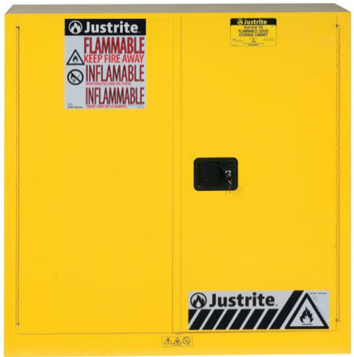  Flammable liquid storage cabinet (CFC 5704.3.2)
Combustible liquids (Class II, IIIA, IIIB)  Flammable liquids (Class IA, IB, IC) | Liquid | 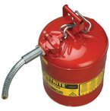  Safety Can  (CFC 5003.9.10)
Flammable solids  Organic peroxides (Class I, II, III, IV, V)  Oxidizers (Class 4, 3, 2, 1)  Pyrophoric solids  Unstable (reactive) materials (Class 4, 3, 2, 1)  Water reactive materials (Class 3, 2, 1)  Corrosives  Highly toxics  Toxics | Solid Liquid | 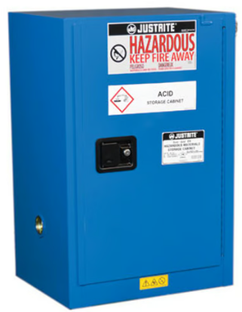  Hazardous materials storage cabinet (CFC 5003.8.7)
Flammable gas  Oxidizing gas  Pyrophoric gas  Unstable (reactive) gas (Class 4, 3, 2, 1)  Inert gas  Gases not otherwise classified  Corrosive gas  Highly toxic gas*  Toxic gas | Gas  Liquefied gas | 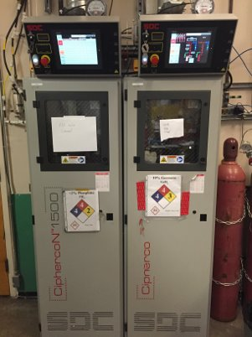  Gas cabinet  (CFC 5003.8.6)
Flammable gas  Oxidizing gas  Pyrophoric gas  Unstable (reactive) gas (4, 3, 2, 1)  Inert gas  Gases not otherwise classified  Corrosive gas  Highly toxic gas*  Toxic gas | Gas  Liquefied gas | 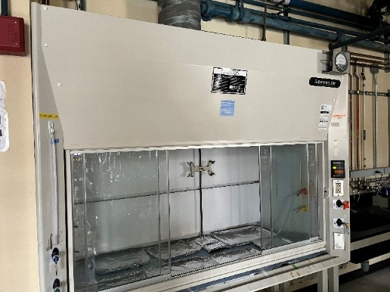  Exhausted enclosure  (CFC 5003.8.5)
Cryogenic fluids, Inert  Cryogenic fluids, Flammable  Cryogenic fluids, Oxidizing | Liquid | Not Applicable

2022 California Fire Code (CFC) Section reference
National Fire Protection Association (NFPA) Codes and Standards
Code of Federal Regulations (CFR)
*Approved storage is required

