Request for Faculty Seed Grant Proposals for Award Year 2026-27
December 1, 2025

Overview of Funding Opportunity
The UC Cancer Research Coordinating Committee (CRCC) is a systemwide, faculty-directed cancer research program that provides competitive intramural research awards for topics in any discipline that address any aspect of cancer, including its origins, detection, prevention and cure. Funding for this opportunity is provided through 33 bequests to UC for cancer research, as well as donations made through the California Cancer Research Voluntary Tax Contribution Fund.

CRCC Faculty Seed Grants support meritorious research spanning all areas from basic research to applied clinical and community-based research in any field relevant to cancer. Proposals must be directly relevant to cancer. Relevance and impact should be articulated in relation to theoretical and/or practical problems in cancer in any discipline, and may include the likely impact of the research on communities disproportionately at risk or afflicted by cancer. If directly applicable to cancer prevention, education or treatment, proposals that explore effective avenues for expanding culturally sensitive, community-based education to raise awareness about the causes and prevention of cancer are also invited.

Applications in disciplines outside of basic and clinical/translational science are welcome (e.g., public health, law, social sciences, psychology, health services research, community-based research, implementation science) as are multi-disciplinary applications.

The CRCC provides one-year seed grants to faculty on the 10 UC campuses, with the expectation that the most promising endeavors will become competitive for larger, long-term grants from other funding sources. Currently, the CRCC awards grants to UC Academic Senate faculty in the following categories:
- New faculty to initiate cancer research projects;
- Established investigators in other areas of research to initiate cancer research projects;
- Established cancer investigators to initiate cancer studies in new areas.

Awards are made in two categories: New Assistant Professor (NAP) and Regular (REG), as described below. The maximum award amount for the 2026-27 award year will be $85,000. The award term is October 1, 2026 through September 30, 2027. General program information regarding the CRCC may be
found on the CRCC website.

Trainee Supplement Opportunity: Applicant Principal Investigators (PIs) selected for a Faculty Seed Grant in 2026 will have an opportunity to request a supplement of up to $10,000 concurrent with their award year to support undergraduate, master’s and post-baccalaureate trainees. See Appendix 5 for more information.

Key Dates:
RFP Release: | Monday, December 1, 2025
Applicant Webinar (recommended)*: | Monday, December 15, 2025 and Tuesday, January 6, 2026
Letter of Intent Due (required): | Thursday, January 22, 2026 (12 pm NOON Pacific Time)
Notification of LOI Decision: | by Wednesday, February 11, 2026
Full Proposal Due: | Thursday, April 2, 2026 (12 pm NOON Pacific Time)
Notification of Review Outcome: | Tuesday, August 4, 2026 (expected)
Award Start Date: | October 1, 2026

This Request for Proposals (RFP) contains information regarding due dates, eligibility and exclusion criteria, budget guidelines, application components, and the review process and program contacts. Letters of Intent (LOIs) and applications must be submitted in compliance with this RFP and instructions. Proposals must be submitted through the PI’s campus Office of Research (C&G or SPO). The PI is responsible for obtaining all required signatures and following campus proposal submission procedures.

* Attendance of the webinar is strongly encouraged. Registration and call-in information and other program updates will be available on the CRCC website.

Overview of the Application and Selection Process
The LOI is a requirement for the application process. Applicants must submit their LOIs using the online SmartSimple application system. LOIs will be reviewed for eligibility, and those that do not meet the criteria listed below will be declined. Only approved LOIs can proceed to full proposals.

Access to the full application in SmartSimple is available only to those with approved LOIs, submitted by the LOI deadline. Full proposals must be submitted online and in accordance with the instructions, templates and guidelines provided in SmartSimple, and must conform to the requirements of this RFP. It is the applicant’s responsibility to check the program website for any updates or clarifications prior to submitting the full proposal.

Full proposals undergo a competitive peer review and ranking process by the CRCC active membership, and are scored on merit as well as cancer relevance and impact, as outlined herein. Program funding varies on a year-to-year basis, but it is expected that about $2 million will be available for new awards. Funding decisions are based on ranking and availability of funding and are final.

Eligibility and Exclusion Criteria
Adherence to eligibility requirements will be evaluated at the LOI stage, as well as during the full proposal review. Please review these criteria and the attached FAQs (Appendix 1). If questions about eligibility remain, please direct them to UCRI@ucop.edu.

- Eligible Principal Investigators (PIs): Proposals must be submitted by a member of the Academic Senate at one of the 10 UC campuses who serves as the PI for the award. PIs must be employed a minimum of 50% time on UC-administered payrolls at a UC campus, and must apply through their UC campus. Awarded proposals will be administered by the campus department or unit identified in the proposal. A signature from the PI’s Department Chair or chair of their administrative unit is required at the full proposal stage for verification of appointment, percent time employed, and Academic Senate membership.

PIs may apply in one of two categories: Regular (REG) or New Assistant Professor (NAP). Applicants in either category must have an initial UC appointment date of no less than one year prior to the award start date. Eligibility for the NAP category requires that the applicant have an effective initial UC appointment date (for the purpose of merit and promotion timing) of between one to six years prior to the award start date. (For award year 2026-27, the effective initial appointment date must be between October 1, 2020 and October 1, 2025.) If the PI’s promotion schedule has been altered for any reason, changes must be explained in the LOI and will be reviewed as part of the LOI approval process. Applicants eligible for the NAP category may not apply in the REG category.

The CRCC does not award grants to investigators or research groups already receiving substantial research support. Awards will not be made to investigators who have support for their research program exceeding $350,000 (in direct costs only) in the proposed award year. Please review the attached FAQs (Appendix 1) for guidelines on calculating research program support.

- Proposal Eligibility: Each applicant may submit only one proposal per year. Applicants in the NAP category may apply annually. Applicants in the REG category are eligible to apply no more than twice in any sequential three-year period. Resubmission of a revised, previously unsuccessful proposal is allowed only once, and that resubmission must occur no later than two years after the original submission.

- Logical Extension: CRCC REG Faculty Seed Grants are intended to support new projects, not continuing projects. Logical Extension, defined as proposed research that is a direct scientific continuation or next step of research carried out with prior extramural funding (e.g., science that one would expect in a renewal application of the extramural grant), is not allowed for REG awards. Applications in the NAP category may propose projects that are logical extensions of existing research.

- Exclusion Criteria: An applicant is eligible to receive CRCC funds in nonconsecutive years only. The CRCC does not award grants to investigators or research groups already receiving substantial research support. Awards will not be made to investigators who have support for their research program exceeding
$350,000 (in direct costs only) in the proposed award year, excluding suspended grants. Please review the attached FAQs (Appendix 1) for guidelines on calculating research program support. In addition, it is not the intent of the Committee to continually provide support to any one investigator, laboratory or research team. Applicants who have previously received Research Grants Program Office (RGPO) funding must be in compliance with all reporting requirements to be eligible to receive CRCC funding.

Budget Guidelines
- Budget Request: The maximum award request is $85,000. All budget line items must directly support the research and dissemination activities in the proposal and must be justified in relation to the scope of work. Support for graduate students, postdoctoral scholars and other trainees is highly encouraged. Costs to supplement other awards are not allowed.

- Duration of a Grant: Grants are awarded for a one-year period, October 1, 2026 through September 30, 2027. If the research program described is of longer duration, it is the applicant’s responsibility to clearly designate what part of the project is to be undertaken during the award year with CRCC funds. These seed grants are not intended to be a source of continuing support, and extramural support should be sought for projects requiring further funding. The CRCC expects that the funds provided will be used for a full year of research and dissemination by the PI. The CRCC will not provide funds for a partial year of research. The funds may not be transferred to another researcher. The PI should not accept the award if there is a likelihood of leaving the University of California within the award period.

- Logical Extension and Overlap: CRCC funds may not be used to support REG projects with logical extension or overlapping projects in either the REG or NAP categories. Overlap is defined as research that is substantially the same as research described in a pending or funded extramural proposal.

- Allowable Costs: CRCC funds may be used to support graduate students and postdoctoral scholars working on the project, provide salary support for technical assistance, and purchase supplies, services and equipment required specifically for the project and not otherwise available through department or university facilities. Funds may also be used for community-based education activities related to the scope of the research, and/or to increase community awareness about the causes and prevention of cancer. Travel expenses are allowed only for data collection directly related to the proposed research. Please note that it is not the intention of the CRCC to fund the purchase or construction of general laboratory equipment. Equipment purchases and expenses for equipment maintenance and service contracts, personal computers (including computer hardware and/or software), and/or consultants require sufficient justification as to their specific need for the proposed research, and will be considered on a case-by-case basis. Consultant expenses, if approved, must be spent within California. A budget itemization and justification is required in the full proposal.

- Non-allowable Costs: The following costs may not be charged to a CRCC award: salary support for the PI or faculty co-Is, regular or visiting academic (either research or teaching) staff, clerical assistance; subcontracts; clinical trials; patient care costs; office supplies, books, periodical subscriptions; patent execution costs; membership fees; registration fees; fundraising costs; meeting or conference travel. CRCC grants do not provide indirect cost recovery.

Letters of Intent: Components, Review and Selection
All applicants must submit an LOI using SmartSimple. LOI instructions are available online in SmartSimple and Appendix 2 of this document. LOIs must be submitted by the deadline listed on page 1.

The LOI must include the following information:
- PI name, title, departmental and campus affiliation, and PI ORCID;
- Applicant category: Regular (REG) or New Assistant Professor (NAP) and eligibility criteria;
- Indication of resubmission status;
- Abstract (2400 characters/~350 words) providing a brief description of the proposed scope of research and activities (this is the body of the “Letter of Intent”; do not submit a separate letter);
- Topic/Discipline: Applicants are asked to select the topic or discipline most closely aligned with their research; and
- Common Scientific Outline Code: Applicants are asked to code their research according to the Common Scientific Outline (CSO) classification system.

LOIs must include required elements and will be evaluated for eligibility to submit full proposals in accordance with the criteria outlined in the Eligibility and Exclusion Criteria section above. LOIs will be evaluated for responsiveness to this RFP in three areas: 1) Eligibility and completeness; 2) Compliance with program requirements; and 3) Alignment with the program goals and funding priorities. Information provided in the LOI will be used to assist in planning for the full review. All applicants will be notified of the LOI outcome, but no feedback or comments on the proposed research will be provided.

Full Proposal: Content, Review and Selection
Proposals must adhere to all the requirements to be forwarded to the peer review stage. Instructions for the full application will be made available in early February 2026 in SmartSimple. Proposals must be submitted through the PI’s campus Office of Research (C&G or SPO). The PI is responsible for obtaining all required signatures and following campus proposal submission procedures.

Scope and Content of the Full Proposals
The full proposal must include the following components and use the templates provided (maximum page length indicated for each section must be strictly adhered to):

- Abstract (2400 characters/~350 words): The abstract should be appropriate for a general scholarly audience. Avoid disciplinary jargon or technical language specific to a single field. The abstract is not counted in the 5-page limit.

- Proposed Research Activities (5-page limit, not including literature cited): Describe the scope of the proposed research and its significance, including: a concise statement of the problem to be solved (e.g., state the hypothesis to be tested); sufficient background to orient those not familiar with the problem; preliminary data if available or other relevant data from the applicant’s work or that of others; and sufficient detail describing the applicant’s proposed research and specific aims such that the Committee can evaluate the applicability and likelihood of success of the research plan, as well as the potential significance of the results. Include a brief description of the expected publications or other plans to disseminate the results of the research.

The scope of the proposal should be suitably limited such that completion in one year is a reasonable expectation. The narrative must emphasize what the PI expects to accomplish with the CRCC funds, including expected outcomes, potential problems and alternative strategies. Sufficient detail must be given in this section to make it possible for Committee members to clearly distinguish this project from others in the applicant’s research portfolio with respect to issues of potential overlap and/or logical extension.

Applicants may include up to 2 additional pages (not included in the 5-page limit) for literature cited.

- Cancer Relevance and Impact (1 page): CRCC funds are intended to support research clearly and directly related to cancer and are not intended for support of general biological or other health research. Proposals should articulate their cancer relevance and impact in relation to theoretical and/or practical problems in cancer in any discipline. Relevance and impact may also include the likely impact of the research on communities disproportionately at risk or afflicted by cancer, or the likely impact on diversity of the cancer research workforce through training or community education components. Proposals are scored for cancer relevance and impact separately from overall scientific merit.

- Itemized Budget and Justification: Provide an itemized budget for the proposed activities in accordance with the allowable costs and budget guidelines. A budget justification that describes significant project expenditures is also required. The budget should include direct costs only (no indirect costs are allowed).

- Other Support: Use the template provided to identify all current and pending grants that provide direct financial support to the PI’s laboratory or research group. The list should include all research grants, program project grants (details and funds for the PI’s sub-project only) and other pertinent sources of funds that support the applicant’s research for the award calendar year. Include direct costs only. List suspended grants as pending. Do not include start-up funds, salary-only grants and fellowships for the PI, training grants for graduate students that do not supply research support for the PI’s laboratory or research group, or funds for administrative or core facility components of multi-project grants. For each grant, include the abstract, and describe any scientific relationship that exists between that grant and the proposed CRCC project and, specifically, how they differ.

- Additional Attachments (all required unless otherwise noted):
- PI biosketch: Not to exceed two (2) pages. Please use the NIH template with the following modifications to adhere to the page limit: include Position Title; Education/Training; Positions, Scientific Appointments and Honors; and relevant peer-reviewed publications only (Contributions to Science). (If space allows within the two-page limit only, you may, at your discretion, include a brief Personal Statement.) Exclude Research Support.
- Signature of Department Chair or Chair of the PI’s administrative unit verifying the PI’s appointment eligibility, using the template provided in SmartSimple.
- Human subjects, animals or biohazards: Indicate anticipated IRB or IACUC review requirements and, if applicable, provide a summary of any human subjects or animal use issues.
- For resubmissions only: If the proposal being submitted is a revision of one that was not previously approved for CRCC funding, include the “Revised Proposal” template in the application (if applicable only).
- Letters of collaboration may be included from individuals who will be participating in the project in a significant way, on an ongoing basis (optional). Letters may not exceed one page each. Do not submit any letters from individuals not directly participating in the research.

Proposal Review and Scoring Criteria
The review process is competitive and the CRCC will evaluate proposals based on the scoring criteria and program priorities. Committee members are faculty drawn from the University of California system with a wide variety of expertise. Review assignments will be made to ensure a fair and balanced review and to address conflicts of interest.

Proposals receive a combined score based on merit and cancer relevance and impact. Scoring is based on specific consideration of the following:

- Significance of Questions/Problems to be Solved: Proposed research should address compelling questions related to cancer research or proposed cutting-edge directions that are likely to lead to important scientific or scholarly breakthroughs relevant to any aspect of cancer.

- Proposed Methods: Methods proposed are appropriate and feasible for the questions to be solved. Community-based education activities, if included, or other research dissemination plans are appropriate to the targeted community and likely to enhance awareness about the causes and prevention of cancer.

- Probability of Success: Proposed research project can be accomplished within the 1-year time frame of the award, and the research team is well-qualified to undertake the project.

In making funding recommendations, reviewers also consider:

- Budget: Appropriateness of requested budget for the proposed activity.

- Overlap and Logical Extension: REG proposals that are found to have overlap or be logical extension of existing research projects may receive a recommendation for zero budget (not funded) regardless of scientific merit. For NAP applications, logical extension criteria do not apply, but overlap will still be considered as part of the funding recommendation.

Final Selection
The final determination of awards will be made based on a rank-ordered list of proposals approved by the CRCC and available funding. Funding decisions are not subject to appeal.

Upon nomination for funding, applicants will be required to provide updated Other Support information and meet other pre-funding criteria. Abstracts of funded proposals will be made publicly available. Funded proposals must comply with all relevant UC, state, and federal research policies and PIs are required to submit a progress report at the end of the fund year, and final report of research outcomes in four years. Publications and other dissemination resulting from research supported by the CRCC must acknowledge CRCC support in the publication.

Research Program Oversight
CRCC Faculty Seed Grants are administered by UC Research Initiatives, Research Grants Program Office, in the UC Office of the President. Funded proposals will be assigned to a program officer who will serve as the primary program contact.

Additional Information
Please review the CRCC Application Frequently Asked Questions (FAQs) document appended as Appendix 1. For questions on program scope and priorities, please contact: UCRI@ucop.edu.

For administrative questions regarding the application process and for technical questions related to use of SmartSimple, please contact: RGPOGrants@ucop.edu.

Attachments

Appendix 1: Frequently Asked Questions Provides additional information for applicants

Appendix 2: Instructions for Submission of Letters of Intent Provides detailed steps for LOI preparation and submission

Appendix 3: Procedure for Administration of CRCC Faculty Seed Grants
Provides information on post-award administration of funds

Appendix 4: Other RGPO Policies and Pre-Award Requirements
Provides compliance guidelines that will be required of all proposals nominated for funding

Appendix 5: CRCC Cancer Research Traineeship Supplement
Provides information for PIs who are considering applying

Updated Program Announcements, FAQs and RFP clarifications (if any), and applicant webinar information will be posted on the CRCC page of the UCRI website. To ensure LOI and proposal submissions meet all program requirements, PIs and grant administrators are strongly encouraged to check the CRCC website for any program updates prior to submission.

Appendix 1:
Frequently Asked Questions (FAQs)
Version Dated: December 1, 2025

Please reference the Request for Proposals (for Award Year 2026-27) for program requirements

This document is a supplement to the Cancer Research Coordinating Committee (CRCC) Request for Proposals (RFP), and is intended to provide additional guidance to applicants. Based on questions we receive, it may be updated and applicants are responsible for checking the CRCC website for updates.

Required Letters of Intent (LOIs) are due Thursday, January 22, 2026 at 12:00 NOON Pacific Time
Full Proposals are due Thursday, April 2, 2026 at 12:00 NOON Pacific Time

How to Apply:
All application materials must be submitted online via SmartSimple. On the SmartSimple home page (https://rgpogrants.ucop.edu), log in to your account (or create one if you are a new user), click “Available Funding Opportunities,” and then select “CRCC 2026-27 – Faculty Seed Grants.” Applicants are required to submit an LOI as the first step in the application process. The full proposal materials are available only after approval of the LOI. Additional instructions regarding LOI submission are available in Appendix 2 of the RFP dated December 1, 2025.

Eligibility

Who is eligible to apply for CRCC funds?
PIs must be UC faculty in the second year or later of their initial UC appointment by the award start date, must hold an Academic Senate title, and must be employed at least 50% time on a UC-administered payroll. For award year 2026-27, those with an effective initial UC appointment date of October 1, 2025 or earlier are eligible to apply. Eligibility for awards in the New Assistant Professor (NAP) category is restricted to faculty with an effective initial UC appointment date (for the purpose of merit and promotion timing) between October 1, 2020 and October 1, 2025. If the applicant’s promotion schedule has been altered for any reason, an explanation must be provided in the LOI.

Are clinical researchers eligible?
Clinical researchers are eligible provided they meet the criteria described in question 1.

Are adjunct faculty members eligible?
UC faculty in the adjunct series are eligible to apply only if their appointment confers membership in the Academic Senate. Academic Senate membership is determined by each individual campus. Consult your department chair if you are uncertain about your Senate membership status. Adjunct faculty who are not Academic Senate members are not eligible to apply.

I am an Assistant Professor and my start date is after the NAP appointment date cut-off. Am I eligible to apply?
No. Assistant Professors must meet the eligibility criteria that align with their appointment date. Assistant Professors who have been in their first UC faculty appointment for less than two years by the award start date are not eligible to apply.

I currently have a CRCC grant. Am I eligible to apply for another CRCC grant?
No, CRCC applicants are eligible to receive CRCC funds for nonconsecutive years only. Awards are for one year and are non-renewable.

- How often can I apply for a CRCC grant?
Applicants in the NAP category may apply every year. Applicants in the REG category may apply no more than twice in any sequential three-year period.

Am I eligible to resubmit my unfunded CRCC application for reconsideration in the subsequent review cycle?
If you previously submitted a new application, you may resubmit only once and that resubmission must occur no later than two years after the original submission. If your proposal is not selected for funding after two submissions (original and resubmission), you may not resubmit that application again. These resubmission guidelines apply to both NAP and REG applicants.

Can CRCC funds be used to conduct clinical trials?
No, CRCC funds cannot be used to fund clinical trials or pay for patient care costs.

What do I include in the calculation of the research support for the award year?
Investigators may not have more than $350,000 in direct costs to support their research program in the proposed award year. This calculation is based on a sum of all direct costs provided in any research grant for the applicant Principal Investigator’s (PI) laboratory or research group. In completing the required CRCC Other Support form, exclude indirect and F&A costs from the total award amounts. Also exclude faculty start-up funds, salary-only grants and fellowships for the PI, training grants for graduate students that do not cover research expenses, and funds for administrative or core facility components of multi-project grants. Exclude suspended grants. All PIs are required to disclose other current and pending support at the application stage and prior to final award approval.

Example 1: Professor A is PI (or equivalent)* of a research grant. Direct costs of the entire grant are counted. This example applies to multi-PI or co-PI awards that meet the definition below.

Example 2: Professor B receives support from a research grant for which they are not PI (or equivalent)*. Direct costs allocated to Professor B and their laboratory or research group are counted.

Example 3: Professor C is PI (or equivalent)* of a research project within a program project or multi-project collaborative grant. Direct costs of the research project (but not the entire program project or multi-project collaborative grant) are counted.

*A PI equivalent (e.g., multiple PI or co-PI) shares scientific and administrative leadership responsibility for the project with the PI. Co-Is and other collaborators contribute to the significant development of the project but are not on equal footing with the PI.

The proposed co-I on my project will receive more than $350,000 in research grant direct costs for their laboratory during the award year. Does the $350,000 limit in research grant direct costs apply to both the PI and co-I?
The $350,000 limit in research grant direct costs applies to the PI and the PI’s laboratory or research group. Investigators who regularly jointly collaborate on research, and are co-investigators on multiple research grants, are considered members of the same research team. If the co-I is a member of the applicant PI’s research group or laboratory, then any research grant direct costs received by the co-I should be included in this calculation. Instructions for how to calculate the amount of research support are included in the Other Support form as well as question 9 of the FAQs.

Proposal Submission and Application Guidelines

Do I have to submit an LOI?
Yes, each applicant PI must submit an LOI. Only applicants with approved LOIs may proceed to the full proposal stage.
- I missed the deadline to submit an LOI, can I still submit a full proposal without the LOI?
No. Unfortunately, we are unable to accept LOIs after the deadline, and only approved LOIs may proceed to the full proposal stage.

Can I submit more than one LOI?
No. Only one LOI per applicant PI is allowed.

May I submit my own (separate) LOI and proposal as the applicant PI if I am a co-I on another PI’s proposal?
Yes, you may serve as a co-I on one proposal and the applicant PI on one additional proposal only. Note that because it is the intent of the CRCC to distribute research funds broadly across diverse programs and faculty and there are often more meritorious proposals than can be funded, faculty participation on more than one proposal may be considered as part of the final funding decisions.

Do I have to get permission from my campus to submit a proposal?
Yes. Full proposals must include a signed Department Chair approval form. The completed proposal is submitted by the campus Contracts and Grants (C&G) Office or Sponsored Projects Office (SPO). These signatures are not required at the LOI stage. The PI is responsible for obtaining all required signatures and following campus proposal submission procedures for full proposal submission.

- What is the difference between the NAP and REG application categories?
The two award categories are New Assistant Professor (NAP) and Regular (REG). Restrictions apply to each category based on PI appointment date and scope of the research as outlined in the RFP. Please review the RFP for details in the Eligibility and Exclusion Criteria and Budget Guidelines sections.

- My LOI was accepted for full proposal submission. Is the LOI binding or can I make changes?
The LOI should fairly present your research topic and proposed activities. Updates and adjustments may be made to the proposed scope and abstract when the full proposal is submitted. Once the LOI is approved, the PI cannot be changed in the full proposal. All full proposals are reviewed again for eligibility. Proposals that diverge dramatically from the LOI such that they no longer meet the program guidelines may not be forwarded for review.

Budget Requests and Other Proposal Components

What types of personnel costs can be funded on a CRCC award?
CRCC funds may not be used to fund salaries for PIs or faculty co-Is, regular or visiting academic positions, or clerical assistance. CRCC funds may be used to provide support for graduate students and postdoctoral scholars working on the project and salary support for technical assistance. Stipends or part-time positions for undergraduates participating in the research project (not providing administrative support) may also be included. Salary support for technical or research assistance must be described in the budget justification, and the position title included in the justification. Note that requests for salary support for academic personnel described as providing technical assistance will be reviewed by the CRCC and approved at the discretion of the Committee.

Can I use my CRCC award to hire consultants?
Consultant costs are only allowed for hiring California-based consultants. These proposed costs must be described in the budget justification of your proposal, and will be reviewed and approved at the discretion of the Committee.

I want to include figures and/or data as an Appendix. Is this permissible?
No. Everything that the applicant wishes to be evaluated scientifically must be contained in the proposal narrative, and must adhere to the allowable page limits.

I obtained preliminary data in support of my proposal after the due date. May I submit supplemental information to the Committee?
No.

Review and Selection

What is considered in the LOI review, and how will I know if my LOI is accepted?
The LOI is reviewed for eligibility for CRCC funding in general and, for NAP proposals, for adherence to the faculty appointment requirements. Information provided in the LOIs related to proposal scope and content are used for review planning purposes. All PIs who submit an LOI will receive an email by the date indicated in the RFP. You may log in to SmartSimple at any time after submitting your LOI to review its status. PIs with approved LOIs will automatically be given access to the full application materials in SmartSimple.

What does the Committee look for in a proposal?
The review and scoring criteria for proposals are outlined in the Proposal Review and Scoring Criteria section of the RFP. Please refer to these guidelines. The primary intent of the program is to provide seed funds for promising new projects in cancer-related research that are likely to lead to larger, long- term grants from other funding sources. Proposals from well-funded research groups and proposed research with funding overlap will not be awarded. Titles of proposals funded in recent rounds are available on the CRCC website.

What is the success rate for CRCC proposals?
Funding success rates vary annually based on the number and quality of the proposals received and on fluctuations in available funding. Therefore, past success rates may not be predictive of current or future cycles. Recent success rates have been approximately 25-30% of eligible proposals.

My CRCC proposal was not funded. Can I request feedback?
Written comments submitted by the assigned reviewers will be available to applicants in SmartSimple after funding decisions are complete. Please note that these comments are written before committee deliberations and therefore may not reflect the full scope of deliberations related to the proposal or its final score.

I still have questions. Who can I consult for further information?
For programmatic questions related to the research scope, your award or future funding opportunities, please contact: UCRI@ucop.edu.
For questions related to the administration of a grant or reporting procedures, please contact: RGPOGrants@ucop.edu.

Please check the CRCC website for updates to this document and other program announcements.

UC Cancer Research Coordinating Committee

Appendix 2: Letter of Intent Submission Instructions
2026-27 Faculty Seed Grants
Version dated: December 1, 2025

The University of California (UC) Office of the President is pleased to provide applicant instructions for submission of a Letter of Intent (LOI) to the 2026-27 Cancer Research Coordinating Committee (CRCC) Awards Request for Proposals released on December 1, 2025. Submission and approval of a LOI is required to submit a full proposal to this Request for Proposals (RFP). LOIs must be submitted electronically by January 22, 2026 before 12:00 noon Pacific Time in the SmartSimple system. We encourage early submission of LOIs. Please note: LOIs will not be accepted after the deadline.

OVERVIEW OF ONLINE LOI SUBMISSION PROCESS
The LOI must be submitted through SmartSimple. Applicants may submit LOIs via the online system any time between December 1, 2025 and January 22, 2026. The LOI submission must be completed (not merely initiated) by the 12:00 noon PT deadline. Therefore, plan ahead in preparing your submission.

Step 1: Applicant Registration with SmartSimple
Applicant Principal Investigators (PIs) must register as users of SmartSimple to submit an LOI and complete a proposal.

All Users Accessing SmartSimple for the First Time:
- When accessing SmartSimple for the first time, all users should click the “Register Here” button under “Principal Investigator Registration” and follow the instructions to enter your institution, name, and contact information.
- All University of California campuses are in the system; be sure to enter “University of California” in the search box to find the campus.
- Your user account will then be created. You will receive an email with instructions to create a password and complete your account profile. Once you have completed this step, skip to Step 2: LOI Preparation.
- If you see a pop-up message indicating that an account with your email address already exists, return to the SmartSimple main login page, and click the “Forgot Password” link. You will receive an email with a link and instructions to reset your password. If you do not receive the password reset email within one hour, please contact us using the contact information at the end of this document. Make sure to check your spam or junk folder.
  - If you need to change the institution that your existing account is associated with, please email us at RGPOGrants@ucop.edu.

Returning Users: Applicants who have previously registered with SmartSimple or are returning to complete an in-progress LOI should enter their username and password under “Login” and click the “Login” button on the SmartSimple homepage.

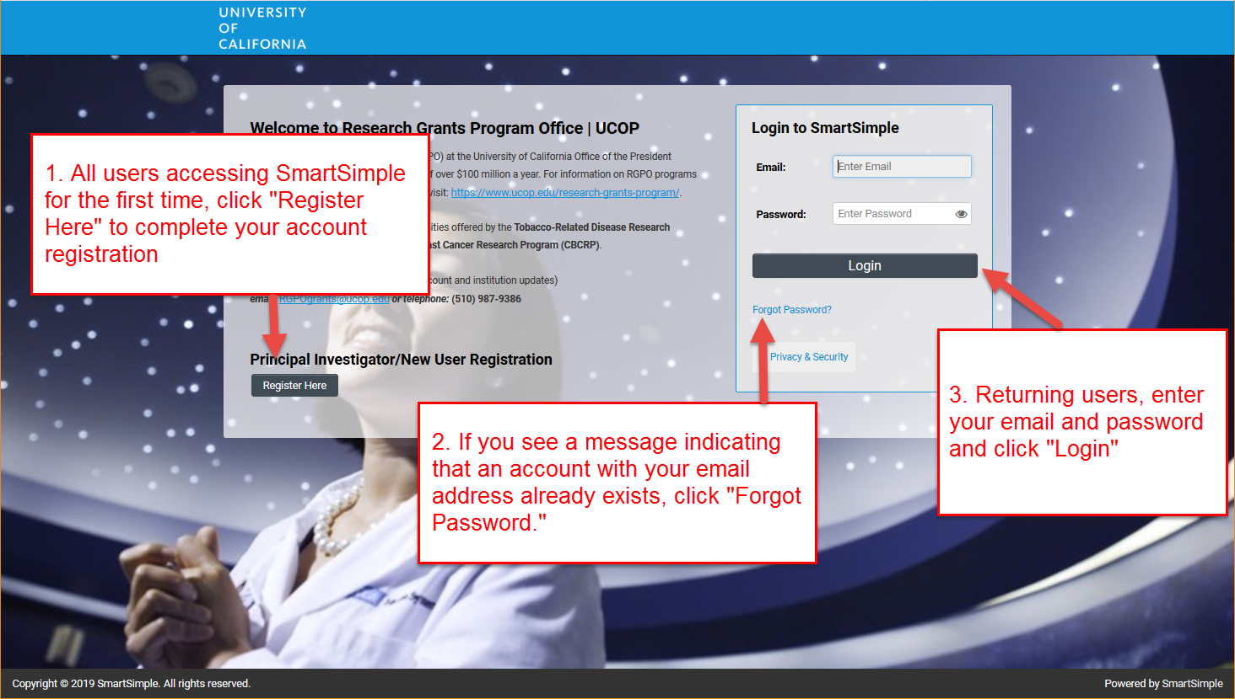

Step 2: LOI Preparation and Submission
- Once logged into the system, click on “Available Funding Opportunities.”
- Find the row for the award type you are interested in, then click “Apply.” You will then be taken to the Eligibility Check.

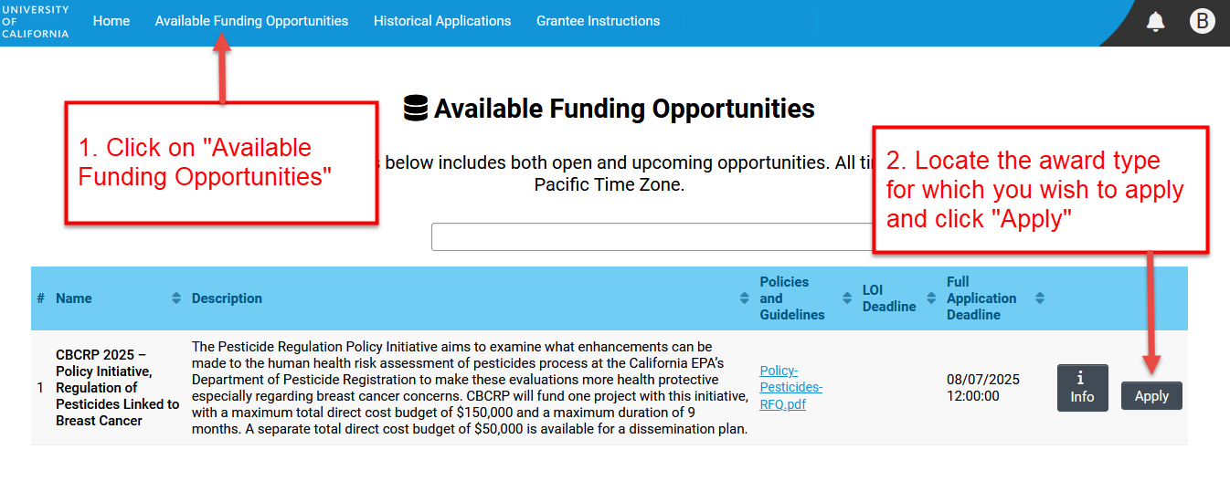

- Complete the Eligibility Check and click “Submit.”
  - The Eligibility Check contains a question regarding applicant eligibility. You must provide an answer to acknowledge that you meet all eligibility criteria listed. Upon submitting a “Yes” response, you will be able to start the LOI process. If your answer is “No,” you are not eligible to apply.
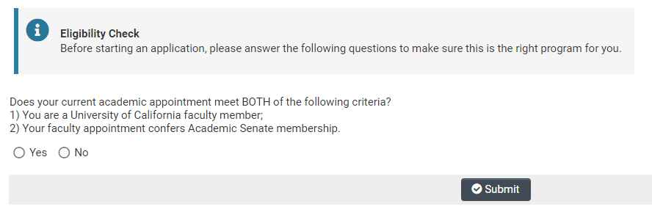

- Review the Helpful Tips, and click “Continue” to begin your LOI.
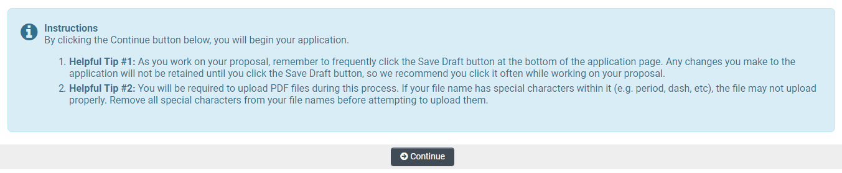

- Once in the LOI interface, you will see two options on the left sidebar: Main and Notes.
  - Main: Click this tab to access each section of the LOI. Detailed instructions for each section are provided below.
  - Notes: Click this tab to create Notes for your LOI. Click “+” to add a new Note. Any Notes stored here are for the applicant’s reference only and will not be reviewed by program staff. Please make sure to include all relevant project information in the LOI sections under the Main tab.

- In the “Main” tab, complete each section of the LOI and submit by the deadline. Please see below for detailed descriptions of each section. Note: Be sure to save your work often by clicking “Save Draft.” You can access your LOI in later visits for additional work by selecting “Open” under “In Progress Applications” on the Home screen.

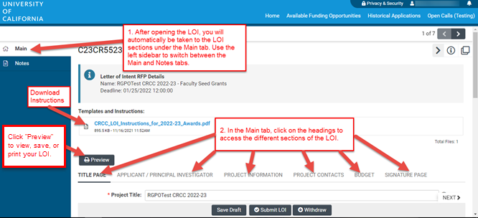

STEP BY STEP: DETAILED DESCRIPTIONS OF EACH LOI SECTION
- Additional details for each section of the online LOI submission form are provided below. To begin the LOI, please select Apply or, if you have already started the LOI submission process and would like to make changes or complete your submission, select “Open” under “In Progress Applications” on the Home screen.
- The LOI sections: Title Page, Applicant/Principal Investigator, Project Information, Project Contacts, Budget, and Signature Page, can be completed in any order and in any number of sessions prior to the deadline. You can move between sections by clicking directly on the section headings, or by clicking the “NEXT >” text at the bottom of the screen. Required fields are denoted with a red asterisk (*). Note: Please be sure to save your work periodically or after each entry.
- As you move through each section using the horizontal navigation bar, instructions are always available for download at the top of the page. If clicking on the applicant instructions moves you out of your LOI, the back button will not return you to the LOI submission. To return, go to the Home screen and select “Open” under “In Progress Applications.”
- Click the “Preview” button at any time to view, save, or print a pdf version of your LOI.

LOI Section: Title Page
- Project Title: Please enter the project title here (100 characters or fewer
including spaces).
- Project Duration (Year): Using the drop-down menu, select the duration of the project. Refer to the call for applications for the award term. You must enter this information before you can enter the amount requested on the Budget tab.
- Project End Date: Please enter the project end date here, one year after the award start date.
- Application Type: Select “New Assistant Professor (NAP)” or “Regular (REG)” to specify the application type. See RFP for guidelines.
  - If New Assistant Professor (NAP): Provide the date of your initial UC faculty appointment. If there has been a change in your promotional schedule, please explain.
  - If Regular (REG): Provide the date of your initial UC faculty appointment.
- Academic Appointment and Status: Please answer the questions regarding your academic appointment:
  - Academic Senate Membership: Please indicate (Yes/No) if your academic appointment confers Academic Senate Membership.
  - Academic Appointment: If your appointment is not listed in the drop-down menu, please select “Other” and enter your appointment title.
  - Percent Time on UC Payroll: Please select the range in which your percent time on UC Payroll falls (0-49% or 50-100%).
- Resubmission: Select Yes or No to specify whether this application is a Resubmission.
  - If Yes: Select your previous application from the drop-down list that appears. If it is not listed, select “Not Listed Above” from the drop-down, click “Save Draft,” and enter your original application number and title in the new text boxes that will appear.
- Extramural research support: Please indicate (Yes/No) if your extramural research support for the CRCC award period exceeds $350,000 in direct costs.

LOI Section: Applicant/Principal Investigator
Applicant/Principal Investigator information will be auto-populated from the “My Profile” section of your SmartSimple account. Please review this section for accuracy. To make changes to this information, click on your name in the upper right corner of the page, and select “My Profile.” Save your changes. Return to the LOI by selecting “Open” under “In Progress Applications” on the Home screen. You can also go directly to the “My Profile” page in your account to make changes at any time.

LOI Section: Project Information
- Lay Abstract: An abstract is required. In the textbox provided, concisely summarize the proposed project. This abstract is limited to 2,400 characters including spaces (approximately 350 words) and should be written in a manner that is appropriate for a general scholarly audience. Information must be entered as text only (scientific notations, special characters, fonts, and other rich-text formatting cannot be saved or displayed). The abstract is non-confidential, and may be published or circulated by the Program.
- Topic/Discipline: Please select from the drop-down the topic or discipline that most closely aligns with your research.
- CSO Research Type(s) and Sub-Type(s): Please select the CSO Types and corresponding Sub-Type(s) that best represent your project.
- Suggested Reviewers: (Optional) This table is used for recommendations for CRCC members, as well as identification of CRCC members who you do not want to review your proposal. Click the “Enter Suggested Reviewer” button to list individuals in either category.
- Recommendations: Proposals are reviewed by active members of the CRCC, who must be members of the UC Academic Senate with expertise in areas relevant to cancer research. We are always interested in identifying qualified UC faculty members. Recommendations will undergo the CRCC process for selecting new members. To make nomination(s), please list the name, institution, and email address of the potential CRCC member(s). In the “Notes” column, please indicate that this is a recommendation.
- Exclusions: You may identify CRCC members who you do not want to review your proposal. A list of the current CRCC membership is posted on the CRCC website. Such requests MUST include a brief explanation of the perceived conflict of interest. Final determination of review assignments is at the discretion of the Program. All requests to include or exclude reviewers are confidential. Use the “Notes” column to describe the perceived conflict of interest.
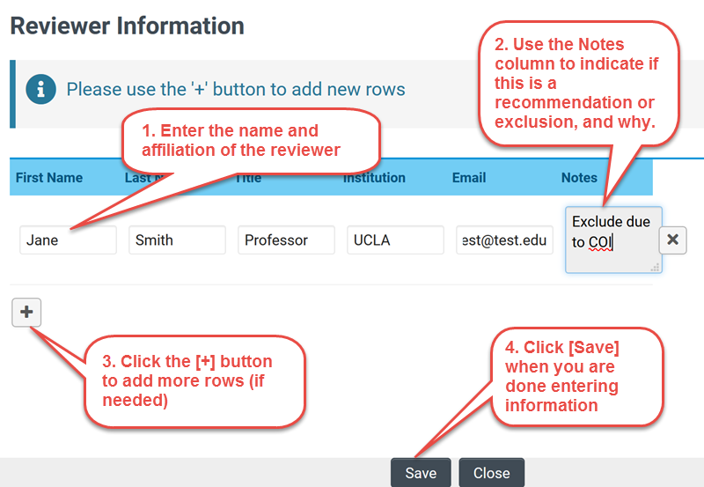

LOI Section: Project Contacts
- Project Personnel: You MUST add all project personnel, including the Principal Investigator of the project. Click “Enter Project Personnel.” A separate window will open. Using the “+” button, enter the names and details of all project personnel. Add rows until you have added all project personnel. Click “Save” to save your changes. Click “Close” to return to the full application.
  - Role on Project: For each personnel, select their role on the project from the drop-down list. See Appendix 2A for the list of allowed roles on CRCC awards.
  - PI/Co-PI column: For single PI awards, please select the Principal Investigator on the project from the drop-down menu in this column.
  - Upload Personnel Biosketches: Once you close the Project Personnel window and return to Project Contacts tab, you will see a display of your Personnel. Click Save Draft, then click the Upload button to upload the biosketch of the person named in the first row, and repeat the biosketch upload process for each Personnel listed. Then click “Save Draft” to display a link to the biosketch that you uploaded. Biosketches are not required at the LOI stage, but the button will still appear in this table.

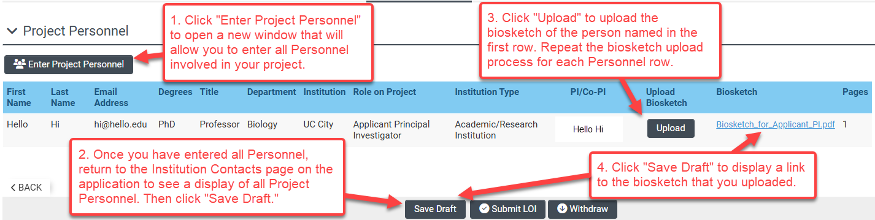

LOI Section: Budget
- Amount Requested: Enter the estimated total amount requested (direct cost) for the project period. Click “Save Draft,” and the system will calculate the total amount requested. This amount is an estimate only and is not binding. If your LOI is approved, you may adjust the amount(s) in the full application stage. Hint: You must first select the “project duration” on the Title Page in order for the system to display the budget line(s) per project period.

LOI Section: Signature Page
All applicants must certify that that the statements provided in the LOI are true, complete, and accurate to the best of the applicant’s knowledge. The applicant is aware that any false, fictitious, or fraudulent statements or claims may subject me to criminal, civil, or administrative penalties. The applicant agrees to accept responsibility for the scientific conduct of the project and to provide the required progress reports if a grant is awarded as a result of this application.
- Applicant Signature: Check the box to certify the information in your LOI.
- Signee: Type your full name into the field.
- Date: Select date on which you have signed the LOI. (Tip: click “Save Draft” after you’ve selected the date.)

Review your LOI: Preview button
Click the “Preview” button (upper left corner) to view, print, or save your LOI submission as a PDF.

Submit your LOI
Click the “Submit LOI” button to submit your LOI to the program. If you decide not to submit the LOI and no longer want to be considered for this funding opportunity, you may wish to withdraw your LOI. Clicking on “Withdraw” will completely remove the LOI record from your account. In lieu of “Withdraw” you can choose not to submit a completed LOI.

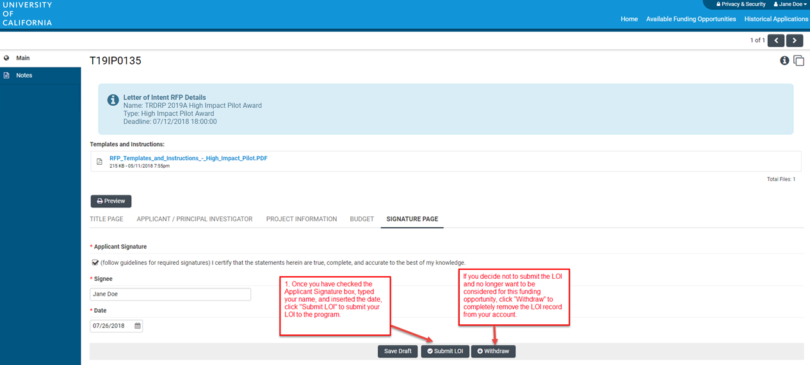

Confirming Status of Your Submitted LOI
Following the submission of an LOI to SmartSimple, applicants will receive an email confirming receipt of the application. The email confirmation typically arrives within a few minutes (the length of time may be greater near the submission deadline). If you do not receive the SmartSimple confirmation email within an hour of your submission, please contact us using the contact information provided at the end of this document. You can also confirm the status of your LOI submission by going to your SmartSimple home page, under the “Home” link in the upper right corner and clicking on “Submitted/Under Review Applications.”

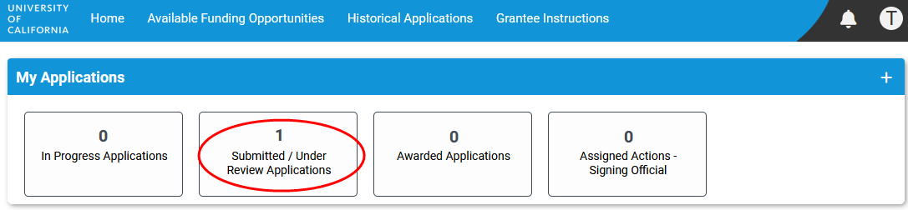

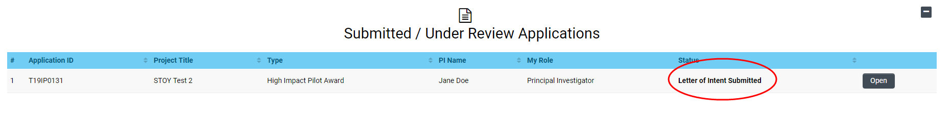

Questions and Technical Support

Should you have any questions regarding your application, please contact:

- UC Research Initiatives at UCRI@ucop.edu regarding program scope, priorities, and eligibility.
- Research Grants Program Office at RGPOGrants@ucop.edu regarding application and pre/post-award procedures, and technical questions regarding SmartSimple.

For the most up-to-date application and review cycle information refer to the CRCC website.

Appendix 2A:

Project Personnel Roles – Definitions, Guidelines, and Biosketch Requirements

The Cancer Research Coordinating Committee (CRCC) Faculty Seed Grants allow the following roles on CRCC awards.

Role on Project | Definition | Biosketch Required?
Applicant Principal Investigator | The Applicant Principal Investigator is the lead investigator on a grant. They direct the research project, serve as the project’s main research and administrative contact, and are responsible for providing progress, fiscal, and other reports to RGPO. There will always be only one PI from an institution. Any additional investigators from a given institution are called Co-Investigators. | Yes
Co-Investigator | Co-Investigators are additional investigators from the same institution(s) as the Principal Investigator. Only one Principal Investigator is permitted per application. | Yes
Consultant | Consultants are project participants who provide a well-defined and restricted service, and are not located at the PI’s institution. | No
Research Support Staff | Individuals providing technical services in support of the research project, such as Project Directors, Research Coordinators and Research Assistants. These individuals are directly involved in the research project. Research staff generally will appear on the project budget. Administrative, secretarial, or other general departmental or center support staff are not considered to be directly involved in the research and should not be listed as research support staff. | No
Trainee – Graduate Student | Named trainees may be graduate students participating in a significant manner in the research as part of a degree program or formal fellowship. Do not include unnamed Trainees in the personnel table. | No
Trainee – Postdoctoral Researcher | Named trainees may be postdoctoral researchers who will devote significant effort to the project, and who do not meet the definition of co-I. Do not include unnamed Trainees in the personnel table. | No

A Role on Project must be selected for each individual listed in the Project Personnel table in SmartSimple, which can be found on the Project Contacts tab of the application. Other roles that you may see as options in SmartSimple may not be used for CRCC awards.

Note that all required biosketches are uploaded directly to the Project Personnel table at the full application stage.

Appendix 3:

Procedure for Administration of Cancer Research Coordinating Committee Faculty Seed Grants

- Restrictions on the use of Cancer Research Coordinating Committee (CRCC) Faculty Seed Grant:
  - The following expenses may not be charged to a CRCC grant account:
    - Salary items for: Principal Investigator or Co-Investigators; supplementation of regular or visiting academic personnel salaries; clerical assistance or consultants; individuals in the Professional Research Series
    - Subcontracts
    - Clinical trials
    - Costs for patient care
    - Office, duplication and communication expenses
    - Periodical subscriptions
    - Preparation and publication of textbooks
    - Books not needed for completion of the research
    - Patent execution costs
    - Meeting or conference travel expenses
    - Registration or membership fees
    - Indirect cost recovery
  - The following expenses may not be charged to a CRCC grant account unless they have been specifically approved in the application budget:
    - Equipment purchases and expenses for equipment maintenance and service contracts
    - Personal computers, computer hardware and/or software
    - Consultant expenses; if approved, expenditures must be made within California
  - Budget changes of any amount require prior approval from CRCC program staff. No funds may be transferred into the equipment budget line item unless prior approval from the CRCC is obtained. Some budget changes may require a formal budget change request per the RGPO Grants Administration Manual.

- Principal Investigators nominated for funding may request an optional Cancer Research Traineeship Supplement for one year concurrent with the parent Faculty Seed Grant.
  - If approved, the following expenses directly related to the trainee’s approved activities may be charged to the Supplement:
    - Trainee wages, stipend, or salary and applicable benefits
    - Supplies and other expenses directly related to the trainees’ research activity
    - Trainee travel directly related to data collection or presenting research findings within the award year

  - The following expenses may not be charged to the Supplement:
    - Equipment purchases and expenses for equipment maintenance and service contracts
    - Financial aid or University tuition and fees
    - Indirect cost recovery

  - Supplement funds may be used only for the approved supplement activities and may not be reallocated to the parent award budget.

- Questions regarding the use of CRCC grant funds for a particular expense should be directed to RGPOGrants@ucop.edu.

- No additions will be made to the award amount for unanticipated increases in salaries or benefits; budget modification requests must be made in accordance with I.C. above.

- The CRCC expects that the funds provided will be used for a full year of research by the Principal Investigator. The CRCC will not provide funds for a partial year of research. The funds may not be transferred to another researcher. The Principal Investigator should not accept the award if there is a likelihood of leaving the University within the award period.

- Equipment authorized by CRCC must be purchased prior to the last 120 days of the term of the grant. All equipment or inventorial items of a permanent nature which are purchased under a research grant shall become the property of the University department or appropriate administrative unit as soon as the grantee's need for them has passed.

- The CRCC will not consider requests for funds to meet overdrafts incurred on Cancer Research funds.

- All scientific publications and other products from this research must acknowledge the funding support from University of California, with specific reference to the Cancer Research Coordinating Committee and the referenced grant ID number. Publications based on funding received from this award are subject to the University’s Open Access Policy. To facilitate compliance with this requirement, publications may be uploaded to the CRCC repository on eScholarship.

- Awards are made for one year only unless specifically noted in the final award letter. No funds may be expended beyond the approved end date unless the Principal Investigator has received prior program approval for a No Cost Extension. No Cost Extensions beyond 3 months will only be approved under extraordinary circumstances. CRCC grant funds remaining at the end of the approved award period must be returned to the UC Cancer Research Coordinating Committee account from which it was transferred by the local campus Accounting Office at the end of the award (within 120 days of the end of the approved performance period). Return of funds instructions will be provided at award closure.

- The Principal Investigator is responsible for the timely submission of progress and fiscal reports, the 4-Year Outcomes Report, and any other reports as requested.

The progress and financial reports must be submitted 90 days after the expiration of the award to UC Research Initiatives in accordance with instructions provided by RGPOGrants@ucop.edu. In addition, CRCC grant recipients are required to submit an outcomes report documenting the outcomes and impact of the research grant 4 years after the award start date. Instructions for completing and submitting reporting forms will be provided at a future date.

Questions about any of these provisions should be addressed to RGPOGrants@ucop.edu.

Last updated: November 18, 2025

Appendix 4:

Other RGPO Policies and Pre-Award Requirements

The following relevant policies and requirements for awards made by the UCOP Research Grants Program Office (RGPO) apply to all proposals nominated for funding. These requirements are outlined in the formal “pre-funding” notification that will be sent to applicants nominated for funding by the peer review and ranking process, and this appendix may not include all pre-award requirements.

Condition of Award for UC Faculty
In accordance with University of California policy, investigators applying from a UC campus must submit proposals through their campus contracts and grants office (“Policy on the Requirement to Submit Proposals and to Receive Awards for Grants and Contracts through the University,” Office of the President, December 15, 1994”). Investigators from other UC locations or from the national laboratories should apply through their institution’s contracts and grants office. Investigators with a joint or multi-location appointment should consult the eligibility guidelines in the RFP to determine through which location they are eligible to apply.

Human Material and Animal Subjects
Approvals for use of human subjects and material, animals, and toxic substances are not required at the time of application. When such approvals are applicable to the research, applicants must apply to the appropriate board or committee as soon as possible in order to expedite the start of the research, and you must do so within 30 days of notification that an award has been offered. Applicants may formally request an extension of this deadline if justified by specific circumstances of the research. All reasonable efforts must be made to obtain appropriate approvals in a timely fashion. Projects that do not obtain the necessary approvals in a timely manner may have their funding reduced or withdrawn.

For multicampus collaborations with research requiring IRB approval, the Memorandum of Understanding governing reliance across the UC campuses allows an IRB at any of the UC campuses to rely upon the review and approval (or determination of exemption) of human subject research by an IRB at another UC campus. Each campus IRB can assist with any questions related to taking the lead or relying on other UC campus IRB reviews. Please note that each study location is still responsible for obtaining other applicable ancillary approvals such as Conflict of Interest, Radiation Safety, etc. Contact your Campus IRB Reliance Coordinator for more information about the UC IRB reliance process.

Publications Acknowledgement and Open Access
All scientific publications and other products from a RGPO-funded research project must acknowledge the funding support from UC Office of the President, with reference to the specific funding program (e.g., CRCC, MRPI, LFRP) and the assigned grant ID number.

RGPO is committed to disseminating research as widely as possible to promote the public benefit. All publications based on funding received from RGPO are subject to the University’s Open Access Policy. To assist the RGPO in disseminating and archiving the articles, the grantee institution and all researchers on the grant will deposit an electronic copy of all publications in the UC Publication Management System, UC’s open access repository promptly after publication. Notwithstanding the above, this policy does not in any way prescribe or limit the venue of publication.

Deposition of Equipment and Supplies at the End of the Grant
Equipment purchases made by projects funded by the research program must be made by UC campuses and are the property of the UC Regents. Special permission must be sought in advance to purchase equipment for a non-UC campus or entity. In the rare event it is approved, the disposition of the equipment must follow RGPO rules.

Appeals of Funding Decisions
RGPO strives to resolve issues raised throughout the grantmaking lifecycle from funding decisions to project closeout. Before submitting an appeal or grievance, applicants are encouraged to discuss their concerns with the appropriate program officer or program director.

The only basis on which an appeal regarding the funding decision of a grant application will be considered is in the case of an alleged error in, or violation of the peer review procedures and/or process. Appeals based on substantive disagreement with the peer review evaluation will not be considered. In such cases, applicants may resubmit applications in a subsequent grant cycle.

Applicant appeals must be made to the program within 30 days of the funding notification. If discussions with the program do not satisfactorily resolve an applicant’s issue, either the applicant or the program may contact the RGPO Executive Director for resolution. If resolution is not achieved, or if the applicant believes that a violation has occurred that has not been adequately addressed through these efforts, a formal appeal may be filed with the Vice President of Research and Innovation.

Other Requirements
Upon request, awardees must supply the following information or documents:
- Supply approved indirect (F&A) rate agreements as of the grant’s start date and any derived budget calculations.
- Supply any missing application forms or materials, including detailed budgets and justifications for any subcontract(s).
- IRB or IACUC applications or approvals pertaining to the award.
- Resolution of any scientific overlap issues with other grants or pending applications.
- Resolution of any Review Committee and Program recommendations, including specific aims, award budget, or duration.
- Modify the title and lay abstract, if requested.

All grant recipients must abide by other applicable pre- and post-award requirements pertaining to Cost Share, Indirect Cost Rates, Monitoring & Payment of Subcontracts, Conflict of Interest, Disclosure of Violations, Return of Interest, Equipment and Residual Supplies, Records Retention, Open Access, and Reporting.

Last updated: 11/14/2024

Appendix 5:

CRCC Cancer Research Traineeship Supplement

The UC Cancer Research Coordinating Committee (CRCC) is pleased to offer Faculty Seed Grant recipients an opportunity to request an award supplement of up to $10,000 to support trainees who wish to pursue careers in cancer research. The intent of this supplement is to provide trainees with meaningful research experiences that advance their career trajectories in cancer research.

The funding should support the trainees in conducting cancer research, and applicant PIs are expected to actively provide research mentorship to the trainees. The one-year supplement must run concurrent with the parent award. One or more trainees may be supported by the supplement.

PI/Mentor Eligibility: Faculty Seed Grant recipients with award start dates of October 1, 2026.

Trainee Eligibility:
- Enrolled University of California (UC) undergraduate students or first-year students in a terminal master’s program. Post-baccalaureates not concurrently enrolled in a graduate program are also eligible if they graduated from a UC undergraduate program no more than 10 months prior to the CRCC award start date or if they are formally enrolled in a UC post-baccalaureate program.
- Individuals currently enrolled in a pre-doctoral or terminal doctorate program or who have earned a master’s or doctoral degree (e.g., Ph.D., M.D., J.D.) are not eligible to be supported by this Supplement.

Supplement Details:
- Maximum award amount and duration: One year, concurrent with CRCC Faculty Seed Grant, and $10,000 (direct costs only).
- Allowable costs: Trainee stipend or salary and benefits, supplies, trainee travel directly related to conducting the research or presenting research findings at a conference within the award year. (Funding for supplies must be related to the trainees’ participation in the research and may not supplant supplies covered by the parent award.)
- Non-allowable costs: Equipment purchases, financial aid and indirect cost recovery.

Supplement Proposal: Content, Review and Selection
Funding may be requested to support one trainee for a year, or 2-3 trainees for a summer or academic term. One training plan should be provided regardless of the number of trainees to be supported by the funding. A candidate nomination form is required for each trainee. Proposals must include the following components, and be completed using the templates provided:
  - Training plan (2-page maximum; to be completed by the PI/mentor): Use the template provided to outline the trainees’ research activities, mentoring and other training opportunities in accordance with the instructions on the form. The trainees’ research must be within the scope of the funded CRCC project.
  - Candidate nomination (1-page maximum): Use the template provided. If more than one trainee is proposed, each candidate must have a separate nomination form. Describe the trainee’s interest in pursuing a career in cancer research.
  - Itemized budget and justification: Use the budget template to provide an itemized budget indicating how the funding will support the trainee in accordance with the allowable costs. All or most of the funds must directly support the student in the form of stipend or salary and benefits. A short budget justification for each line item is required. (If funding is approved, the budget will be entered into SmartSimple, in connection with the parent award.)
  - Candidate resume or biosketch (2 pages): Please attach a resume, CV or biosketch for each nominated trainee. The resume or CV should specifically indicate the candidate’s education, training, and other relevant experience.

Supplement Submission Procedure:
Upon notification of nomination for a CRCC Faculty Seed Grant Award, applicant PIs will receive instructions on how to submit a supplement application. The application must be submitted during the pre-funding process for the parent Faculty Seed Grant.

Research Program Oversight:
CRCC Faculty Seed Grants and the Cancer Research Traineeship Supplement are administered by UC Research Initiatives in the UC Office of the President. Funded supplements will be incorporated in the CRCC parent award. Your assigned Program Officer will serve as the primary program contact.

