UC Tech Awards 2023 Candidate
Category: SUSTAINED IMPACT
Name: Chris Brandt, CIO, School of Veterinary Medicine
Number of people: 1
Location: UC Davis
- Person submitting the application/nomination
  - Allison Zwingenberger, Professor, Surgical and Radiological Sciences, School of Veterinary Medicine, faculty.
  - Email address: azwingen@ucdavis.edu
  - The name of your organization: UC Davis

- Award category Sustained Impact

- Name of person, name of the team, or name of the project to receive the award : Chris Brandt, CIO, School of Veterinary Medicine

- All project team members - N/A

- Which location was affected by the work? School of Veterinary Medicine

- Summary Chris Brandt has served the Veterinary School since 2001. A veterinarian himself, he developed software to enhance companion animal patient care, administration, and teaching in the veterinary curriculum. He now leads the SVM IT as the Chief Information Officer and champions developing systems to support artificial intelligence and clinical research.

- Narrative

Chris Brandt is the CIO of the School of Veterinary Medicine at UC Davis. He graduated as a veterinarian in 2001, but was drawn to the information technology team to contribute to technical advancements in the delivery of teaching, performance of research, and clinical care to veterinary patients. His impact over his 22-year career at the SVM has been both broad and deep, touching the lives of faculty, students, staff and the owners and patients we serve.

Chris began by developing mobile applications for Academic Programs division of the Veterinary Medicine Dean’s Office in the early 2000’s when palm pilots and pocket PC’s were the forefathers of mobile technology. He developed a formulary and laboratory application to aid clinicians and students in the hospital, and a mobile version of the electronic medical record (VMACS). He also began developing web-based applications including the Veterinary Computerized Anesthetic Record System (VCARS) to capture pre-anesthetic and peri-anesthetic information using wireless tablet PC’s, and the OnCall system to manage on-call schedules for hospital faculty and residents.

From 2005-2014 Chris joined the Computing and Technology Services of the SVM as an instructional Media Development Specialist. He designed and developed VIPER, a flexible framework for all Dean’s Office intranet applications. There are now 80 tools in the framework and all new development takes advantage of the the built-in capabilities such as efficient
content creation, authorization, alternate display modes, automatic Excel export, and built-in
error reporting. VIPER and its integrated set of tools won the Larry Sautter Gold Award
at the 2007 UC Computing Services Conference (UCCSC). He conceived of and developed the Roles and Permissions system to control access to all web applications including the electronic medical record, and this system integrates with Active Directory to assign roles.

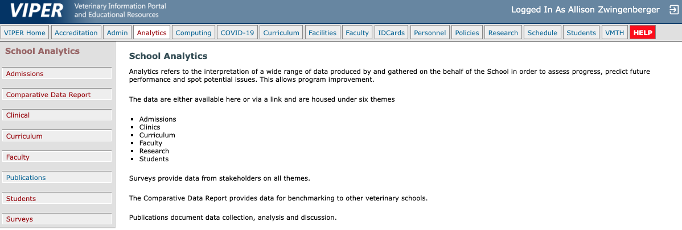

Chris’s impact on instructional mapping and curricular effort tracking has been instrumental in the school retaining its AVMA accreditation and being the top veterinary school in the country. Each class and clinical rotation has mapped outcomes that track to the learning outcomes for each student. He integrated these with the course catalog (CREST) for effort reporting, MyInfoVault, Eval360 (student and faculty evaluations), and the merit and promotions voting system. Chris also designed the SVM admissions system and was a lead organizer for the Multiple Mini Interview (MMI) process. These applications are fundamental to faculty, staff and students and support our core mission of delivering excellence in the veterinary curriculum.

From 2014 to the present, Chris has moved into a leadership role culminating in CIO in 2020. He oversees projects that include managing and progressing the systems he developed previously, and directing the code updating and continuous improvement of our electronic medical record (VMACS). He has managed multiple complex projects such as implementing a PACS system for medical image management and integrating it with VMACS, a clinical care software that facilitates inpatient treatments, and migration to UC Path. He has been very engaged in transforming our legacy EMR data into a common data model format using tools from OMOP/OHDSI in order to facilitate clinical research and projects involving artificial intelligence. He supports the hospital administration by designing and implementing dashboards for financial and business information, as well as those that support accreditation displaying complex institutional data.

Chris has had an impact on all of the citizens of the veterinary community through his passion and interest in making systems that help our complex processes. He is the most creative and engaged person in the success of the School of Veterinary Medicine, and is a positive force for excellence and innovation. His intentions and work embody the UC mission to provide innovative and effective operations across all areas of the school. His personal values include a wide scope of collaboration and inclusion for any of the projects he has created, with impeccable accountability and integrity in making sure all stakeholders are involved and heard. His projects are led with the best interests of all in mind, and he holds himself as the responsible agent for any change. He holds the university’s mission driven commitment to education, research, and public service in the highest regard, and is always seeking innovative solutions to new problems, and to future opportunities that we have not yet realized. He is a wonderful, positive person to work with who always has time for questions and new ideas, and thoughtful, creative responses.

Chris Brant has had an immeasurable positive sustained impact on the School of Veterinary Medicine through his personal mission to improve and innovate in the service of our community. His nomination for the Sustained Excellence Award is made with the desire to recognize his passion, service, and impact on the SVM and the appreciation we all hold for his work.

