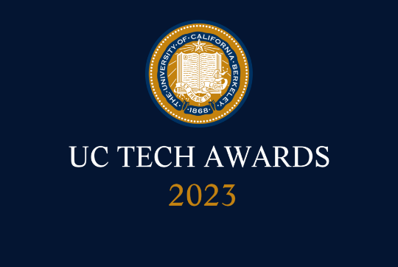
UC Tech Awards 2023 Candidate
Category: OPERATIONAL EXCELLENCE
Name: Using MS Teams for Regulatory Surveys
Number of people: (2)
Location: UC San Diego
- Person submitting the application/nomination
  - Allen Tran, Director Inpatient Clinical Systems, staff
  - Email address: art015@health.ucsd.edu
  - The name of your organization: (i.e. UCLA) UC San Diego

- Award category Operational Excellence

- Name of person, name of the team, or name of the project to receive the award Using MS Teams for Regulatory Surveys

- All project team members - if applicable

  - Matthew Redila, Nurse Informaticist (mredila@health.ucsd.edu)
  - Cynthia Edgelow, Dir. Regulatory Affairs (cedgelow@health.ucsd.edu)

- Which location was affected by the work? (the name(s) of the organization affected)
UC San Diego Health

- Summary The introduction of a digital collaborative tool like Microsoft Teams has transformed how UC San Diego Health collaborates during health system regulatory surveys, introducing a level of relationship building and teamwork never seen. This single tool displaced a significant amount of phone calls, texting, emails, and paper documentation, all of which contributing to improved efficiencies.

- Narrative

Regulatory surveys in healthcare have always been a complex, fast paced, highly coordinated affair. These multi-day and multi-location events involve not only the health system leadership team, but also many frontline clinicians, staff, and specialists. Responding to inquiries and providing data, policies, and other information in a timely and thorough fashion can be daunting. The introduction of a digital collaborative tool like Microsoft Teams has transformed how UC San Diego Health (UCSDH) works together. Each custom grouping of members in and out of the organization (the 'Team') provides tools such as a message board, instant messaging, file sharing, video / phone calling, tags, email integration, and an expanding catalog of potential third-party add-on widgets to maximize the experience. However, the adoption for collaborative use has been within team units, less commonly across departments, and rarely across the organization. This changed once UCSDH started using this tool to communicate and manage regulatory surveys. We leveraged Microsoft Teams to be the single point of communication, information sharing, information gathering, issue tracking, and collaboration throughout regulatory surveys. This single tool displaced a significant amount of phone calls, texting, emails, and paper documentation, all of which contributing to improved efficiencies. Above all, this tool introduced a level of relationship building and teamwork never seen. Over 500 organizational leaders were now working together in an intimate space to address a common mission.

Although the implementation, education, and adoption of Microsoft Teams to manage organizational surveys took place in 2022, this new process was put to the test at UC San Diego Health during the 2023 Joint Commission Triennial survey. The Joint Commission is a health system accrediting organization, and this survey is an “all-hands on deck” initiative for UC San Diego Health. Using Microsoft Teams allowed leadership to respond more quickly to the questions of The Joint Commission surveyors, provided a much smoother path to enacting interventions from survey findings, and enabled collaboration that aligns with the health system’s goals of togetherness. The experience using Microsoft Teams for The Joint Commission survey resulted in leaders implementing the use of this tool to collaborate on other initiatives. Team members have been re-inspired to explore even more ways to incorporate technology into processes, particularly those complex ones involving multiple teams and departments.

