UC Tech Awards 2023 Candidate

Category: OPERATIONAL EXCELLENCE
Name: Process Landscape (4)
Number of people: (4)
Location: UC San Diego

- Person submitting the application/nomination
  - Name, title, department, location/organization, and please indicate if you are faculty or staff: Prachi Raheja, Business Analysis and Continuous Improvement Lead, IT Services at UC San Diego. Staff.
  - Email address: praheja@ucsd.edu
  - The name of your organization: UC San Diego
- Award category Operational Excellence
- Name of person, name of the team, or name of the project to receive the award
Process Landscape, UC San Diego
- All project team members -
  - Mojgan Amini - Director, Process Management & Continuous Improvement, Information Technology Services
  - Prachi Raheja - Business Analysis and Continuous Improvement Lead, Information Technology Services
  - Shawn Munro – Info Systems Analyst, Information Technology Services
  - Mark Hersberger - Communications Manager, Information Technology Services
- Which location was affected by the work? UC San Diego
- Summary
Imagine your department is about to head into a journey of overhauling a major administrative system such as Research administration, Finance administration, Student administration and such. How would you ensure that the old inefficient processes are not being carried over to the new advanced enterprise systems? How would you make data-driven decisions about which areas need process improvement and which processes need to retire, before introducing a system for implementation?
At UCSD, we used a technique called “Process landscaping” to make well-informed, data-driven decisions about where to spend our valuable resources and to lay a solid foundation with process improvement before diving into technology transformation.
- Narrative
[See below]

Forging Process Excellence Through Dense Process Jungles

Problem
UC San Diego was about to head into a journey of optimizing and overhauling core business and administrative practices for Research Administration, Finance Administration and Student Administration, Personnel Management, and Space and Real Estate Administration, replacing them with cloud-based systems that would effectively meet the needs of our growing university. As we were embarking on this initiative, we were clear that we did not want to take our old and inefficient processes and transfer them into modern technology. It would have been like replacing an old car by putting the old engine in our brand-new BMW!

Going into the effort, our problems and questions were:
- How to ensure that the old and inefficient processes were not being carried over to the new advanced enterprise systems?
- How to make decisions about which areas need process improvement before introducing a system for implementation?
- How to gain an understanding about current processes in our organization. What could we do to surge awareness across departments, build consensus, and elevate collaboration, while forging our way into organizing and sorting through complex process jungles? Where to start?
Overview
This is where the idea of a “process landscape” was born. Process Landscapes started as a tool for communicating information about the business processes across a large business area to stakeholders, in a visual, more easily digestible way, in order to inform the Enterprise Systems Renewal (ESR) program at UC San Diego. This has now evolved into an effort crossing boundaries across UCs, strengthening our ability to view our capabilities as a university, and providing a common basis for transformative planning to fuel university-wide growth.

The Purpose of “Process Landscapes”
What is a process landscape? When we are conducting any kind of discovery on our processes, we are gathering information to answer three primary questions: What is it that we do? How do we do it? Who does it? Process landscapes focus on the aspect of “What do we do” and “What capabilities are we offering in this administrative area.”

Below is an example from the UC San Diego Student Information System Project (Fig-1). This one pager view shows what are the various process areas within the entire student administration system. Each one of the purple boxes (level 1) is decomposed further into more detailed level processes represented in the 2nd layer of blue boxes.

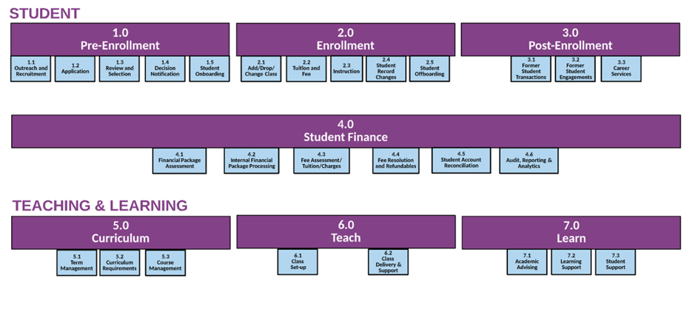<- Fig-1

Each level-2 box is further decomposed into level-3 (one example is shown below in Fig-2).

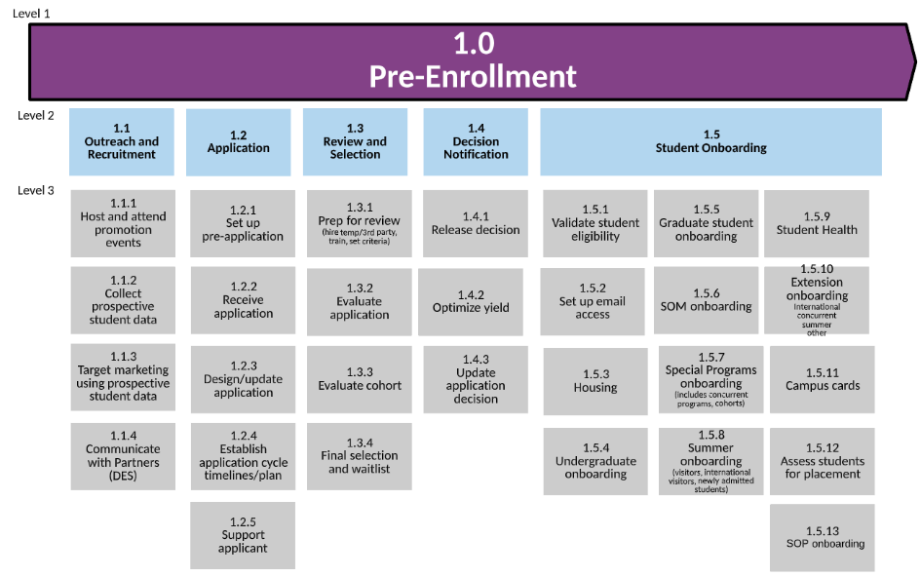
<- Fig-2

It’s like peeling the layers of the onion, and not going deeper into any one area before identifying all processes within scope. In our experience, it is at level-3 where we have the right amount of detail to make informed decisions about evaluating the processes for further deep dives or making an intentional decision to carry forward with the current process or deciding that the process needs to retire.

This means that process landscape helped stakeholders to better understand the outcomes of time invested in process analysis and helped make more informed, data driven decisions about spending highly valuable resources on prioritized process areas. This translated into thousands of hours saved on investigating processes that would have retired in short periods of time and laser focusing the process analysis efforts on processes with maximum friction. For a large-scale project like Enterprise Systems Renewal, this translates into soft savings of millions of dollars.

The processes that were strategically selected for deep dives received detailed current state process mapping, process analysis and process improvements. This allowed us to prepare for an intentional transformation across large administrative areas such as Student Administration,
Research Administration, Finance Administration system and more.

Once we had a process landscape for each administrative area, it provided the pathway to:
- Encapsulate current business capabilities
- Provide a common basis for process planning and organizational change management planning
- Prepare for an intentional technological transformation
- Involve appropriate stakeholders that define the strategy
- Enable discussions about what needs to be done to meet current and future challenges

After creating process landscapes for each administrative area, the strategic next step was to create a university-wide process landscape (Fig-3), which was intuitive and rewarding. With all the foundational process work, we have built a rich body of knowledge that is serving as a “north star” in selecting and implementing new systems.
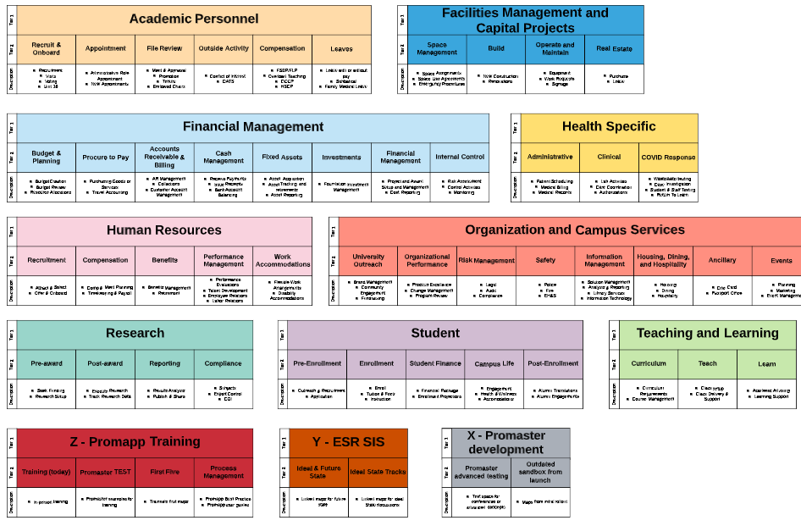
<- Fig-3

Results:
With the approach of starting with the process landscape and strategically choosing which processes need deeper dives, UC San Diego has created a process map library of 800+ processes mapped over 5 administrative areas –Research (150+ processes), Finance (150+ processes), Student (170+ processes), IT (110+ processes) and HR (200+ processes).

These process landscapes and processes have been viewed 57,000 times. Meaning staff, administrators, subject matter experts and executives are actively referring to these processes to inform strategic planning and day-to-day operations.
Imagine the potential of each UC having a process landscape of its process capabilities and being able to use these process landscapes as the basis for process planning and strategic collaboration across UCs.

