UC Tech Awards 2023 Candidate
Category: OPERATIONAL EXCELLENCE
Name: Nathalie Gholmieh, Director, Data and Integration Services (1)
For: Data Driven Decision-Making
Number of people: (1)
Location: UC San Diego
- Person submitting the application/nomination
  - Name: Nathalie Gholmieh
  - Title: Director, Data and Integration Services
  - Department: IT Services (central IT for campus)
  - Location/organization: UC San Diego
  - I am a staff member
  - Email address: ngholmieh@ucsd.edu
  - The name of your organization: UC San Diego

- Award category: Operational Excellence

- Name of person, name of the team, or name of the project to receive the award: Nathalie Gholmieh, for Data Driven Decision-Making

- All project team members - if applicable (n/a)

- Which location was affected by the work? UC San Diego

- Summary:
A use case of data driven decision making to lower platforms total cost of ownership, improve operational efficiency, motivate the workforce, and increase value by connecting priorities to business outcomes.

- Narrative:
[See below]

Data Driven Decision-Making

Introduction

The Data and Integration Services (DIS) team is the Enterprise Platform Engineering team at UC San Diego’s central IT department. We operate the Enterprise development platforms for data, integration and application development. We manage our platforms as products, releasing a roadmap for each one, and taking decisions with the goal of continuously optimizing the Total Cost of Ownership (TCO) of each platform. We partner with various other teams within our department to ensure service reliability, scalability, automation and security compliance of our enterprise platforms.

The value of our Data
Data is an essential part of our decision-making process. It helps us visualize, measure and quantify the amount of work required to offer the best products/services we can provide. Decisions based on gut feeling are important, but enriching business cases and proposals with evidence using data makes the message much more powerful. Planning using data helps us with balancing workloads, resourcing for project, and projecting completion dates.
Each employee in our department is required to log their time for the work they do. All this data is aggregated in a database that we call the Project Activity Hub and that we use to derive reports that help shape and support our roadmap decisions and our priorities. So, each work deliverable is accompanied by a set of tasks that the engineers log the time they spent to. In order to gather the dataset, we follow the philosophy of “no ticket no work”. Everyone on the team is bought into this philosophy because they saw how the data helps us win business cases on multiple occasions and increase the value we bring to the table.

Let’s dive into some details
On the Data and Integration Services team, we classify our work into 3 big buckets:
- the “unplanned work”: that is the hours spent by any given team member on incident response and ad-hoc customer service requests
- the “planned work”: that is all work that we can plan for and prioritize such as platform upgrades, automation, enhancements and other roadmap items
- the “overhead”: that is people out of office, attending miscellaneous meetings (not project related), responding to emails, etc…

Here is a graph describing the time investments by all FTEs and contractors on the Data and Integration Services team during the entire 2022 calendar year:

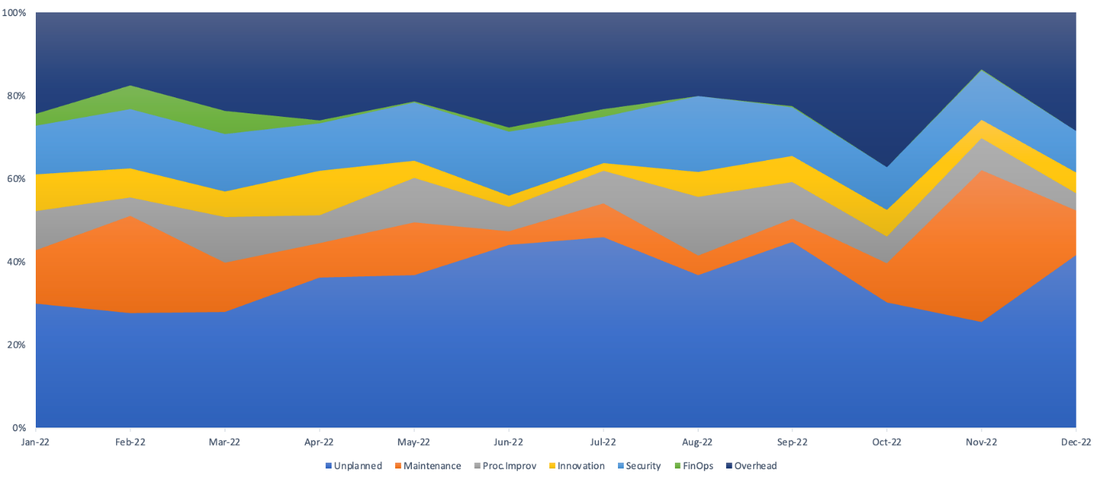
Graph 1 - Work distribution of the Platform Engineering Team - 2022 calendar year

This graph above shows that the platform engineering teamwork distribution is as follows, from top to bottom:
- “Overhead” (top dark blue) is a consistent 20% section of the team’s bandwidth. So based on a 40 hour work week, 20% of that time people are either out of office, attending non-project related meetings, answering emails, attending non-project related trainings and activities.
- The graph shows that about 45% of the team’s time is invested in “planned work” that we classify in the following sub-categories:
  - 10% on Service/Platform Maintenance (orange): such as system upgrades
  - 10% on Process improvements and automation (gray): such as the development of automations and service improvement tasks
  - 8% on Innovation (yellow): this category highlights the implementation of approved business cases, and highlights the adoption of new technologies and continuous innovations
  - 15% on Security (light blue): this is all the compliance work, implementation of security controls and management of vulnerabilities
  - 2% on FinOps (green): Cost optimization work of cloud-based platforms.
- Finally, the bottom blue bar represents the team’s time investment in “unplanned work”: that is service requests and incidents. That is about 35% of the total time
  - Graph 2 below is a subset of the data, that displays ONLY the “unplanned work” category, but shows the split between Service requests and incidents. The graph shows that the unplanned work is split almost 50%-50% between service requests and incidents

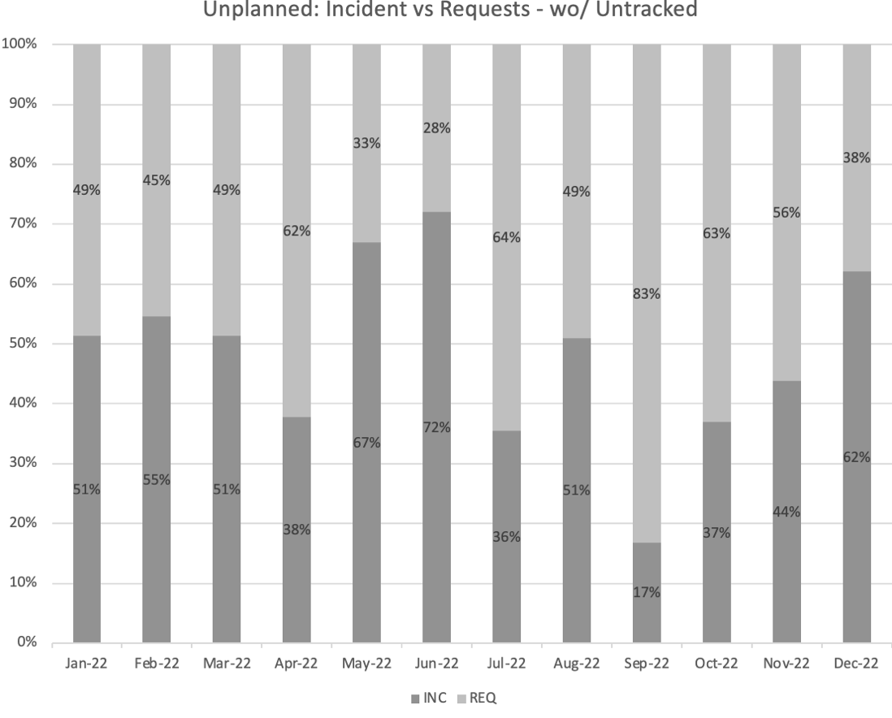

Graph 2 - Unplanned work - Incidents vs Requests in 2022

Analysis - The story this data tells and decisions it informs
- due to the consistent 20% “overhead” shown in the data, we can deduce that the bandwidth that we can commit a full-time employee to do work is 80% of their total availability for work. We do plan accordingly.
- the “planned work” is where the value lies
- maintenance and most security compliance work (platform upgrades, security remediations and vulnerabilities management) have no value added to the business and are not directly linked to business outcomes. We have used the time investment information to quantify the maintenance cost of our platforms. We have used this information to support business cases to move our platform to Software as a Service Packages. If we do not host and run the infrastructure, maintenance and security remediation efforts will be shifted into automation, performance and cost optimizations, that help reduce the platform TCO over time
- time investment in service improvements and automation started to reduce the number of incidents that the team handles over time. We do see that slightly beginning in Graph 2 above starting September 2022, and we expect this trend to continue growing over time. We also see a dip in the “unplanned work” category in Graph 1 above, where the “unplanned work” time investment has dipped from 40% in September to 20% in November. The time gained by the lower number of incidents is invested in the other planned work areas: more improvements, more innovation. It becomes a positive cycle and with additional automation over time we are able to do more with the same headcount we have, hence more added value and a lower TCO
- visualizing all workstreams and backlog of work using data helps with balancing workloads amongst team members and prioritizing work. We strive to ensure no one is overwhelmed with work at any given time, and that we have a fair workload distribution amongst team members.

Conclusion
We are committed to do work that is directly linked to business outcomes, striving to continuously reduce the TCO of our platforms and services and we use this data to support our decisions.
In 2022 we have invested time into the “innovation” and “FinOps” categories represented in yellow and green on the graph above to implement a new automation that we branded as the Duty Cycle.
The Duty Cycle is an automation developed by our engineers to shut down non-production environments outside of business hours to save on cloud infrastructure cost. This is now a process that we apply widely on all of our cloud-based platforms in AWS, part of our standard practice, and that have yielded cost savings that are higher than AWS Reserved Instances and Savings Plans.
Our steepest cost savings amongst others that our engineers have proudly achieved with the Duty cycle amounts to $140,118.84 a year on the hosting cost of our streaming platform! That is a 38% reduction on the AWS hosting cost for that platform.
In conclusion, data is a golden asset for us, and we will continuously evolve our methods in leveraging it. It not only helps us link our efforts to business outcomes, but also helps keep our engineers motivated to give more to help the mission of the university!

END of Narrative

