UC Tech Awards 2023 Candidate
Category: OPERATIONAL EXCELLENCE
Name: UCSB Web Theme WebOps Team
Number of people: (6)
Location: UC Santa Barbara

- Person submitting the application/nomination
- Mihoko Jones, Director, Web Services & Technology, Public Affairs & Communications, UC Santa Barbara
- Staff
- mihoko.jones@ucsb.edu
- UCSB

- Award category: Mojgan Amini Operational Excellence Award

- Name of person, name of the team, or name of the project to receive the award
UCSB Web Theme WebOps Team

- All project team members - if applicable (Name, title, department, location/organization, and please indicate if they are faculty or staff, along with their email address(s).

- Mihoko Jones, Director, Web Services & Technology, Public Affairs & Communications, UC Santa Barbara (staff, mihoko.jones@ucsb.edu)
- Ryan Vizena, Web Developer, Office of Public Affairs & Communications, UC Santa Barbara (staff, vizena@ucsb.edu)
- Elda Schaffield, Manager, Student Services Information Systems Unit, Information Technology Services, UC Santa Barbara (staff, emscha@ucsb.edu)
- Alex Sokolov, Content Management Systems Developer, Information Technology Services, UC Santa Barbara (staff, asokolov@ucsb.edu)
- Eric Mayes, UI / UX Developer, Student Services Information Systems, Information Technology Services, UC Santa Barbara (staff, mayes@ucsb.edu)
- Matt Perko, Senior Web Designer, Public Affairs and Communications, UC Santa Barbara (staff, mperko@ucsb.edu)

- Which location was affected by the work? (the name(s) of the organization affected)

UC Santa Barbara

- Summary The WebOps initiative team came together, breaking the department barriers, to develop the university's first official web framework, UCSB Web Theme. It was created to change the longstanding practice of campus web development where each department and unit works in silos that contributed to a redundant and duplicate team effort, ununified web appearance, and inconsistent user experience.

Since its inception, Web Theme has offered a dynamic web solution for university websites: hosting, security, technical support, branded templates, best-in-class user experience, and continuous enhancement.

- Narrative Project Background

At UC Santa Barbara, each department and unit historically have its own IT team, which develops custom design templates, functionality, and workflows to build its websites. Working in silos causes redundant and duplicate team effort, ununified web appearance, and inconsistent user experience.

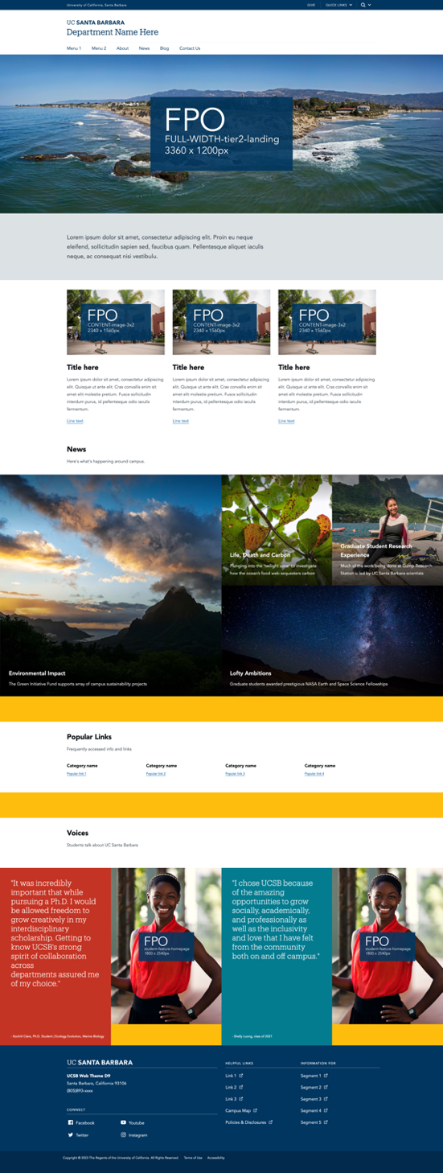
We needed a sole web framework that can be adopted by various campus departments and units — large and small in size — with their unique audiences and objectives. The framework has to be easy to use so that users with no prior web experience can build their sites but be flexible enough for developers to customize if they choose to. We wanted a turnkey web platform solution with custom features and components that creates vibrant, dynamic webpages that meet WCAG requirements and campus branding guidelines.

Innovation & Collaboration
With the goal in mind, the WebOps initiative team came together, breaking the department barriers, to develop the university's first official web framework, UCSB Web Theme in early 2022.
Teams from Public Affairs & Communications and Information Technology Services worked together to merge separate themes and custom modules that have been managed independently into one Custom Upstream. We established the workflow and predefined responsibilities to keep the framework updated with security patches and enhancements. It's packaged with pre-build page layouts, branded templates with the university color palettes and web fonts, custom functionality, and 300+ commonly used Contributed modules from Drupal.org.
The demo site (https://webtheme-demo.brand.ucsb.edu/) was created to showcase the UCSB Web Theme’s page templates, features, and placeholder imageries. We launched the User Guide site (https://webtheme.brand.ucsb.edu/) to provide how-to documentation, resources, change logs, and testimonials.
Figure 1- UCSB Web Theme Demo Site

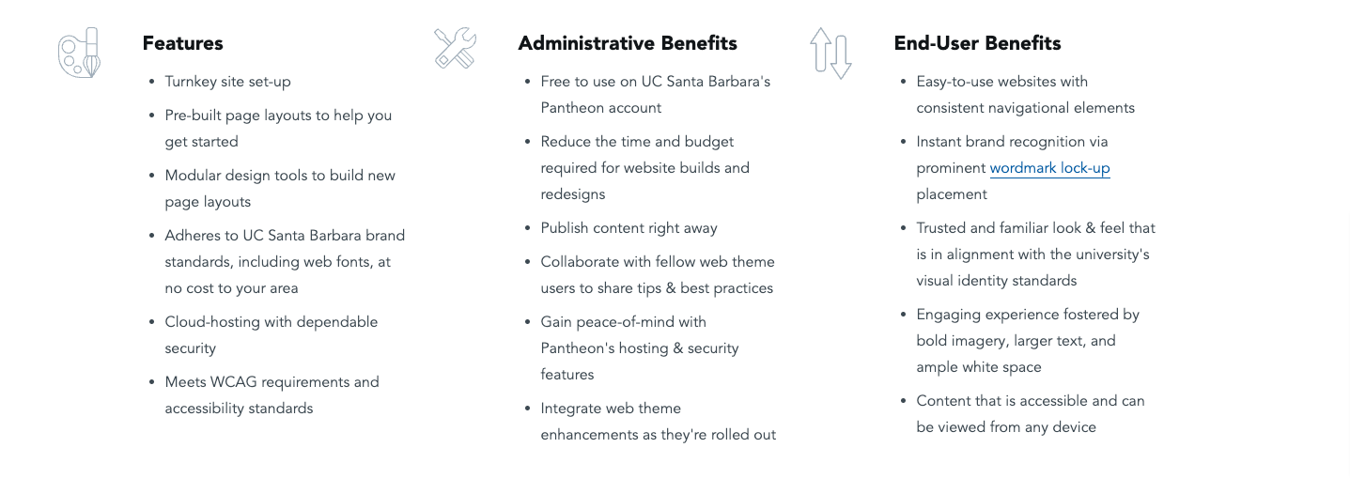

Project Impact & Success
Subsequent to the establishment of our new framework, we started the process to migrate existing Drupal 8 sites that were using our legacy themes into Drupal 9 UCSB Web Theme. In collaboration with ETS, we offer Web Theme for free to use on the Pantheon platform. We migrated 138 sites and completed the process in September 2022.
We clone our demo site for a new Web Theme user with the intent to reduce the development time, resources, and budget by simply plugging in their content. We also offer a clean install without any data if the option fits their needs. By using Pantheon's Custom Upstream and UCSB Web Theme WebOps workflow, new features and functionality are continuously developed and distributed to each site as custom modules after a thorough review for adherence to Accessibility and brand guidelines. We offer user support via weekly office hours, chat, and quarterly “User in Charge (site owner)” roundtable meetings, and encourage them to collaborate with fellow Web Theme users to share tips and best practices.

As of April 26, 2023, we have a total of 222 Web Theme sites, of which 162 sites have been launched.

A testimonial from one of many happy customers reads: "This was a very custom website, but the predefined navigation and footer saved me time when developing the site. Also the predefined font styles and color scheme saved me time when developing the site. I also like the blade and column structure because it’s easy to add new components to them. I also really like the slideshow and accordion components!"
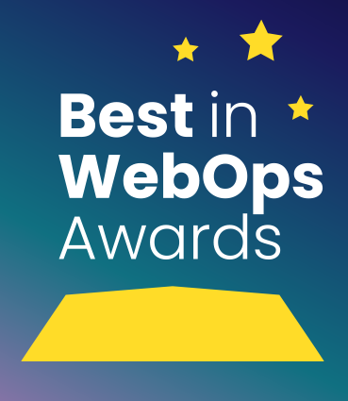
This year, Pantheon has named our team as one of its Best in WebOps Award Winners in the Team Category. This award recognizes high-performing web teams that have embraced the core principles of WebOps and are making a huge impact on their organizations.
https://pantheon.io/pantheon-best-webops-awards

UCSB Web Theme WebOps Team
WebOps is a set of practices that facilitates collaboration and automates processes to improve the productivity of the whole web team from developers and designers to content editors, stakeholders, and more. The result is cross-functional web teams empowered to develop, test, and release website changes faster and more reliably.

Our WebOps team consists of:
Developers: develop new functionality, troubleshoot, and deploy changes to the upstream
Web Designer: designs and reviews changes to make sure the sites look good and follow campus branding guidelines
Accessibility Specialist: ensures digital materials and online experiences meet accessibility standards and regulations
UI/UX Developer: reviews changes for logical flow and pleasant user experience

