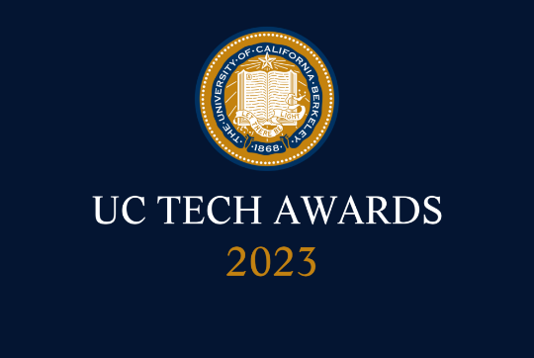
UC Tech Awards 2023 Candidate
Category: IT SECURITY + INNOVATION
Name: IAMRiverside Implementation
Number of people: 15+ many more
Location: UC Riverside
- Person submitting the application/nomination
  - Dewight F Kramer, CISO ISO/ITS, UCR, Staff
  - Email address: dewight.kramer@ucr.edu
  - The name of your organization: UCR

- Award category Innovation, IT Security

- Name of person, name of the team, or name of the project to receive the award \
  - Project: IAMRiverside Implementation
  - Team: IAM Riverside Implementation Team

- All project team members - if applicable
    - The list of individuals is really long as this was a major effort across the entire campus. The core members of the team were:
      - Sureyya Tuncel, Information Security Office in ITS, IAM Manager, Staff, sureyya.tuncel@ucr.edu
      - Bryan Meeker, Information Security Office in ITS, IAM Architect, Staff, bryan.meeker@ucr.edu
      - Patricia Sanchez Jaques, Project Management Office in ITS, Senior Technical Project Manager, Staff, patricia.sanchezjaques@ucr.edu
      - Alexandra Chrystal, Coms in ITS, Communications and Training Manager, Staff, alexandra.chrystal@ucr.edu
      - Ellen Eramya, Information Security Office in ITS, IAM Engineer, Staff, ellen.eramya@ucr.edu
      - Ron Huynh, Information Security Office in ITS, IAM Engineer, Staff, ronald.huynh@ucr.edu
      - Cliff Veasey, Student Systems in ITS, Associate Director, Staff, clifford.veasey@ucr.edu
      - Lily Barger, Computing Support Services in ITS, Director, Staff, lily.barger@ucr.edu
      - Jeremy Fisher, Infrastructure in ITS, Executive Director, Staff, jeremy.fisher@ucr.edu
      - Disha Kibria, HR/APO Systems in ITS, Associate Director, Staff, disha.kibria@ucr.edu
      - Carol Marquez, UCPath, Technical Project Manager, Staff, carol.marquez@ucr.edu
      - Lakesha Lee Welch, UCPath, Business Support Analyst, Staff, lakesha.welch@ucr.edu
      - Lorena S Velasquez, HR Information Systems at UCR, Director, Staff, lorena.velasquez@ucr.edu
      - Marilyn Y Parker, Employee & Org Development at UCR, Learning Management System Administrator, Staff, marilyn.parker@ucr.edu
      - Sonia Kalogonis, Academic Personnel Office, Policy Analyst, Staff, sonia.kalogonis@ucr.edu

    - Again there were dozens of others that really helped a great deal in this process.

- Which location was affected by the work? (the name(s) of the organization affected)
  - UCR

- Summary: I am nominating an amazing set of individuals for the IAMRiverside Implementation. This project focused on the modernization of the Identity and Access Management program, and took exceptional collaboration, dedication, and expertise to implement. The project has resulted in significant benefits for the campus community, including a transition to a modern IT infrastructure and a forward-looking focus on security. The team's collaborative spirit has set them apart, engaging with stakeholders to ensure that the new infrastructure meets their needs and expectations, building trust and support for the project.

- Narrative

I am writing to nominate the team of individuals who helped implement the first phase of the innovative Identity and Access Management program, known as the IAM Riverside implementation Project. This team has demonstrated exceptional collaboration, dedication, and expertise, resulting in significant benefits for the campus community.

The first major benefit of this project was the transition from legacy hardware and scripts into a modern IT infrastructure. This was no small feat, due to the complexity of the architecture and business processes, and it required a great deal of technical expertise, collaboration across campus, and careful planning.

Another major benefit is that it is a forward-looking project focused on security, as the new tool and service lays the foundation for a new paradigm of security. This new service supports UCR’s move to a more formalized digital trust security posture. Thanks to the team's hard work, the organization now has a much more reliable, efficient, and secure IT environment, and allows us to start to take advantage of modern architectures or allows us to grow into more advanced ways of supporting IAM.

However, what truly set this team apart was their collaborative spirit. They worked closely not only within ITS but also across the campus, and UCPath, engaging with stakeholders to ensure that the new infrastructure met their needs and expectations. This inclusive approach helped to build trust and support for the project, and it allowed the team to identify and address potential issues before they became major obstacles. Even with the few obstacles we have had, the team worked diligently to address and correct those issues. There are still things that need to be figured out but this team and all the supporting members have really promoted a supportive culture.

This is the first phase of revamping the entire IAM technology stack and service, and took over a year to complete. The new IAM Riverside Service went live on March 20, 2023, and through the end of April we have been in hyper care. Although there have been transitional issues, we have already seen some great successes. The major one has been that more than just one subject matter expert person that has the tribal and historic knowledge of the system can help troubleshoot and fix many issues that arise on a day-to-day basis.

Thanks to the efforts of this team, both the highly collaborative engagements and the modern IT infrastructure have had and will continue to have a highly positive impact on the organization. I am truly grateful for their dedication and expertise, and I believe that they are truly deserving of recognition for their outstanding work. Thank you for considering this nomination.

