UC Tech Awards 2023 Applicant
Category: IT SECURITY + DESIGN
Name: UC Merced Identity & Access Management Team (4)
Number of people: (4)
Location: UC Merced

- Person submitting the application/nomination
  - Christy Snyder, Assistant Vice Chancellor and Deputy Chief Information Officer, UC Merced Office of Information Technology (staff)
  - Email address: csnyder4@ucmerced.edu
  - The name of your organization: UC Merced

- Award category IT SECURITY – They switched from Design

- Name of person, name of the team, or name of the project to receive the award
UC Merced Identity & Access Management Team

- All project team members - if applicable
Avi Badwal, Director of Enterprise Technologies
Matt Faulkner, Enterprise Services Architect
John Kamminga, Identity Management Architect
Josh Swink, Programmer Analyst

- Which location was affected by the work? UC Merced

- Summary
UC Merced recently completed a total overhaul of our outdated Identity and Access Management system. The new design is fully aligned with campus brand to create an intuitive and cohesive experience for campus applicants, students, faculty, staff, and alumni; supports Lived Name by allowing username choice during Account Claim; offers integrated self-service features that drive security awareness, and incorporates artwork and animation in way that are engaging and playful while also increasing account and campus security.

- Narrative
In 2022, UC Merced’s Identity and access management (IAM) system reached a critical nexus as a “system of concern:” it had a fair bit of technical debt, it didn’t meet modern security requirements, its branding was out of date, and it created a fair amount of administrative work for multiple campus departments due to a lack of self-service features.

With recent security breaches at nearby Merced College and the City of Merced on their minds, the UC Merced Office of Information Technology’s Identity and Access Management (IAM) team knew it was time for a complex overhaul of UC Merced’s identification management system the campus’s 14,000 students, staff, and faculty. The system, which responds to hundreds of thousands of login requests each day and is supported by multiple form factors, had a number of issues:

- Obsolete UI/UX
- Not able to deliver real-time information for account claims
- Not able to handle Gender Recognition and Lived Name (GRLN)
- Problematic for international students due to email delay issues
- Not up-to-date with current campus brand standards
- Lacked the necessary security measures to keep up with advancements in the technical landscape

With these problems in mind, Avi Badwal, Director of Enterprise Technologies at UC Merced, partnered with cross-functional teams across the organization to envision a modern IAM system. After multiple meetings with HR, Admissions, Student Affairs, Security, Service Desk, and other campus stakeholders, the team set out to design and build a new system. Their vision was a user-friendly, accessible, and engaging IAM system that provided secure access to campus resources and could help protect university members' personal information.

During initial discovery phase, the UC Merced IAM team worked with stakeholders to document the current system's pain points, including issues with user experience, security, and accessibility, along with desired features and outcomes for the new system. They also made sure to thoroughly review support tickets across multiple departments to understand the challenges faced by end users. They also found that the dated branding of the existing system was especially problematic—new applicants and admits, in particular, didn’t understand the look and feel change they experienced when moving from admissions materials to account claim or login experience. The team recognized that this was a way in which they could support the campus’s strategic enrollment growth goals while also addressing technical debt (we like win-win situations!)

In the design phase, the team focused on creating a user-friendly and thoroughly accessible interface that would simplify the overall digital experience of this essential and necessary administrative application for everyone on campus. The old system generally needed a complete overhaul with modern security in mind, so new system specifications included a streamlined login process and new self-service capabilities for managing passwords, Duo MFA, and more. And since the requirements list was already a mile long, the team decided to implement Duo Universal Prompt alongside all the other changes for an even more secure sign-on experience for campus members.

During the development phase, the team addressed the need for more modern security alignment with features such as the security check-up, which gives individual users an “at-a-glance” understanding of their general security posture and includes a view into their Duo MFA devices and last login, days since last password change, and more. The team also implemented animation and artwork to compliment the campus brand standards. The new design supports the UC Merced brand and creates a fresh, playful digital experience for users—while also making it more difficult for bad actors to impersonate UC Merced’s Single Sign On (SSO) pages and identity services.
On March 27, 2023, the team deployed an elegant, modern system that offers an intuitive and ultimately more secure user experience for UC Merced applicants, students, faculty, staff, and alumni. The final project delivery included a new Identity Management page, multiple new self-service features, a new Account Claim experience with more customization to support lived name, a new Single Sign-On experience, and Duo Universal Prompt.
Throughout the effort, the team employed a collaborative approach which allowed for an iterative design and development process. Like any project team, they had to weather some scope creep and last-minute requirements changes, but the final product(s) are modern, engaging, intuitive, and accessible – excellent representations of the UC Merced brand. The changes to this critical and highly visible campus system create a significantly improved and cohesive experience for applicants and admits during Account Claim and Single Sign-On—fundamental elements of the admissions process and thus deeply supportive of the campus strategic goal of increasing enrollment. The updated system also works to educate campus members via intuitive features like the security check-up, so campus awareness of basic security hygiene will increase as they use that feature. The number of support tickets for account management issues to Admissions, HR, and the Office of Information Technology Service Desk have been significantly reduced due to the incorporation of self-service features. Kudos to all involved in this sustained effort to modernize our campus technology offerings!

Old System Single Sign-On (SSO) Page:
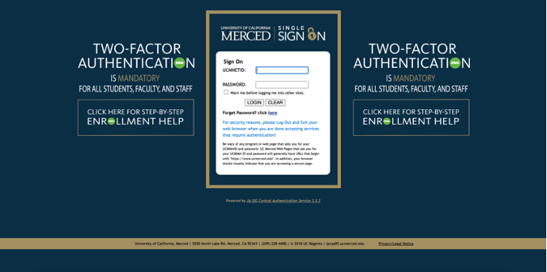

Old System Self-Service - https://idm.ucmerced.edu/
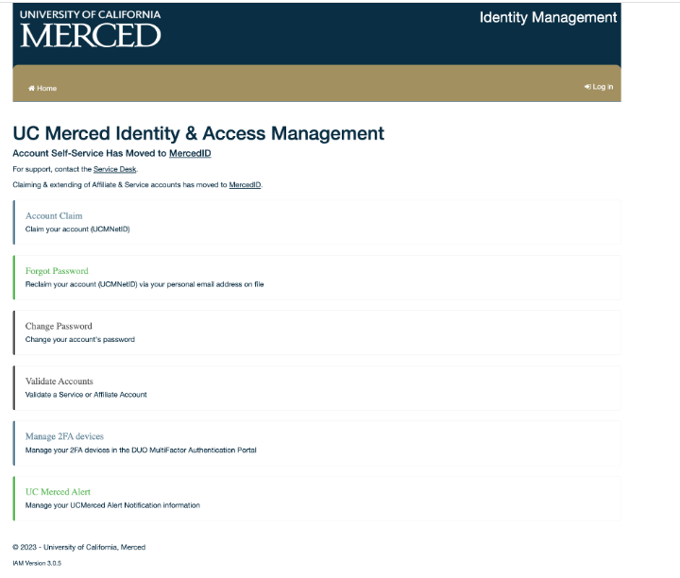

New System:
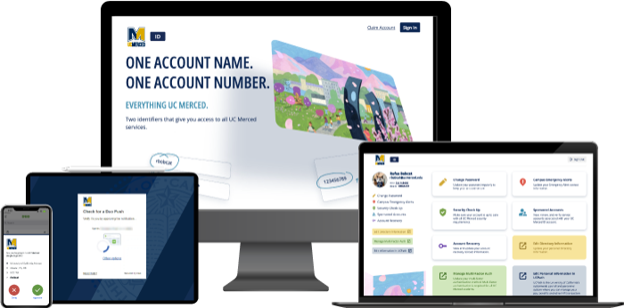

New System – SSO Page:
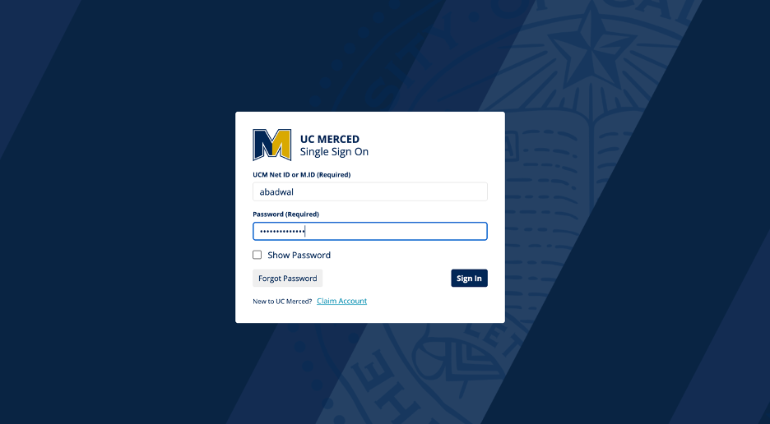
New System – Self-Service Page:
https://ucm.edu/ID
(test login with userID: UCTech2023 PW: W3DeservetoWin!)
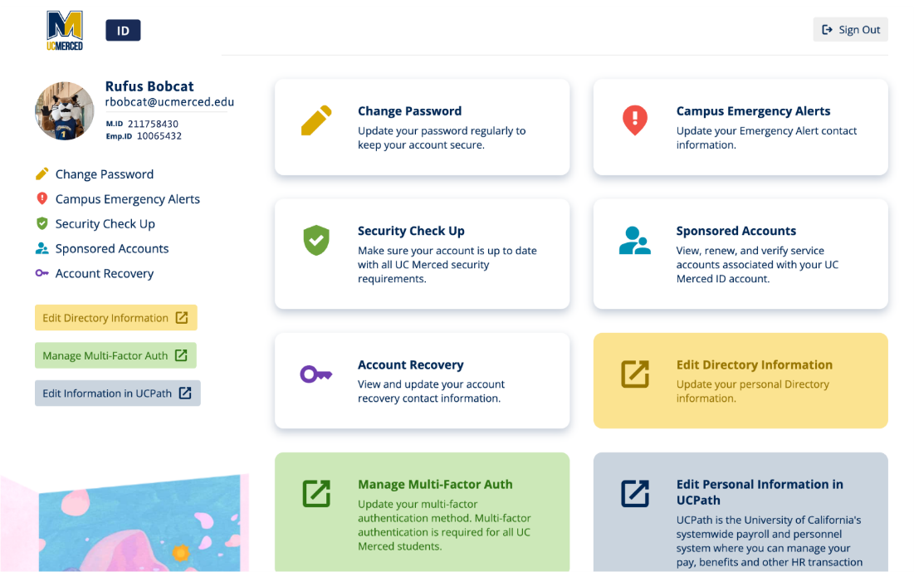

New Account Claim:
