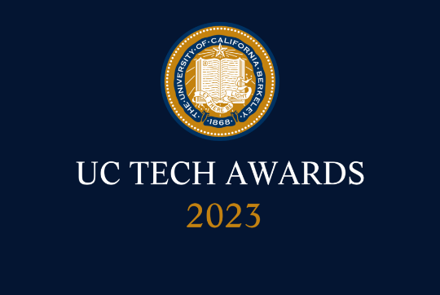
UC Tech Awards 2023 Candidate
Category: INNOVATION
Name: SPOKE Biomedical Open Knowledge Network (5)
Number of people: (5)
Location: UCSF

- Person submitting the application/nomination
  - Sharat Israni, Chief Technology Officer, Bakar Inst, UCSF; and Dir of Rsch Comp, Center for Prec Med & Data Sci, UC Davis; and Data Scholar, NIH. Staff.
  - Email address: sharat.israni@ucsf.edu
  - The name of your organization: UCSF

- Award category: Innovation

- Name of person, name of the team, or name of the project to receive the award: SPOKE Biomedical Open Knowledge Network.

- All project team members
Sergio Baranzini, PhD, Professor of Neurology, UCSF (Faculty)
Scooter Morris, PhD, Professional Rschr, Pharm Chem/School of Pharmacy, UCSF (Staff)
Charlotte Nelson, PhD, Assoc Specialist, Dept of Neurology, UCSF (Affiliate Staff, ex-Student)
Pete Rose, PhD, Director of the Structural Bioinformatics Laboratory San Diego Supercomputer Center, UCSD.
Sharat Israni, PhD, CTO, Bakar Inst, UCSF & Dir Rsch Comp, CPMDS, UC Davis (Staff)

- Which location was affected by the work?
UCSF (primarily);
UC San Diego (Structural Bioinformatics);
UC Davis (proposed to Council of Chairs, May 3);
UC Santa Barbara (via integration with a geographic knowledge graph by Krzysztof Janowicz); and
National impact as member of NSF Convergence Accelerator Program, and NIH NCATS Biomedical Translator Program.

- Summary
Knowledge Networks, a novel representation of data and knowledge in the world of biomedicine and health care, bring a new generation of insights into medical researchers and doctors. They span from the atomic (gene) on up through proteins, tissues, whole person and into their environment. From its origins at a six-agency workshop organized in Bethesda by nominee Israni, where nominee Baranzini was keynote speaker, KN's have become a Congressionally mandated national AI priority. SPOKE has become a nationally recognized leading such Network. Today, SPOKE has over 50 million medical concept "nodes" and 100 million "relationships" between them. As described in this nomination, its impact is now being felt across several UCs and the whole field. It is a truly innovative biomedical platform contribution.

- Narrative
Knowledge Networks are a foundational technology of National interest. In support of AI applied to five (5) critical applications of national interest, they are a Congressionally-mandated priority (see p. 448). Two of these critical areas are Health Care and Sciences, including Life Sciences (see p. 37). That report borrowed from the White House-issued summary of the Open Knowledge Network workshop. The keynote speaker for Biomedicine at this workshop was Baranzini; the workshop itself was organized by Israni as PI. We believe these credentials already speak to the innovation factor for a UC Tech Innovation award.

As an outcome of the above, Baranzini as PI (and Israni as co-PI) were then funded by NSF Convergence Accelerator for a major grant to create a biomedical open knowledge network (OKN, called SPOKE) – the only biomedical OKN to be funded in the country by NSF.
The fact that SPOKE is now part of the NIH NCATS Biomedical Translator speaks to its recognition as a worldwide leader in innovation and capability. Recently, it was the subject of a major publication.

Major products such as Google Search and Apple Siri, are based on knowledge graphs. Today, thanks to SPOKE, UCSF and its collaborators are at the forefront of biomedical knowledge graphs/networks. The SPOKE OKN maps out the fundamentals of human biology from the genetic level, on up to through the layers of human biology, through the tissues up to the whole human body – and on up into the "exome," which are the environment and human behavior that impact health. (Fig.1). In doing so, it goes through the "dark " sub-cellular layers, where little is known about the how disease progresses – such as protein expression, protein interactions, cellular signaling pathways, metabolites and microbiomes. For the first time in history, scientists and doctors are beginning to get a holistic, computable, view of the insides of the human body. As one of the most advanced biomedical OKN's in existence, SPOKE brings this possibility home to the UC system.
Figure 1: The layers of SPOKE –
from the Genome to the Exome

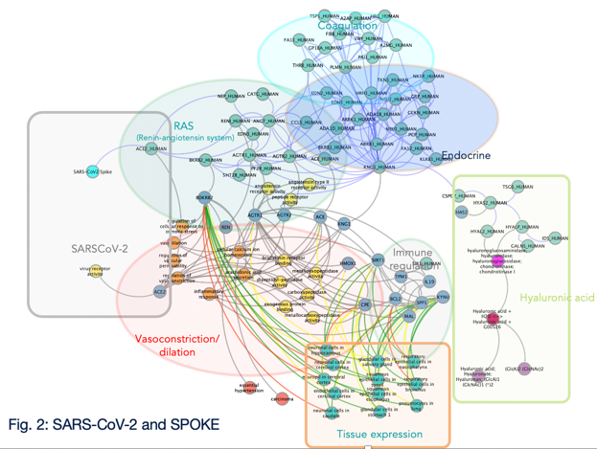
The applications are vast. Some include drug discovery, especially for rare diseases, but also for complex conditions (such as diabetes, sleep disorders and depression). There are an estimated 7000 "rare" diseases, affecting 25-30 million Americans and 400 million worldwide. Similarly, there are powerful applications in disease diagnostics and therapies. In March 2020, SPOKE predicted that hospitalized patients with COVID-19 under mechanical ventilation would benefit from dexamethasone use, which was later confirmed in a clinical trial (Fig 2 provides a visual). Closer to home, today it provides direct clinical support for difficult to diagnose diseases of aging. (Fig. 3).
Figure 2: SARS-CoV-2 and SPOKE

Complexity: By its very nature of mapping human biology, SPOKE is vastly complex. But today, it includes over 50 million nodes (genes, drug, proteins, organs, diseases, etc.) and 100 million relationships between them (e.g. gene MUC5B is "associated with" pulmonary fibrosis). This size and complexity needs the power of AI, algorithmic graph traversal, and big parallel computing to gain insights - all of which are supported by UCSF's IT-cofunded Wynton High Performance Cluster.

SPOKE has its origins about 12 years ago. However, it has had stepped up activity over the last 5 years with intramural Bakar Institute and Marcus Foundation funding, and especially the above NSF grant in 2019.

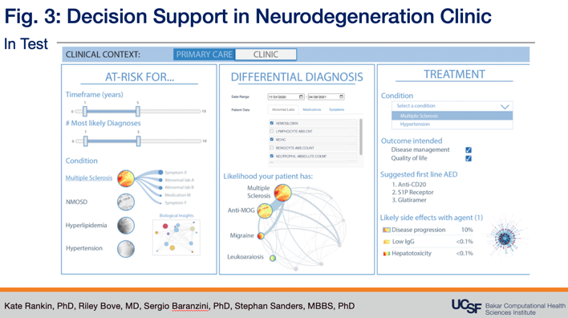
Impact: In November 2021, the Bakar Institute faculty identified SPOKE as one of the most important computational platforms in support of research at UCSF – into disease diagnosis, management, and therapies, including drug discovery. This extends into the clinic. Three papers have been published or are in press describing algorithms to integrate EHRs and SPOKE to predict diagnosis of chronic diseases (Multiple sclerosis, Parkinson’s and Alzheimer). Furthermore, SPOKE recently integrated environmental contaminants in soil and water, and social determinants of health, to allow a holistic description of a given patient’s health status that is medically accurate, and socially inclusive (Fig. 3).
Figure 3: Decision Support in
Neurodegeneration Clinic
SPOKE also affords our graduates some of the most advanced computational training in biomedicine. SPOKE has also been identified as an important platform by the co-leaders of the Center of Precision Medicine at UC Davis, as they go deeper into the molecular basis behind common but dangerous conditions in cardiology, oncology and neurology. We expect many other UC centers to avail of it, starting in the near future. SPOKE is freely available to all UC's; and as a commercial product via Mate Bioservices (nominee Nelson, a UCSF graduate, is CEO).

Further demonstration of the innovation and impact of SPOKE is provided by ongoing collaborations with National agencies (NASA and Lawrence Livermore National Labs) on projects related to space flight biology and early response to biological threats.

Biomedical Knowledge graphs are a strategic tool as recognized by National agencies and industrial partners, and very few exist around the world, mostly due to their complexity, scale, and know-how needed to build and maintain them. UCSF’s SPOKE is among the most cited and referenced knowledge graphs in the literature and conferences and most recently ChatGPT can describe its main features and impact (See Fig. 4 below)
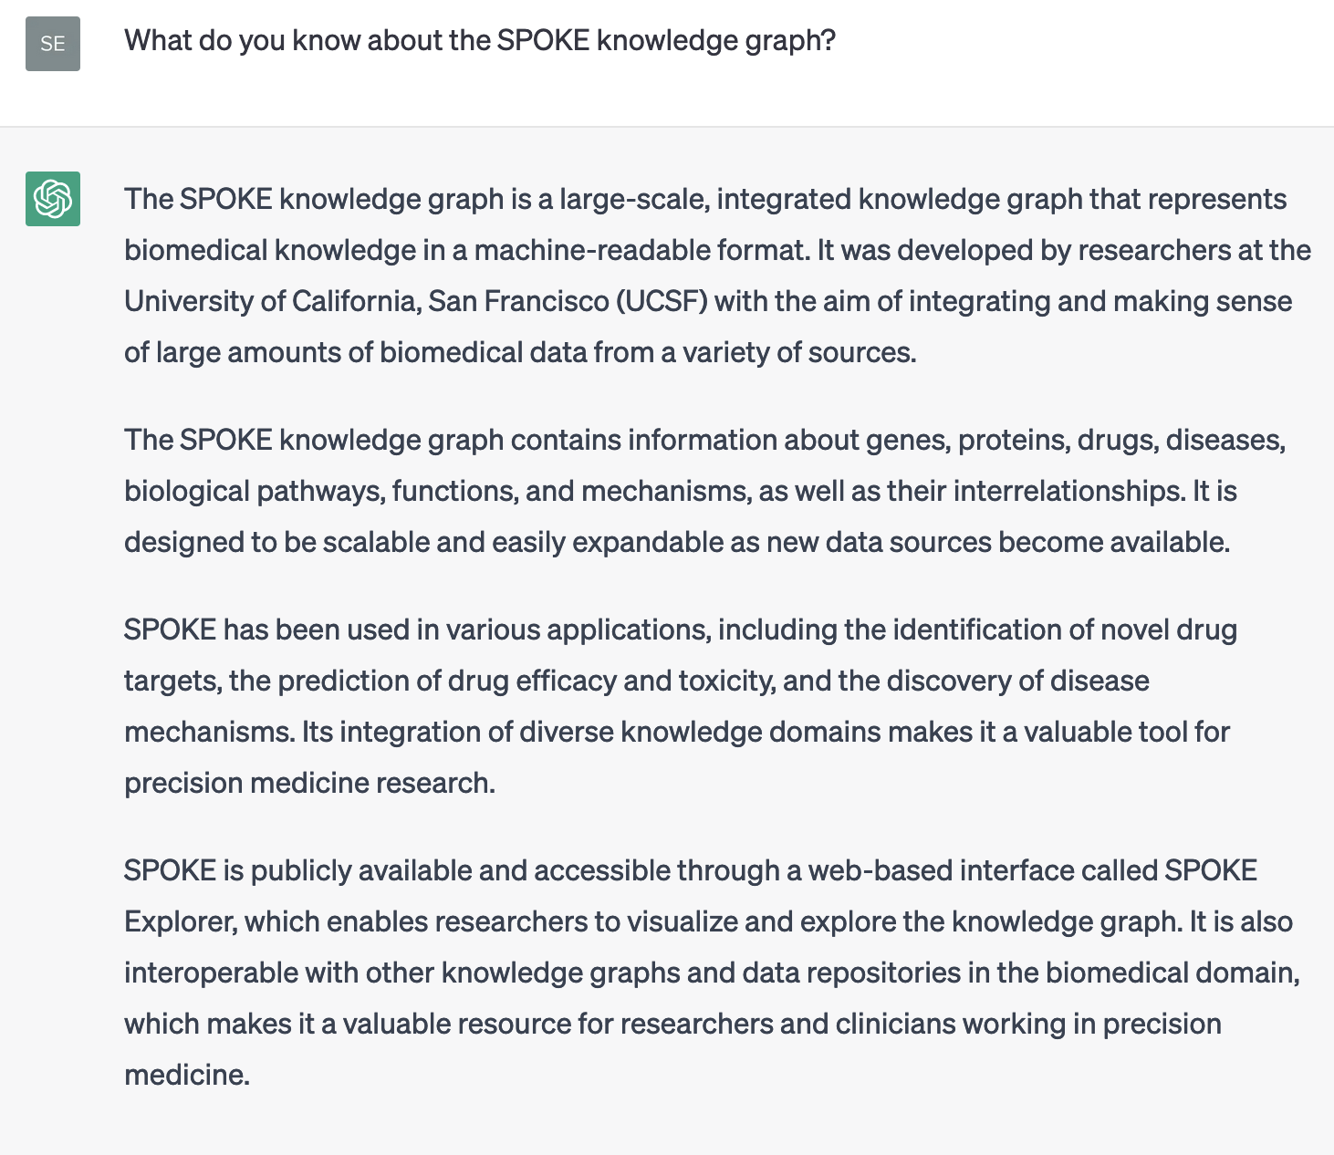
Figure 4: ChatGPT-3's Knowledge of SPOKE

Success Measures:

Since its creation, SPOKE has been increasingly used by researchers all over the world. Its reach is now at similar to the monthly usage of all clinical data warehouses within UCSF (Fig. 6).

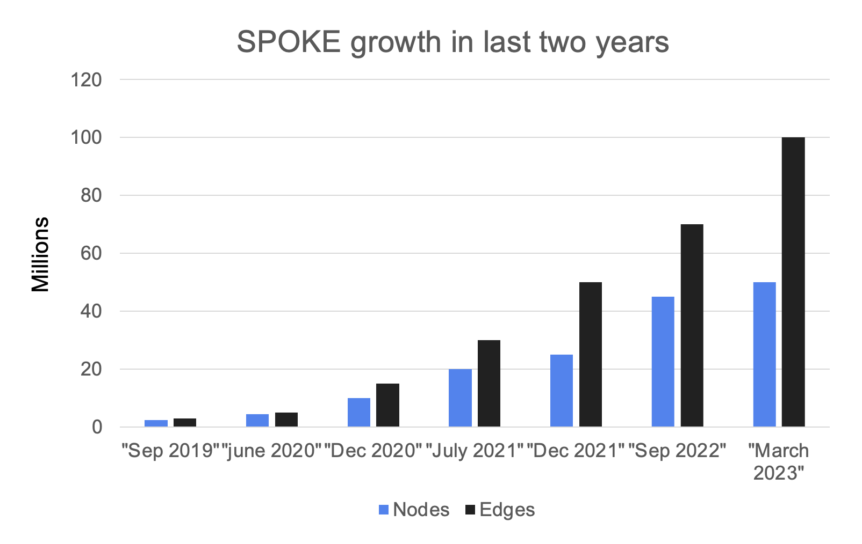
Figure 5: SPOKE size growth
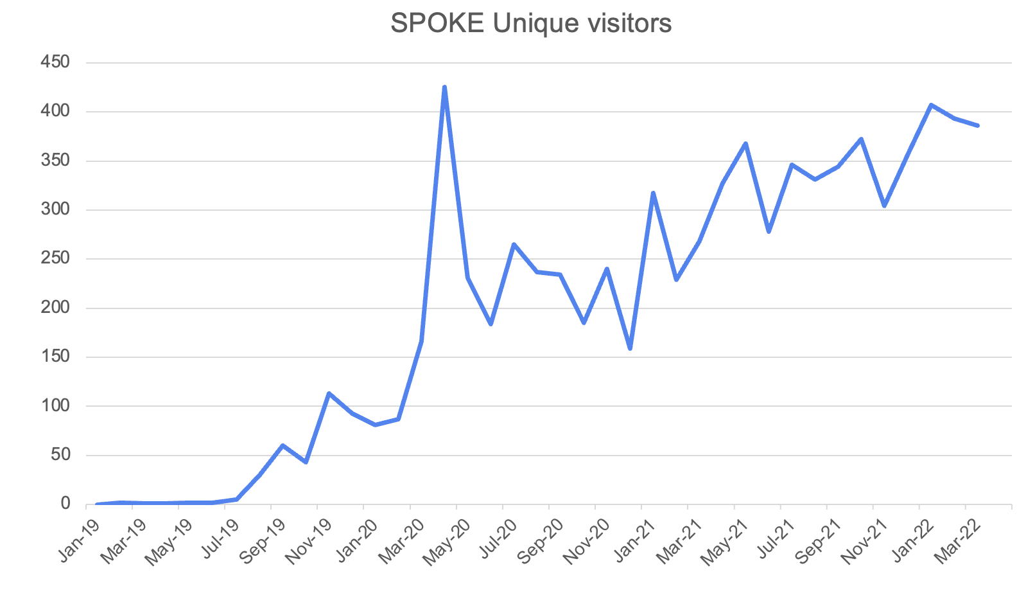
Figure 6: SPOKE reach growth

UC Tech 2023 Awards Program Background Information

[This is for your information only. Judges will not be reviewing this section. It is here to provide you with additional information to help you shape the narrative, above.]

Eligibility
- Individuals or teams, including those who were equally involved in large projects (Individuals only for DEI/Sustained Impact)
- Staff or faculty
- Those working closely with tech and/or IT teams
- The project must be operational and have been implemented within the last 3 years (delineate the time frame during which the work was done)
- Those working in cross-location and cross-functional teams are encouraged to participate

Criteria:
- Complexity: How complex was/were the problem(s) addressed?
- Impact: How impactful was the work – number of individuals impacted, and/or depth of impact?
- Mission Alignment: How the work advance the university’s mission, vision or values

About Judging and the IT Leadership Council’s “Selection Committee”
- The UC Tech Awards Program Selection Committee is composed of five members of the IT Leadership Council, including one member of the UC Office of the President and four others from locations who rotate annually. The names of committee members are listed on the program website after the selections have been announced each year.
- The committee determines the award winners on the basis of submitted materials and in accordance with the selection criteria.
- The judges will select up to one Golden and one Silver award will be selected for each category.

UC Tech Awards Category Descriptions:

- Larry L. Sautter Award for Innovation in Information Technology – The award is
given to an individual or a team for having implemented an innovative technology initiative that has had significant impact on the university’s academic/research mission, student life, business operations, patient care, or public service mission. Innovation is defined as the new application of technology, the creative use of limited resources, or an emphasis on collaboration to solve a problem.
- DEI Leadership Award (For individuals only) – Recognizes the leadership of an individual in advancing diversity, equity, and inclusion in technical communities, as demonstrated by specific tactics to create vehicles that improve visibility, access and engagement of underrepresented populations.
- IT Security Award – The award is given to an individual or team that advanced IT security at the University of California through awareness and training, policy, technical controls, and/or IT security hygiene. Projects that intersect with legal, privacy, and compliance are eligible.
- Yvonne Tevis UC Collaboration Award – The award is given to an individual or team that conducted a strong collaborative technology initiative across two or more UC locations, across a UC campus and UC health system, and/or with other UC partners.
- Mojgan Amini Operational Excellence Award – The award is given to an individual or team that transformed a business process (via reliability, speed, scale, efficiency, and/or effectiveness), whether through business process design, automation, customer service, digital transformation, or another initiative.
- Design Award – The award is given to an individual or team that transformed one or more touch points through the application of various design disciplines (e.g., visual design, interaction design, user experience (UX) design, customer experience (CX) design and/or industrial design to improve usability and/or create a more elegant experience for everyone, including people with disabilities.
- Sustained Impact Award (For individuals only) – The award is given to an individual who, over time, has contributed significant expertise, passion, and commitment to the university as evidenced by a portfolio of work supporting the technology arena.
For more information, please contact Laurel.Skurko@UCOP.edu or visit the UC Tech Awards 2023 Background & Application Page

*Accessibility Tip – If you upload images into your Word document, please include a Caption and AltText (a vivid description of what is in the image). NB: Word now has an “Accessibility” tracker, which can help you identify and fix accessibility issues.

t

