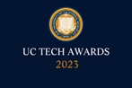
UC Tech Awards 2023 Candidate
Category: INNOVATION
Name: UC San Diego, EdTech Podcast Admin Team
Number of people: (7)
Location: UC San Diego
Person submitting the application/nomination
  - Treb Padula, ITS, UCSD, Staff
  - tpadula@ucsd.edu
  - UCSD

Award category: Innovation (Sautter)

Name of person, name of the team, or name of the project to receive the award UC San Diego, EdTech Podcast Admin Team
“The Best of Both Worlds: Pairing Cloud Vendor Technology with On-Campus Innovation in Lecture Capture”

All project team members -
Matthew Fedder, Senior Systems Integration Engineer, ITS/ATS (Academic Technology Services, UCSD, Staff
Adam Tilghman, IT/Systems Architect, ITS/ATS, UCSD, Staff
Galen Davis, Senior Educational Technology Specialist, ITS/ETS (Educational Technology Services), UCSD, Staff
Robin Martin, Director Multimedia Services, ITS/ETS, UCSD, Staff
Treb Padula, Senior Educational Technology Specialist, ITS/ETS, UCSD, Staff
Dan Suchy, Senior Director, Educational Technology Services, ITS/ETS, UCSD, Staff
Paul Jamason, Manager, Academic Technology Innovation, ITS/ATS, UCSD, Staff

Which location was affected by the work? UCSD Campus, Instructors and Students

Summary: Over the past few years, the team managing UC San Diego’s lecture capture system has incorporated industry-leading solutions “into” our podcast system instead of relying solely on an external vendor as a replacement. This approach allowed us to develop an automated, flexible, and customizable homegrown system while leveraging an existing vendor's robust video hosting and delivery, improving the service's reach, stability, and support while increasing user satisfaction.

Narrative: The lecture capture system on the UCSD campus has existed for over a decade. Initially, it focused on capturing the lecture audio and, in some cases, the content being shared over the classroom's projector. This content was captured with a small PC in the room at one frame per second. This kept storage needs minimal and facilitated mobile consumption of the media. The programming of the system was developed internally, and the files were hosted on physical machines on the campus.
This self-hosting worked well initially when few instructors elected to record their lectures, and file sizes were manageable. Several changes over the last few years, however, vastly increased the stress on the system and required new solutions. Instead of buying into an online solution that would lock us into proprietary hardware and take away our ability to improve the current system continually, we looked at industry partners with more open solutions and APIs that would allow us to keep much of the control over the service in-house.
While upgraded capture hardware and the installation of a few video cameras in our lecture halls first taxed our ability to host the content ourselves, it was the pandemic that caused the largest shift in the usage of our lecture capture system. Almost overnight, our system shifted from a “nice to have” solution used by some to a “must have” system used by many of our faculty. Cameras were rapidly installed in more classrooms, increasing the number of content and video capture-ready classrooms from 15 to 126. With the addition of video, our data storage needs soared.
The graph below shows that requests for podcasted classes went from about 400 requests per quarter (just before the pandemic) to just under 800 requests the quarter we returned to campus, an increase of 89.5%.
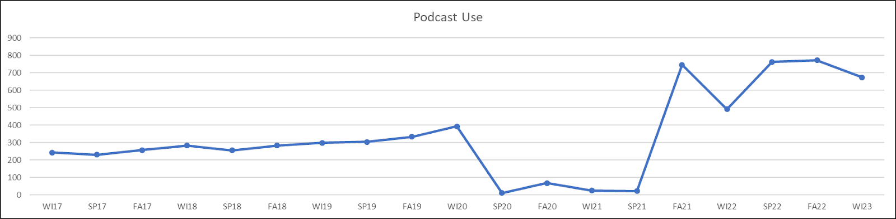
Chart representing the number of requests to capture the lecture of a class per quarter.
Before the pandemic, our campus signed an enterprise contract with Kaltura, a video hosting and delivery vendor offering unlimited media storage. While the primary purpose of this contract was to consolidate videos hosted by departments and programs on aging servers, we also discussed the idea of shifting our lecture capture system to Kaltura. While switching to a web-based solution hosted by a large 3rd party sounded beneficial initially, we soon realized how much we would lose.
The discussion came down to two main features: administrative capabilities and post-processing. Our homegrown system was robust, highly automated, and customized to UCSD’s needs. This system allows an instructor to go to our lecture capture main page and request a recording of their class with just a few clicks. Automated scripts schedule the recording and even move their class with them if a change happens from the registrar and auto-adds review sessions. This admin system also allows tier 1 support staff to quickly resolve most issues with lecture recordings without escalating to more senior staff.
The other feature we didn't want to lose was the ability to perform multimedia post-processing customized to the specifics of the lecture recorded. While sending the raw recording directly to Kaltura might simplify the workflow, this simplification would eliminate key features that improved quality, facilitated support, and increased instructor satisfaction. Some examples include:
- Detailed analyses of ingested media. Such analyses would create graphs to indicate at a glance rooms that had issues with audio or video.
- Applying a 3D denoise filter. Many classrooms operate in low-light conditions. This filter improved the quality of the camera content in addition to reducing file sizes by up to 12x.
- Cropping content. Black bars were eliminated, maximizing the use of the player space and vastly improving the mobile viewing experience.
- Creating back-ups. Copies of podcasts would be stored for several weeks on local storage in the event that transfers to Kaltura failed, or the instructor mistakenly deleted the content.

After reviewing the options, the decision was made to incorporate Kaltura into our lecture capture system but not purchase their lecture capture solution outright, instead relying on existing pieces of our infrastructure that had led to such satisfaction and high adoption.
The final piece of this puzzle was just completed this year. With the design of incorporating industry-standard hardware (Extron SMP recorders) and robust web solutions (Kaltura) into our current homegrown lecture capture system, we needed a way to transport and temporarily store the data along with a repository for the administration side of the system.
We first tried using Amazon's AWS system. While this solution worked initially, the cost was prohibitive and the files could not be sent directly from the room recording device to Amazon, requiring an intermediate hosting step. The team came up with the idea to use Qumulo since the campus already had an instance of it running. This solution was more cost-effective than Amazon and allowed our uploads to go directly from the room recording devices to Qumulo storage -all on the high-speed campus network. These files can also easily be searched and retrieved by tier 1 support.
The goal of this project was to preserve much of the existing technical infrastructure and workflow but try and find a quick win with an outside solution to have the best of both worlds: one where we incorporate the best solutions available into a system that we have been improving for years. Below are some reasons we have found to try and combine homegrown solutions with cloud-based solutions instead of just going all-in with outside vendors.
- Customization. We can tailor our lecture capture service to meet the specific needs of our instructors and support staff in addition to the variety of devices and setups within the classrooms. This level of flexibility and customization is simply not possible with outside vendors.
- Integration. We leverage existing enterprise contracts to maximize the value of our investments.
- Cost. While purchasing a solution may seem less expensive in the short term (both with respect to manpower and money), the cost can add up quickly over time, especially if vendors add licensing fees or development charges necessary to achieve parity. By developing and maintaining our own system, we anticipate saving money in the long run.
- Control. We free ourselves from dependence on a vendor to provide updates, maintenance, and support and can respond with alacrity if needs change or new challenges arise.
- Innovation. We can arguably be more innovative than outside vendors since our service is tailored specifically to the needs of our particular instructors, classrooms, and teaching methods.

We take enormous pride in the design of our lecture capture system, and the service continues to grow. While any homegrown solution requires ongoing effort and FTEs, we think that the advantages of such a hybrid solution far outweigh any disadvantages.

Current Lecture Capture Workflow