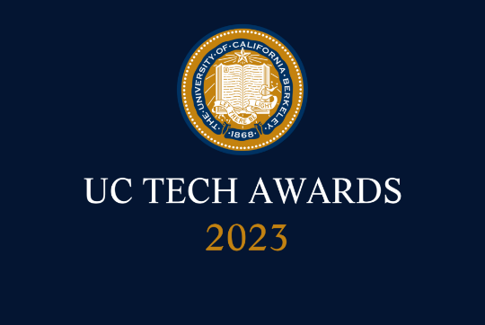
UC Tech Awards 2023 Candidate
Category: INNOVATION
Name: The UC Merced Connect ModulesTeam (17)
Number of people: (17)
Location: UC Merced
- Person submitting the application/nomination
  - Christy Snyder, Assistant Vice Chancellor and Deputy Chief Information Officer, UC Merced Office of Information Technology (staff)
  - Email address: csnyder4@ucmerced.edu
  - The name of your organization: UC Merced

- Award category : UC-Wide Collaboration (THEY SWITCHED TO “INNOVATION”)

- Name of person, name of the team, or name of the project to receive the award : The UC Merced Connect Event ModulesTeam

- All project team members (all staff)
- Christy Snyder, Assistant Vice Chancellor and Deputy Chief Information Officer, Office of Information Technology
- Katie Adams Arca, User Experience Specialist and UC Merced Connect administrator, Office of Information Technology
- Christian Ortiz, User Experience Specialist, Office of Information Technology
- Chris Abrescy, Creative Director, Marketing & Public Relations
- Christine Wallace, Director of Protocol and Signature Events, Office of External Relations
- Lizbeth Lupi, Admissions and Outreach
- Dustin Noji, Director of Admissions, Admissions and Outreach
- Lisa Perry, Students First Center Director
- Cassie Gunter, Graduate Resource Coordinator, Graduate Division
- Brenda Ortiz, Graduate Communications Coordinator, Marketing & Public Relations
- Jessica Gardezy, Director of Internal Communications, Marketing & Public Relations
- Amy Lozano-Smith, Director of Enrollment Management Marketing and Communications
- Jody Murray, Supply Chain Communications Specialist, Marketing & Public Relations
Shoba Spencer, Director of Marketing, Marketing & Public Relations
Note: Shoba has taken a new position as the Associate Vice Chancellor and Director of Brand Identity, UC Riverside
- Jackson Muhirwe, Chief Information Security Officer, Office of Information Technology
- Antonio Garcia, Security Analyst, Office of Information Technology
- Phil Herechski, Security Analyst, Office of Information Technology
- James McKinzie, Security Analyst, Office of Information Technology

- Which location was affected by the work? UC Merced

- Summary
In March of 2022, the director of Marketing at UC Merced approached the Connect (campus app) team in the Office of Information Technology with a question: how quickly could the team spin up some content that could support Bobcat Day, the huge campus admissions event that was projected to bring nearly 6,000 admitted students and their families to campus? Over the course of three short weeks, what would become the UC Merced Connect Event Modules team answered that question, creating fifteen new screens, quick polls, an in-depth schedule of events, and campus wayfinding maps—all in both English and Spanish!—and making countless customizations to typical app configuration to support the event. The successful collaboration has since spawned six subsequent collaborations and has significantly improved engagement with the campus app and helped participants more easily navigate campus-wide events.
- Narrative
In March of 2022, the director of Marketing at UC Merced approached the Connect (campus app) team in the Office of Information Technology with a question: how quickly could the team spin up some content that could support Bobcat Day, the huge campus admissions event that was projected to bring nearly 6,000 admitted students and their families to campus?
Over the course of three short weeks, what would become the UC Merced Connect Event Modules team answered that question, creating fifteen new screens, quick polls, an in-depth schedule of events, and campus wayfinding maps and making countless customizations to typical app configuration to support the event. At the suggestion of one especially thoughtful student worker, the team also translated the entirety of the module into Spanish to support UC Merced’s largely Spanish-speaking, first-generation population.
The app module was a significant improvement over what had, until that point, been a largely email and paper-based event. The response from families—especially those who spoke mainly Spanish—was overwhelmingly positive. The effort was hugely collaborative as no one department or group “owned” all of the information or expertise necessary to make the module a success, and the successful collaboration model quickly spawned similar efforts that brought in new collaborators and continued to challenge the team to develop new ways to engage campus visitors and event participants.
Throughout 2022 and into 2023, the team worked on Bobcat Day (English Spanish), Spring Commencement, Graduate Orientation Week, Fall Welcome Week, supported a Fall Treasure Hunt, ran a month-long Cyber Security Awareness Month module complete with weekly content changes including videos, quizzes, educational material and an engagement competition, and is now repeating the cycle in 2023. Though the Office of Information Technology has made a conscious decision to direct resources toward this effort, the modules couldn’t happen without the matching effort of our partners across campus.
To visitors and new students on campus for specific events, these modules represent the first step towards a thoughtful and useful digital guide that helps them navigate what might otherwise be a confusing and sometimes disjointed experience—all from the convenience of their phone. For those new to campus, these pop-up app modules offered quick access to maps, promotional materials, and orienting information. For more seasoned students, faculty, and staff, these digital experiences cut through some of the noise of e-mail to promote and drive understanding of and engagement with big campus events.

The analytics for each of the modules tell an increasingly compelling story - our users are eager to turn to the campus app for timely communication and information, and will respond quickly to calls for action designed to enhance their experience of particular events. (Sample analytics: Bobcat Day | Commencement | GROW)
The engagement and collaboration that we’ve seen from other campus units is heartening - they’ve recognized the value of a unified campus app and are partnering with us to design content and messaging to help students, faculty and staff more easily find information and navigate through their day-to-day experiences on campus.

