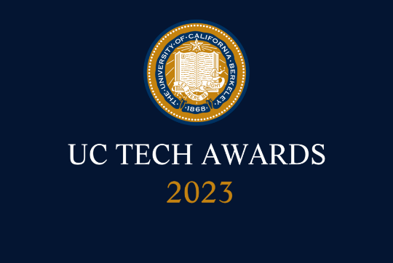
UC Tech Awards 2023 Candidate
Category: INNOVATION
Name: Experiential Learning Program (ELP)
Number of people: (3)
Location: UC Irvine
- Person submitting the application/nomination
  - Tom Andriola
  - Email address: tom.andriola@uci.edu
  - The name of your organization: UC Irvine

- Award category INNOVATION

- Name of person, name of the team, or name of the project to receive the award Experiential Learning Program (ELP)

- All project team members - if applicable (Name, title, department, location/organization, and please indicate if they are faculty or staff, along with their email address(s).

- Tom Andriola | VCITD| UC Irvine | staff
- Xanat Hernandez | Director of Communications | ODIT | UC Irvine | staff | xanath@uci.edu
- Nyma Cain | Exec Assistant| ODIT | UC Irvine | staff |

- Which location was affected by the work? (the name(s) of the organization affected)
UC Irvine

- Summary The Experiential Learning Program (ELP) creates a bridge between classroom learning and career readiness by providing a space for underrepresented students to build new competencies and hone their skills. Opportunities exist for students both inside and outside STEM majors, supporting everything from social media management to content creation & storytelling to AI/machine learning. ELP offers positions for summer, part-time and project-based employment.

- Narrative

The ELP program was started to address the issue of providing valuable skills to underrepresented students in the field of technology. We seek to connect students to real-world scenarios and build connections, allowing students to gain experience they can add to their resume and real scenarios they can speak to in job interviews.

To do so, we partnered with local companies that are in need of student talent, research teams on campus, and our UCI career pathways team. We have now placed over 171 students with paid opportunities.

Our projects include:

Metaverse Classroom
Participating in the experimentation and evolution of education, ELP is partnering with The Paul Merage School of Business to create the UC's first metaverse learning experience.

Digital Humans & Chatbots
The next generation of chatbots is here. Students are building empathetic, interactive digital humans powered by natural language processing and generative AI to create superior, self-driven experiences.

Zot Bot
What can generative AI tools such as Chat GPT do for an institution like UCI? We're exploring how generative AI solutions can enhance the student experience and even create potential startups.

Personal Health Navigator
Students are leveraging various wearable, biometric and healthcare data to achieve personalized recommendations for health & wellness.

Data Science & Machine Learning in the Lab
Students looking to participate in cutting-edge research are given the opportunity to collaborate with UCI faculty to bring technology and data skills to the research setting in response to growing data and computational needs.

Cloud Migration
We're bringing UCI into the cloud. Students assist in building & migrating our campus and health environments into the cloud, receiving the opportunity for training and certification.

Each project has a staff and faculty advisor, and all projects have flexible outcomes and formats. We want students to have a place on campus to experiment with cutting-edge technology, all while receiving financial support for doing so.
This year ELP is launching The Hub—a playground for those that are not placed into paid opportunities. The Hub grants all students access to sandboxes provided by leading tech companies. Our current partners includes Salesforce Trailhead Academy, Soul Machines Academy, AWS Training and Certification, Udemy, Gartner, Siemens and ServiceNow.

We are also launching a physical location in June at the UCI Antrepreneur Center. It will be a place for students to congregate and access our sandboxes.

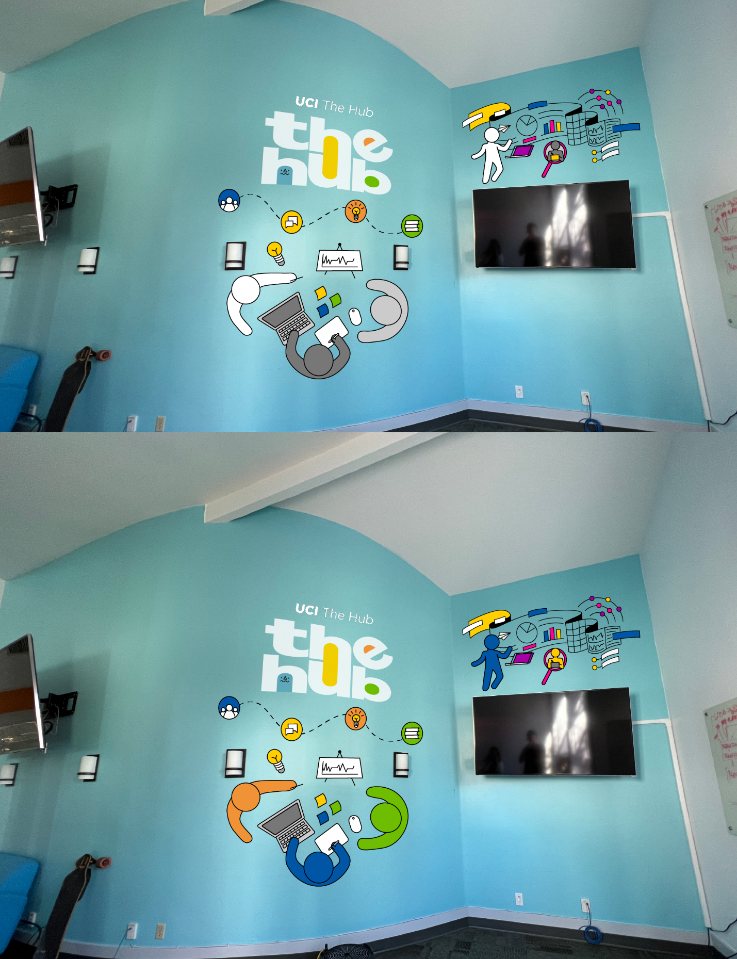

UC Tech 2023 Awards Program Background Information

