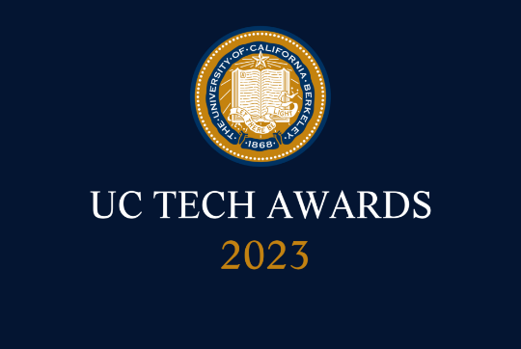
UC Tech Awards 2023 Candidate
Category: INNOVATION
Name: EVOLVE: Talent Enhancement Program (7)
Number of people: (7)
Location: UC Irvine

- Person submitting the application/nomination
  - Name, title, department, location/organization, and please indicate if you are faculty or staff:
  - Email address: xanath@uci.edu
  - The name of your organization: UC Irvine

- Award category Innovation

- Name of person, name of the team, or name of the project to receive the award EVOLVE: Talent Enhancement Program

- All project team members

- Nidia Barrios | Director, OIT Human Resources | HR | UC Irvine | staff | barriosn@uci.edu
- Babette Vogel | Director, OIT Business Services | UC Irvine | staff | vogelb@uci.edu
- Lucy Zheng | Project Lead| HRIT | UC Irvine | staff | lqzheng@uci.edu
- Xanat Hernandez | Director of Communications | ODIT | UC Irvine | staff | xanath@uci.edu
- Jeff Martin | Senior Project Manager | PMO | UC Irvine | staff | jeffrym@uci.edu

- Which location was affected by the work? (the name(s) of the organization affected)
UC Irvine

- Summary: EVOLVE is an AI-powered talent enhancement program at UC Irvine that promotes resiliency and employee engagement. Benefits to our employees include: the opportunity to showcase their talents in different teams across the organization, identify competencies and areas for growth, discover new opportunities, and build their own career path. For the organization, a program such as this enables workforce dexterity, agility, and resilience.

- Narrative *Please note, our narrative is 1,015 words, it seems longer because of the visuals.
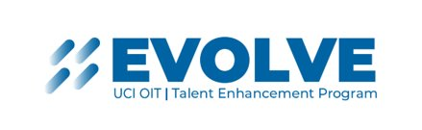
Intro and Background

In 2020, UC Irvine struggled with the typical aches and pains every organization faced during pandemic times. Our institution faced employee burnout, turnover, and disengagement, quickly followed by the “Great Resignation” and “quiet quitting.” In many ways, the pandemic brought issues that were quietly growing under the surface to the forefront of our hearts and minds.

UC Irvine acted and invested in an engagement tool with the potential to truly make a difference—EVOLVE. Through EVOLVE, the Office of Information Technology (OIT) is empowering employees by putting their career journey in their own hands.

What is EVOLVE?
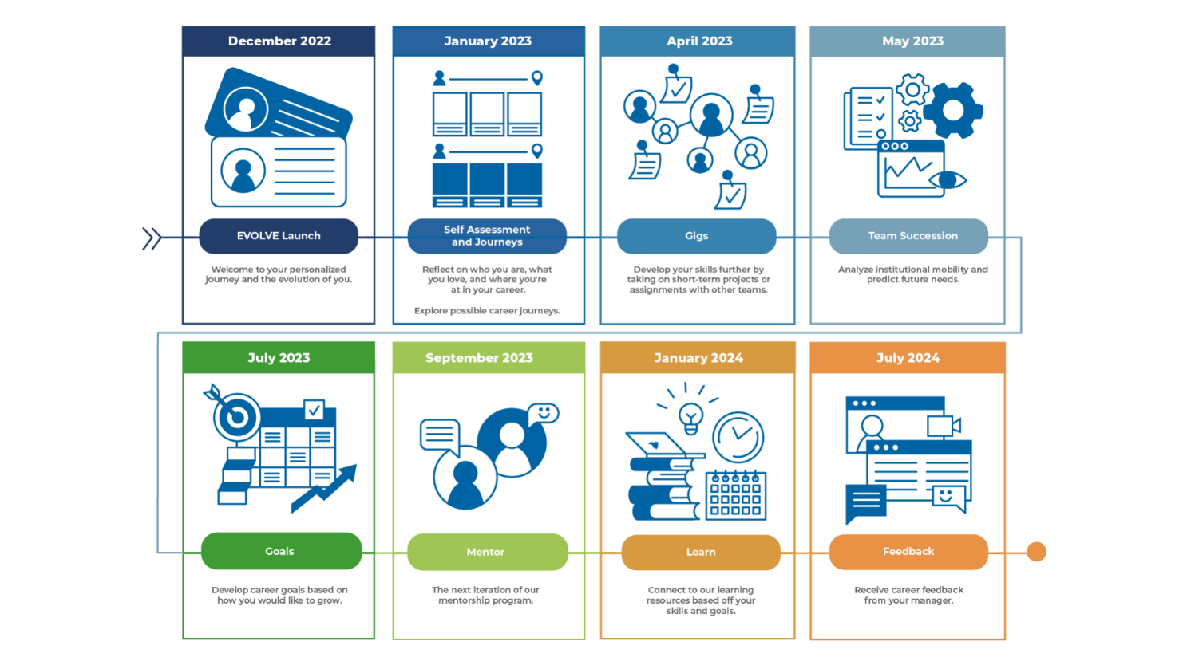

EVOLVE is a talent enhancement tool driven by AI. It is a vendor-powered platform made up of a series of dynamic modules. In Winter 2022, after a year of planning, OIT launched the first modules: Personalize and Journeys. Our employees completed a series of exercises that provided insight into their work style to build their profile. They were also able to rate their skills and capabilities through gamified activities and discussed these ratings with their manager. Thus, the backbone for the AI tool was built.

The next module, Vacancies, integrated this information seamlessly. Now all OIT vacant positions are listed in the EVOLVE platform and each employee can assess their “fit” based on their profile.

Our next module launch was Gigs. Through Gigs, team members can take on short-term assignments outside of their team to build new skills. This also enhances OIT’s workforce dexterity and agility.
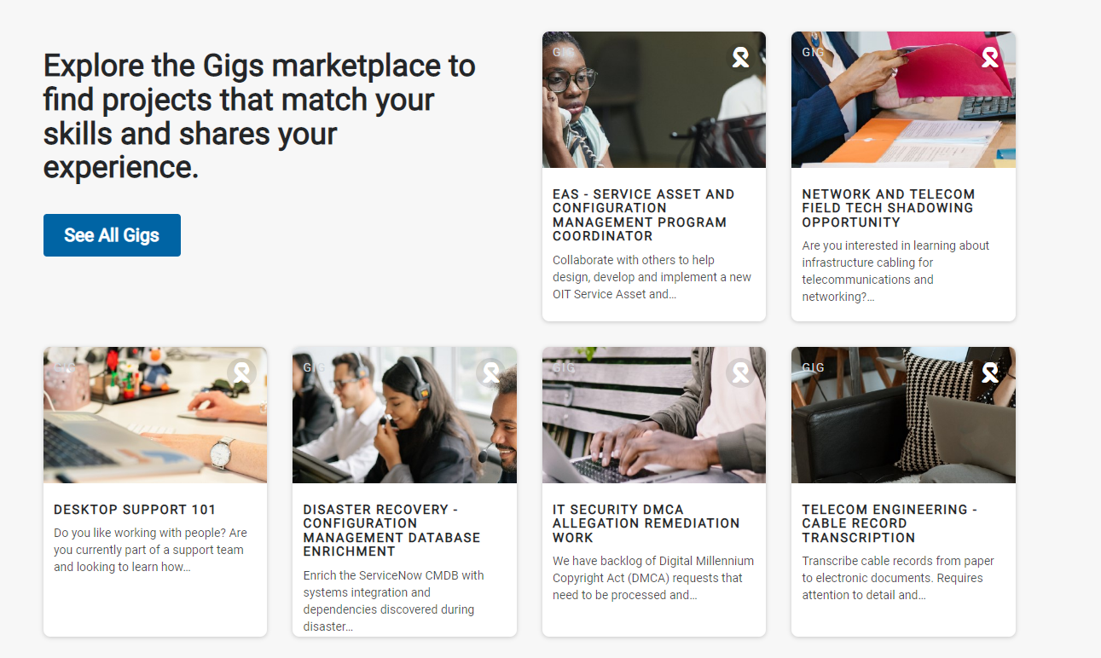
Our project roadmap has scheduled additional module releases through July 2024. An immediate impact of EVOLVE has been the proliferation of honest career conversations. EVOLVE encourages managers to have regular career check ins with their staff to discuss an employee’s future goals and how to best support them.

Complexity

A rollout of this kind was no easy feat. With over 375 employees to integrate into the platform, the EVOLVE team assessed every job classification before launch.

For example, we may have 20 application developers at OIT. However, each employee may have a very different work reality. The team came together to standardize basic capabilities that each application developer would have, such as ‘Customer Centricity’ and ‘Software Development Life Cycle (SDLC)’. This exercise was performed for over 261 job classifications and then verified and revised by HR.

Naturally, getting to this stage of the project was a task in and of itself. Making the decision to invest in the platform (Fuel50) and obtaining leadership buy-in was key. Consensus building was facilitated by agreeing on four project pillars:

- Internal Talent Pathways – Identifying emerging roles and preparing employees to fill them
- Workforce Dexterity – Optimizing our cross-departmental relationships as work ebbs and flows
- Quality Hiring – Knowing the skill set we need for each job and hiring for those qualities
- Career Discovery – What are your strengths & passions and how can we identify, foster and align those with your current job and future career

Although this project is backed by a vendor, OIT went beyond the out-of-the-box solution in many ways. Every prompt and piece of text was edited or rewritten to speak to our audience and our OIT pre-defined values. Images of our campus and of Peter the Anteater were used throughout the platform to foster a sense of familiarity and trust.

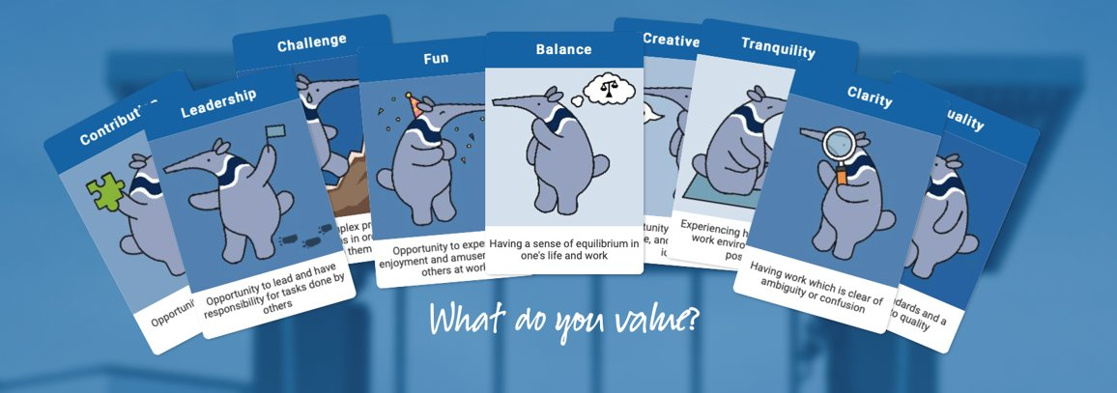

Impact

We uploaded 369 active staff into EVOLVE. So far, 176 unique logins have been created, of which 127 are returning users. 72% of our current user base return to Evolve on a regular basis. Out of our users, 128, or 73%, have completed at least one tool. We have provided 19 Gigs for staff to test and grow their skills in different technical environments.
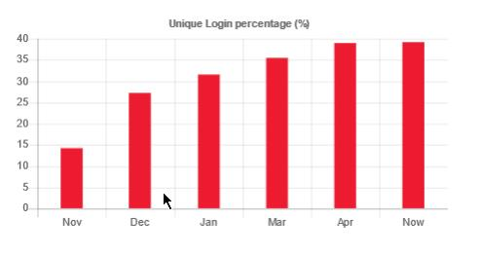
Our team’s answers and scores from the self-assessment modules provide us insight into their career and development. We measure success by analyzing their top engagers, top personal values, most satisfied career values and overall satisfaction rating. The dynamics in the Gigs module, the Mentorship module and the Learn module will drive their overall satisfaction rating, which will only help increase their satisfaction. We will continue to grow and track our user base to continue to measure our success.

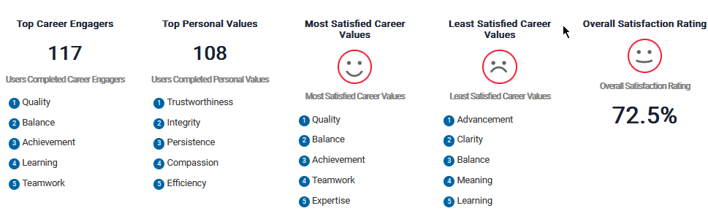
Mission Alignment

Kickstarting a major implementation like EVOLVE in the midst of the aforementioned stressors and challenges (Great Resignation, burnout) was only possible through the deep and sustained alignment with UC mission and values.

Vision Statement: The UC vision statement says: “We will be the #1 public sector employer in the area of employee engagement. We will attract and retain diverse top talent, and our employees will find meaning and purpose in their jobs.” The EVOLVE program delivers on this vision through its gamified tools and hyper-personalized interactive modules, offering a world-class career experience.

Collaboration: The EVOLVE program is facilitating the “exchange of information, expertise, and skills” within our organization by looking beyond the traditional organization chart and providing employees a more flexible experience through a “choose your own adventure” style career journey. OIT leaders see the value of collaboration and are committed to providing their teams with the extra time to complete the personalize exercises and explore different career paths through gigs, mentorship, and training.

Diversity and Inclusion: Talent enhancement and DEI are inextricably linked. UCI’s EVOLVE reduces bias that impedes diversity by giving employees a platform to display their skills, contributions, and gain visibility into the organization as a whole. The program offers a level playing field and promotes an inclusive culture.

Excellence: Superior outcomes require superior strategy and EVOLVE is a next-level approach to talent management.

Innovation: This first of its kind deployment in the UC system is an example of cutting-edge IT and higher ed innovation.
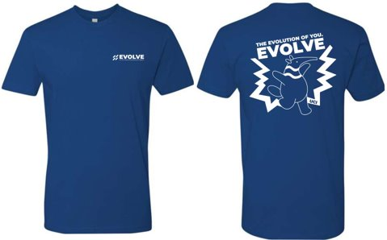
Conclusion

At UCI we are committed to helping our team grow in their careers without feeling like they must seek their next challenge somewhere else. Our employees want career growth and development opportunities, and we want to create a solid foundation to foster these opportunities.

By giving employees the tools and framework to grow their skills and advance their careers, we are actively creating a resilient workforce that’s agile, engaged, and ready to tackle tough challenges.

