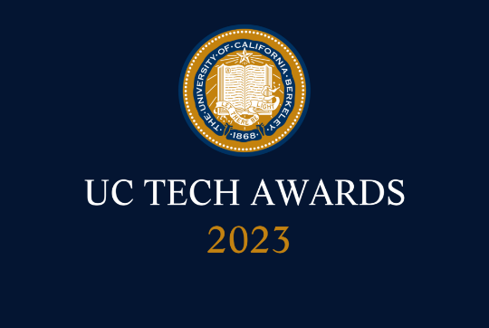
UC Tech Awards 2023 Candidate
Category: INNOVATION
Name: Virtual Front Desk for Student Advising
Number of people (3)
Location: UC Davis
  - Person submitting the application/nomination
    - Jeremy Phillips, IT Director, College of Letters and Science, UC Davis, staff
    - Tracy Grissom, Director for Advising and Policy, College of Letters and Science, UC Davis, staff
  - Email address:
    - jmphillips@ucdavis.edu
    - tsgrissom@ucdavis.edu
  - The name of your organization: (i.e. UCLA)
    - UC Davis

- Award category: Innovation

- Name of person, name of the team, or name of the project to receive the award
  - Virtual Front Desk for Student Advising

- All project team members - if applicable
  - Fei Li, Lead Application Developer, College of Letters and Science, flcli@ucdavis.edu, staff
  - Jarold Wong, Application Developer, College of Letters and Science, cwjwong@ucdavis.edu, staff
  - Edgar Duran-Perez, Application Developer, College of Letters and Science,
eduranperez@ucdavis.edu, staff

- Which location was affected by the work? (the name(s) of the organization affected)
  - UC Davis

- Summary: Initially developed to address advising needs during the pandemic, the Virtual Front Desk application has transformed how our students access advising services and significantly increased our capacity to provide advising services to students without increasing our advising staff. The development team have continued to improve the application, including interfacing with our advising system to track student contacts, adding the option for students to call in via phone, and providing live analytics to help advising teams navigate traffic spikes and determine staffing needs.

- Narrative

Returning to in person instruction from the pandemic, student expectations for advising have changed. At the same time, the need to connect with our students and provide them with services to support their educational goals has never been more urgent. During our first quarter back on campus, we quickly realized that students were no longer choosing to visit advising services in person—what had been long lines at our advising offices had become a trickle, and the demand for online appointments was overwhelming. While we had systems in place to handle online advising by appointment, the missing piece was immediately available drop-in advising. We initially tried using Zoom to fill this need, but we quickly found that between FERPA/privacy concerns and limitations in the technology, we were not able to meet the demand. We looked for commercial solutions, but everything we found was a component of a larger student advising/engagement or other student information system. That led us toward developing a custom solution.

In less than five months, Fei and the team he leads were able to develop and deliver the Virtual Front Desk, which launched in April 2022. Since the launch, Virtual Front Desk has been used for more than 14,497 advising sessions across 20 advising groups at UC Davis. The average student wait time has 4 minutes 7 seconds via computer and 2 minutes 37 seconds via phone. These numbers are unprecedented at UC Davis: we have been able to see far more students than we were able to using our pre-pandemic methods, all without increasing our advising staff. Since the launch, the team have continued to add features to the application, including interfacing with our advising system to track student contacts, adding the option for students to call in via phone (which also makes the system accessible to more students), and providing live analytics to help advising teams navigate traffic spikes and determine staffing needs.

With the changes and improvements, the VFD application has evolved from a virtual reception space, to a fully functional on demand advising service application. This past year our office has rebranded the service as “Express Advising”, which has quickly become a cornerstone of our advising services. We are able to offer service to students 9am-4pm daily, and with the flexibility the application provides, we are able to meet high traffic demands as they occur throughout the term. In addition to the roughly 300 pre-populated appointments, we were able to see weekly, Express Advising allows us to meet with and serve an additional 300-500 students per week depending on demand.

The change to an “Express Advising” model has also allowed us to mostly eliminate the need for dedicated reception services, which has historically served as a buffer/barrier to accessing advising. Under the old model students had to come to our front desk and be booked a same day appointment. In some cases, students may have had to wait hours, days or even weeks to meet with an advisor. Now, our students are able to speak with an advisor on-call (often waiting less than 5 minutes).

We knew from the inception of this project that the need for an online drop-in advising platform extended beyond our college and beyond our university, so the team developed the system to be easy to share with other advising teams at UC Davis and across the UC system. Fei presented Virtual Front Desk at UC Tech 2022 along with an offer to make it available to any UC campus. Given the transformative impact this tool has had on advising in one college, we expect that it can easily serve tens of thousands of students within the next year—and what could be more aligned with the UC mission than helping our students attain their educational goals?

Additional information about Virtual Front Desk, including a screenshot tour, is available at the project website: https://getvfd.ucdavis.edu/

