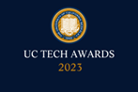
UC Tech Awards 2023 Candidate
Category: INNOVATION
Name: Oliver Kreylos (Augmented reality sandbox + Virtual reality projects)
Number of people: (1)
Location: UC Davis

- Person submitting the application/nomination
  - Name: Pamela Reynolds, Associate Director
(co-submitted by Carl Stahmer, Executive Director)
UC Davis DataLab: Data Science and Informatics (Library)
Academic staff
  - Email address: plreynolds@ucdavis.edu; cstahmer@ucdavis.edu
  - The name of your organization: UC Davis

- Award category: Larry L. Sautter Award for Innovation in Information Technology

- Name of person, name of the team, or name of the project to receive the award: Oliver Kreylos (AR + VR projects)

- All project team members - Individual Award

- Which location was affected by the work? UC Davis and installations across the UC system (UCSB, UCLA), CSUs (Humboldt, Pomona, Fullerton), other universities, primary to secondary schools, science centers, museums, and other institutions globally.
- Summary (1-3 sentences synthesizing the longer “Narrative - see below)
Oliver Kreylos has pioneered the development of augmented reality and virtual reality software for research, teaching, and outreach. The latest innovations to his open source AR Sandbox and Virtual Reality User Interface (Vrui) platforms, and their novel integration, are reducing equity barriers and providing opportunities for researchers and students to interactively immerse themselves in 3D data visualizations and collaborate together in real-time. Oliver’s contributions advance our commitment to furthering data-driven discovery by promoting collaboration and fostering diversity and inclusion by reducing barriers and promoting access to innovative data visualization technologies.

- Narrative
We are nominating Oliver Kreylos for the Larry L. Sautter Award for Innovation in Information Technology. Oliver holds a PhD in computer science and is the Virtual Reality Research Specialist at UC Davis DataLab: Data Science and Informatics. Prior to joining DataLab in 2021, Oliver was the programmer at UC Davis’s W.M. Keck Center for Active Visualization in the Earth Sciences (KeckCAVES). Oliver has made tremendous technical contributions to the research and education mission of UC Davis, which have benefited the entire UC system and institutions worldwide. We hope you will join us in your appreciation for Oliver’s groundbreaking work on developing innovative technologies for three-dimensional data representation and user accessibility platforms for collaborative data immersion and analysis.

Studying and teaching concepts involving 3D data, from tiny crystalline structures to the surface of our planet, poses many complexities and challenges for researchers and educators. All projections for transforming 3D data onto a 2D plane introduce distortions, which at best make it harder to interpret the data and generate novel discoveries, and at worst lead to incorrect conceptual models and results. Oliver has dedicated his career to developing software and interfaces that overcome these constraints by allowing researchers and students to become immersed in 3D data via augmented and virtual reality. Two of Oliver’s products, the Augmented Reality (AR) Sandbox and Virtual Reality User Interface (Vrui), are revolutionizing research programs and college curricula, as well as addressing key accessibility concerns and contributing to our mission to accelerate and diversify STEM. Oliver’s latest innovations to integrate the two systems provides unprecedented opportunities within and beyond academia.

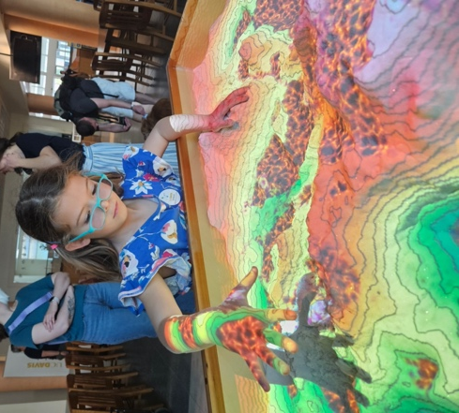
AR Sandbox
Oliver installed a new portable AR Sandbox at DataLab in 2023.
Oliver began developing the underlying open source software, technical specifications, and design of the Augmented Reality (AR) Sandbox as part of an NSF-funded project on informal science education awarded to him and colleagues at UC Davis, in collaboration with the UC Davis Tahoe Environmental Research Center, Lawrence Hall of Science, and ECHO Lake Aquarium and Science Center.
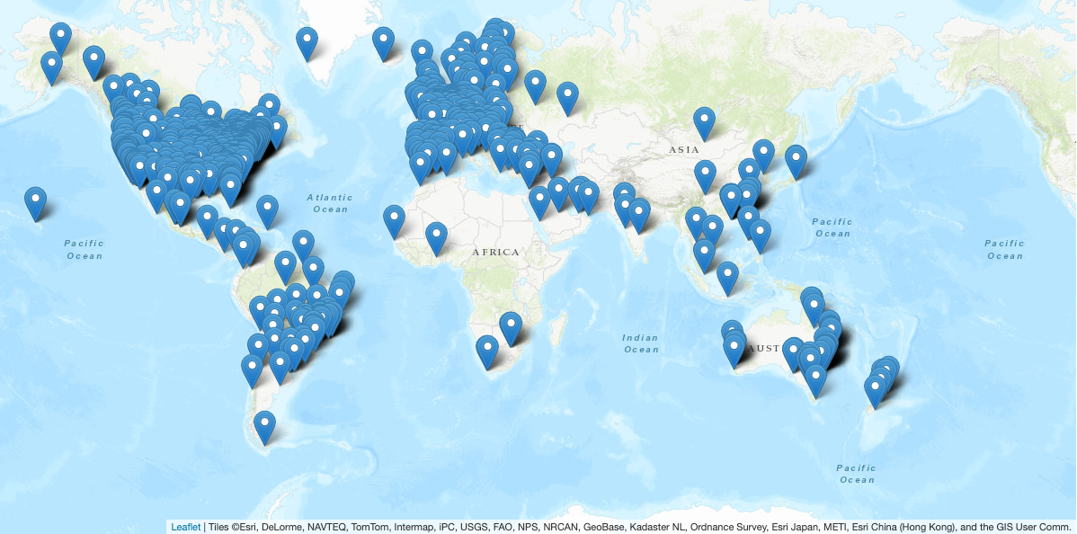
The AR Sandbox’s simulation and visualization software allows for hands-on interactive engagement with a 3D landscape, enabling elementary to college-aged students and faculty researchers to experience and study forces in geologic, hydrologic, and physical sciences. As users shape real sand in the sandbox, a Microsoft Kinect 3D camera captures minute elevational changes, which are processed, interpreted and rendered by Oliver’s software and projected in real-time back onto the surface of the sand to display an elevational color map and topographic contour lines. Added functionality to the code allows users to recreate an existing landscape (such as the Tahoe-Truckee Basin) or capture a novel one, and to simulate rainfall or lava flows to observe fluid mechanics at scale. Through truly hands-on learning, the AR Sandbox facilitates greater understanding of STEM concepts and spatial skill development. Exposure to the AR Sandbox has been shown to enhance undergraduate performance in introductory to advanced sciences courses, and it has aided research teams with fieldwork planning.
In his commitment to making tech accessible, Oliver designed the AR Sandbox to be cost-effective; the entire hardware setup costs ~$1,300. We estimate there are over 2,000 AR Sandbox installations at universities and middle to high schools, museums, and centers worldwide. The AR Sandbox at the Lawrence Hall of Science is experienced by over 250,000 people per year.
World map of known AR Sandbox installations.
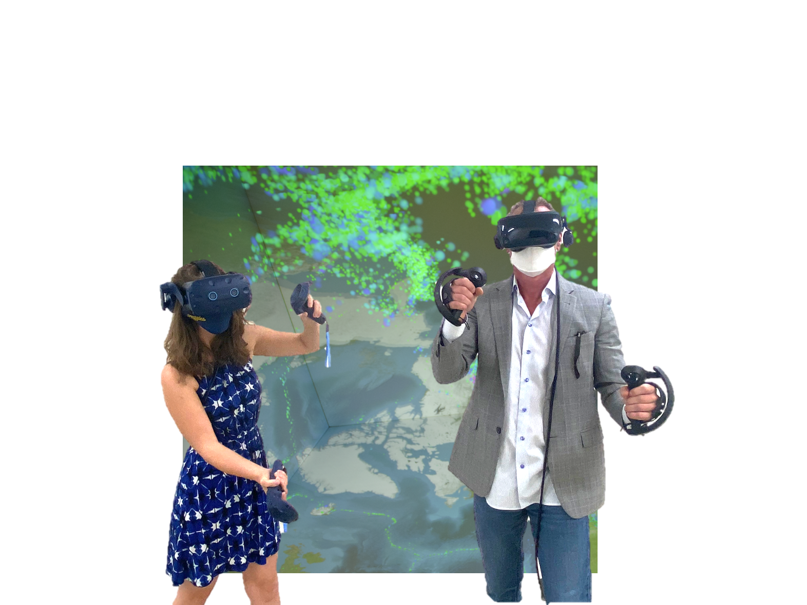
While the project is currently largely unfunded, Oliver continues to maintain the software, support the global user community, and is continually working on new features. In 2023 Oliver developed and introduced a simplified installation procedure, and released a simplified calibration routine, both designed to facilitate utilization of the AR Sandbox by more primary schools and public education centers.

Vrui: Next Gen 3D Data Viz
The UCDavis KeckCAVE was UC Davis’ premier visualization facility, consisting of three walls and floor with stereoscopic displays and tracking for in-depth interaction with 3D images. This facility became nonoperational in 2020 and was dismantled in 2022 due to the high cost of maintaining the system’s multi-million dollar camera system. Due to their expense, such visualization centers pose equity and accessibility barriers for researchers and educators. To address this disparity as well as meet existing and growing 3D visualization needs at the UC, Oliver is developing cost-effective solutions for collaborative, data-driven research. Since joining DataLab in 2021, Oliver has taken his open-source Vrui platform from major version 6 to 11 including significant advancements for supporting commodity VR headsets and controllers to connect to his custom immersive visualization software suite. This release also includes new scene graph architecture, a Vulkan-based compositing server, and support for (off-axis) projected screens in its room setup utility. Using Vrui researchers can spin, walk around, take measurements on and interactively query and subset their 3D data with a start-up hardware cost of only $2,000.
In 2022 Oliver installed a new virtual reality 3D data visualization center featuring commodity VR headsets at UC Davis DataLab.
This year Vrui’s collaboration infrastructure went from major version 4 to 8, featuring new reusable data sharing and bulk data transfer sub-protocols, as well as new shared pointing, drawing, and presentation sub-modules for real-time whiteboard and annotation. These innovations offer compatibility with other VR modalities to create hybrid virtual workspaces, allowing co-located and distributed teams to virtually step into a shared data visualization and co-explore large-scale datasets in real time, enhancing collaboration and generating novel insights. Recent research projects this software has facilitated include large-scale network graphs, LIDAR 3D spatial visualizations, and chemical engineering.
Additional Innovation: Integrating AR/VR Tech
At UC Davis’ Picnic Day and Take Our Children to Work Day in April 2023, Oliver led DataLab’s debut of his latest software development, the integration of the AR sandbox with Vrui. As kids created mountains and valleys, made it rain, and bubbled up lava in the AR Sandbox, other visitors explored the shifting landscape at scale through Vrui. They experienced landscape and weather changes in real time, while onlookers followed their immersive experience projected onto screens in 2D. This integrated exhibit attracted both adults and children. Gate counts from Picnic Day logged 1,996 visitors at the exhibit, and we estimate over 50 families experienced it at TOC. Many elementary aged children made positive remarks including: “This is so cool - I want to be a scientist!” Other comments indicated a successful introduction to core concepts: “I’m making a shield volcano. Lava is viscous;” “Water always goes downhill except when it doesn’t, because of momentum;” and “My mountain is steeper than yours. The [topo] lines are closer together.” Visiting faculty from veterinary and human health, as well as STEM research fields, have requested consultations and advice on applying the technology in their labs and classrooms. This innovative integrated experience piloted with the UC Davis community this spring presents new opportunities for broadening participation in STEM and promises to be the next frontier in accessible, immersive AR+VR technology for research, education, and outreach.

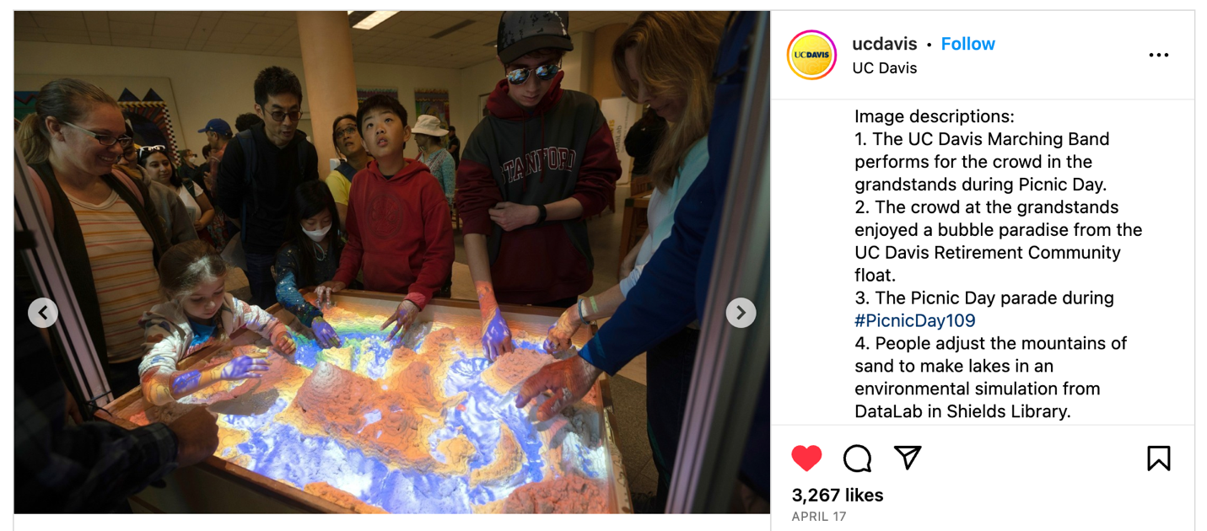
DataLab’s integrative AR/VR exhibit received praise at its UC Davis Picnic Day debut in April 2023.

Here are just a few quotes we’ve received about Oliver and his innovative AR/VR software:
- "… thank you for sharing this awesome educational tool…The science department was completely shocked and the students are completely amazed by it."
- "... It is such a great project and we really appreciate everything you have done to make it so accessible and open source."
- "... the sandbox is a blast. Everyone’s jaw ALWAYS drops when they see it for the first time. This is such an amazing project. One person couldn't stop giggling when they made it rain with their hand... Simply fantastic!"
- “I’d heard about your VR platform, but seeing it is mindblowing. I need to get one for my lab!”

More information about these projects and Oliver Kreylos’ other innovations for information technology can be found on his website (https://web.cs.ucdavis.edu/~okreylos/ResDev/index.html). Thank you for your consideration of Oliver’s nomination for this award.

