UC Tech Awards 2023 Candidate
Category: INNOVATION
Name: Analytics Oversight Committee program team (TBD)
Number of people: TBD
Location: UC Davis Health
- Person submitting the application/nomination
  - Name, title, department, location/organization, and please indicate if you are faculty or staff: Michele Morris, Supervisor, HDOC Program, UC Davis Health IT Data Center of Excellence, UC Davis Health, Staff
  - Email address: mimorris@ucdavis.edu
  - The name of your organization: UC Davis Health

- Award category Innovation

- Name of person, name of the team, or name of the project to receive the award Analytics Oversight Committee program team

- All project team members - if applicable (Name, title, department, location/organization, and please indicate if they are faculty or staff, along with their email address(s).

- Which location was affected by the work? UC Davis Health

- Summary: The Analytics Oversight Committee at UC Davis Health has created a novel and transparent framework for evaluating advance analytical models (AI) at the health system to ensure they are both SMART and SAFE. The criteria ensure that AI models intended for clinical or clinical research implementation are not only strategically aligned and the right solution, but also safe for patient care, effective in their use, and fair/unbiased.

SMART and SAFE - A Novel Framework for Clinical Artificial Intelligence Evaluation at UC Davis Health

Healthcare systems are challenged to focus their efforts and support the rapid adoption of Artificial Intelligence (AI). As new technologies arise and data collection is exponentially growing, health care systems are eager to implement solutions that improve operations as well as patient outcomes. However, without careful evaluation, health care systems are at risk of losing more than time and money. A poor AI model implementation could cause adverse patient outcomes, provider dissatisfaction, and reputational harm.

At UC Davis Health, the oversight of advanced analytics models including AI intended for clinical decision-making and clinical research is delegated to the Analytics Oversight Committee (AOC). Co-chaired by the Chief Nursing Informatics Officer and the Chief Research Informatics Officer, AOC membership includes broad organizational representation, as well as technical expertise required to evaluate the safety, efficacy, and appropriateness of proposed AI models, including physicians, biostatisticians, informaticists, epidemiologists, and members representing operations, IT, diversity/equity/inclusion, and compliance.

In addition to its decision making and consultative functions, the AOC was also charged by UC Davis Health’s Vice Chancellor to establish best practices and standard operating procedures for the evaluation of proposed AI models. In response to this charge, the AOC has created a novel framework for examining proposed models: The S.M.A.R.T. and S.A.F.E. framework.

The S.M.A.R.T. criteria ensure that AI models are evaluated for strategic alignment, organizational fit, and feasibility. The committee evaluates proposed models based on the questions below:

Category | Specifications
Specific | - Has the proposed use of AI been defined in relation to specific business objectives (clinical, research, strategic, financial, etc.)?  - Has the proposed implementation plan been specifically defined?
Measurable | - How will the impact of the proposed solution be measured?  - Will both benefits and potential consequences (direct and/or indirect) be measured?  - Is there a way to differentiate if the post-implementation outcomes are attributable to the AI solution, other associated changes in business workflows, or unrelated secular trends?
Aligned | - Is the proposed use of AI aligned with a defined, organizational strategic objective (e.g. – enterprise clinical strategic plan, Institute for Healthcare Improvements Quintuple Aim, etc.)?  - Who else may be affected by the proposed AI implementation?  - Has the proposed AI solution received conditional support from organizational stakeholders required for successful implementation?
Realistic | - What are the chances that the proposed AI solution will work as promised?  - Will clinical/operational practices change if the proposed AI solution is implemented?
Transformative | - Will the proposed use of AI have an incremental or transformative effect on how we deliver care, conduct research, or manage the organization?  - Will the proposed use of AI transform the way others outside UCDH deliver care, conduct research, or manage the organization?

Without clear strategic alignment, projects with AI technologies need to be revaluated by the sponsor or should not move forward. If the proposed model meets the S.M.A.R.T. criteria, the request moves into the next phase of evaluation, S.A.F.E.

The S.A.F.E. criteria ensure that AI models are safe, accurate, fair/unbiased, and evidence-based before applying to patient care. The committee reviews a proposed model based on the questions below:

Category | Criteria
Safety/Risk | - Is the model acceptably safe to implement?  - Will the model’s use maintain or improve the current standard of care?
Accuracy | - Is the model acceptably accurate for what it is trying to predict?  - Are the false positives and false negatives acceptable for the implementation?  - Is the model performance consistent with our patient population?  - Does the model perform better than clinicians/providers?
Fairness/Bias | - Is the model reasonably fair and unbiased?  - When evaluated inby patient subgroups, does reasonable performance still hold?
Evidence | - Is the model supported by reasonable evidence or, peer reviewed by a quality source?  - Does the evidence support the use of the model in our patient population?

Since the committee’s inception in March 2021, the AOC has evaluated 20 AI models, originating from various sources (Epic, home-grown, or commercial/third-party vendors) and applicable to several health system departments including Population Health, Emergency/Critical Care Medicine, Radiology, Ophthalmology, Surgery, and hospital operations. To date, the committee has approved 3 models for pilot and referred 6 models for additional evaluation utilizing data science and biostatistics expertise to further examine the model features, performance, and any areas of concern. Additionally, the AOC has denied 1 model implementation due to a lack of stakeholder alignment and has recommended 1 model to be decommissioned due to questions regarding the fairness/bias of its features.

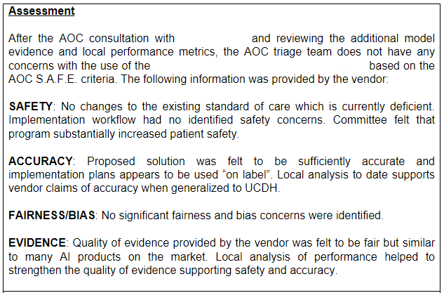
Figure 1: Example of a S.A.F.E. assessment that is part of an AOC decision.

Through the evaluation process, the AOC provides resources for specialized biostatistics or data science support to aid in the creation, understanding, validation, and implementation (or even decommissioning) of an AI model. The committee has created a transparent, informative and educational process to articulate the potential risks as well as support the institution with guidance to drive innovation and improve patient outcomes.

While it is difficult to put a standardized structure and process around the ever-evolving industry of healthcare AI, the need to do so is imperative as the use of this technology is growing exponentially, especially with the popularization of generative AI. Without clear boundaries to manage this deluge, health care organizations run a significant risk when implementing AI. As a learning health system, UC Davis Health encourages innovation and research, and the AOC S.M.A.R.T and S.A.F.E evaluation framework is a transformative methodology by providing a clear pathway for the responsible development of AI and maximizing the benefit to the patients and communities we serve.

