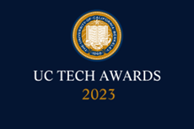
UC Tech Awards 2023 Candidate
Category: INNOVATION + OPERATIONAL EXCELLENCE
Name: MyUCSDHealth
Number of people: (8 + other form MyChart Team and Web Team)
Location: UC San Diego - Health

- Person submitting the application/nomination
  - Benyam Alemu Sood, Mobile Applications Developer, Department of Information Services, Staff
  - Email address: balemu@health.ucsd.edu
  - The name of your organization: UC San Diego Health

- Award category – INNOVATION

- Name of person, name of the team, or name of the project to receive the award – Benyam Alemu Sood, Jeffrey Engel, Marc Sylwestrzak, MyChart Team and Web Team

- All project team members

ALL below are Staff, from UC San Diego Health, Department of Information Services

Name: | Title: | Email address:
Benyam Alemu Sood | Mobile Applications Developer | balemu@health.ucsd.edu
Jeffrey Engel | Applications Programmer | jeengel@health.ucsd.edu
Brittany Partridge | Virtual Care, Technical Lead | bspartridge@health.ucsd.edu
Kimberly Noumi | Manager of Ancillary Applications | knoumi@health.ucsd.edu
Derrick Edwards | Interim Manager of Web Team | dpedwards@health.ucsd.edu
Marc Sylwestrzak | Director of IS Experience and Digital Health | msylwestrzak@health.ucsd.edu
John Torello | Chief Technology Officer | jtorello@health.ucsd.edu
Joshua Glandorf | Chief Information Officer | jglandorf@health.ucsd.edu
MyChart Team and Web Team | Several teammates and roles | MCInternetService@health.ucsd.edu

- Which location was affected by the work? – UC San Diego Health

- Summary: Using mobile applications to deliver exceptional healthcare, expand healthcare access, enhance the patient experience and earn $105 million in telemedicine revenue.

- Narrative (on next page)

MyUCSDHealth - Innovation in Information Technology
Time frame: January 2020 - September 2022

Using mobile applications to deliver exceptional healthcare, expand healthcare access, enhance the patient experience and earn $105 million in telemedicine revenue.

For more information on our business impact, see our other submission “MyUCSDHealth - Operational Excellence”.

Some of our innovations
A crusade against crashes.
We lowered our crash rate per session by 90%. We did this by introducing defensive programming techniques to better handle unknown values. We also introduced Test-Driven Development (TDD) and a comprehensive human verification and validation process.

Making the core experiences faster and simpler.
We redesigned many of our user interfaces. One key focus was to reduce the login process from a 10 second operation to a 2 second operation. We achieved this by adding support for various login mechanisms like TouchID, FaceID and Active Directory login for UCSD employees. We also implemented features like “remember my username” and other usability improvements. See Figure 1 on Page 2.

Support for video visits.
We launched a technology upgrade and many operational changes to enable telemedicine. UCSD Health patients can now video call their healthcare providers to conduct virtual appointments, anywhere across the world **. We conducted over 775,000 telemedicine appointments and generated over $105 million in revenue.

Accessibility improvements for blind and low-vision users.
We performed an accessibility audit to see how people of various walks of life experience our application. We added support for Apple VoiceOver so our software can read outloud what is happening. We also increased font sizes, button sizes and contrast ratios.

Enhanced COVID-19 features.
We added support for SMART Health Cards on the Login screen. This allows users easy access to their vaccination and booster status, so they can show proof of their vaccinations at airlines, sporting events, workplaces or any other required locations. We added this feature using our EMR vendor’s code library.

Adding the latest and greatest technologies.
We added numerous features such as Push Notifications for sending dynamic messages to all of our users, Deep Links to customize our app experience based on a text or email received, Analytics measurement and many more improvements.
Figure 1: Key redesign - Changes to the Login Screen

2020 version:  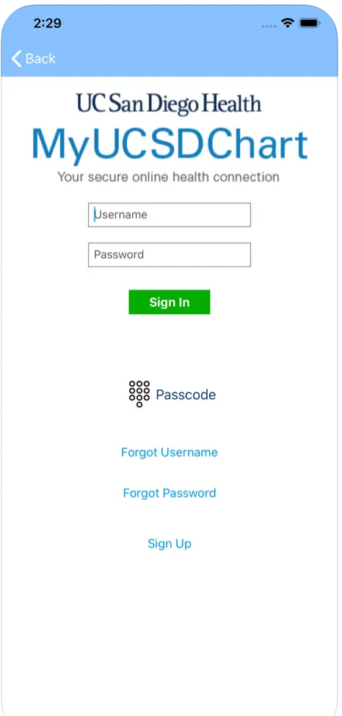 | 2022 version:  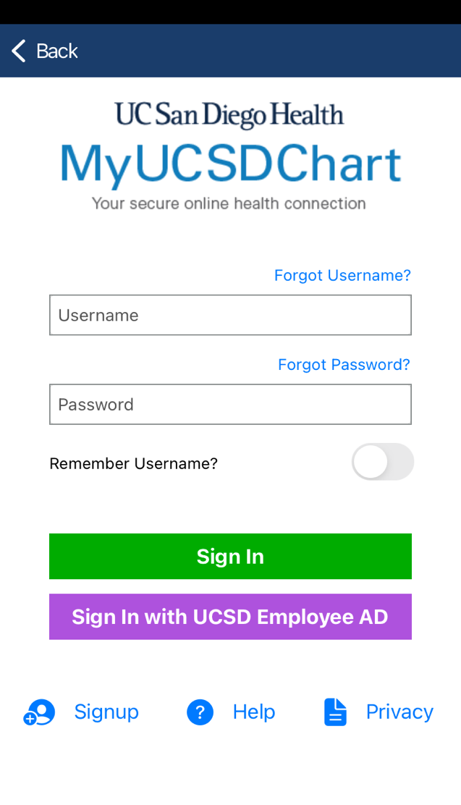

Notice the much wider buttons and fields. We doubled the size of our forms and buttons.

** UC San Diego Health Policy stipulates patient compliance with approved clinic requirements; some limits to patients' physical location for telehealth do apply. *

