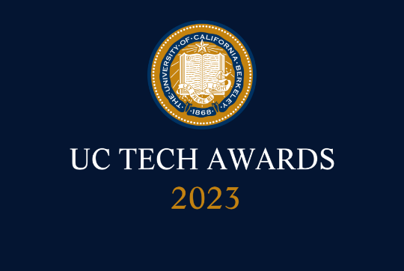
UC Tech Awards 2023 Form
Category: DESIGN
Name: Nan Jiang (INDIVIDUAL)
For: redesigning the WarnMe system
Number of people: (1)
Location: UC Davis
- Person submitting the application/nomination
  - Nan Jiang, Applications Programmer, UCDavis/IET, staff
  - Email address: nanjiang@ucdavis.edu
  - The name of your organization: UCD

- Award category Design

- Name of person, name of the team, or name of the project to receive the award Nan Jiang

- All project team members - if applicable (n/a).

- Which location was affected by the work? (the name(s) of the organization affected)
UCDavis

- Summary: My work in redesigning the WarnMe system exemplifies the qualities recognized by the Design Award. My achievements in tackling complex design challenges, making a significant impact on the user experience, and advancing the university's mission and values make me a deserving recipient of this prestigious award.

- Narrative

I am writing to nominate myself, Nan Jiang, for the Design Award in recognition of my work in transforming the WarnMe system at UC Davis. As an Applications Programmer at the Information and Educational Technology (IET) department, I have applied various design disciplines, including visual design, interaction design, and user experience (UX) design, to improve usability and create a more elegant experience for all users.

Complexity:
The redesign of the WarnMe system was a complex task, as it involved the implementation of a new technology stack, including the Spring framework and Angular while ensuring seamless integration with the UC Davis Online Directory and personal contact information submitted by individuals. The goal was to create a cleaner, more modern user interface that simplifies the process of entering and editing emergency contact information, along with implementing innovative features such as geo-targeting and multi-channel delivery.

Impact:
The new WarnMe system has significantly improved the user experience for faculty, staff, and students at UC Davis. By displaying the input form only when users want to enter or edit contact information, the redesigned system reduces clutter and streamlines the user experience. The modern UI and the additional options for inputting emergency contact information have made it easier for users to update their information and ensure they receive timely notifications during emergencies and other urgent situations. The innovative features, such as geo-targeting and multi-channel delivery, have enhanced the effectiveness and reach of the system.

Mission alignment:
The transformation of the WarnMe system aligns with the university's mission of access, affordability, and excellence by providing an accessible and user-friendly platform for the entire UC Davis community. By enhancing the system's usability, I have contributed to the university's commitment to creating an inclusive environment that serves the needs of all users. The new WarnMe system ensures that vital emergency notifications reach a wider audience, promoting safety and well-being across the campus.

