UC Tech Awards 2023 Candidates
Category: DESIGN
Names: Kelly Chang, Classroom Help Desk Lead and James Fong, AV IT Engineer (2)
For their project name: Designing an Instructor Friendly Classroom Technology Experience (2)
Number of people (2)
Location UC Berkeley

- Person submitting the application/nomination:
  - Kevin Chan, Manager – Classroom Technology, Research, Teaching, and Learning (RTL), UC Berkeley (Staff)
  - Email address: kkc@berkeley.edu
  - The name of your organization: UC Berkeley

- Award category Design

- Name of person, name of the team, or name of the project to receive the award

  - Designing an Instructor Friendly Classroom Technology Experience

- All project team members -
  - Kelly Chang, Classroom Help Desk Lead, RTL, UC Berkeley, staff, kellchang@berkeley.edu
  - James Fong, AV IT Engineer, RTL, UC Berkeley, staff, james_fong@berkeley.edu

- Which location was affected by the work? UC Berkeley

- Summary: Based on both qualitative and quantitative feedback, Kelly Chang and James Fong set about redesigning the touch control interface that is at the center of the UC Berkeley classroom experience. To meet the primary goal of making the technology intuitive to use and invisible to the instructor, Kelly and James used an iterative approach to pilot and get direct feedback on various design choices such as deliberate sizing of buttons and text, use of iconic representation to supplement textual information, and smart default settings to simplify the interaction needed to achieve an outcome.

- Narrative

I am honored to nominate Kelly Chang and James Fong for their exceptional work in redesigning the touch control interface that is at the center of the UC Berkeley classroom experience. Their work will have a significant impact on the university community, including 200+ classrooms, 3,000+ instructors, and 50,000+ students per year.

The primary goal of the redesign was to make the technology intuitive to use and invisible to the instructor. Through an iterative approach that included soliciting feedback from instructors after each iteration, Kelly and James were able to pilot and implement design choices that significantly reduced the time spent setting up technology and enabled instructors to focus on instructional time.

The project timeline spans May 2022 to August 2023 and included six design iterations, an agile approach, and a limited pilot that is progressing to full rollout. New iterations were developed during 2022 Summer Session and 2022/2023 Winter Break, with an initial rollout in six rooms during Fall 2022 semester. The rollout expanded to 32 rooms for Spring 2023 semester and will conclude with the primary rollout during Summer 2023.

Some of the improvements included deliberate sizing and legibility, such as enlarged button size according to importance and larger text for reduced vision, iconic representation to supplement textual information, consistency to help instructors ID cables when they ask for help, and forgiveness through programming that allows instructors to make mistakes.

The measure of success for this project is in the percentage of tickets related to clients having difficulty in operating classroom technology, which dropped from 54 (Spring 2022) to 31 (Spring 2023) in the 32 rooms with the updated design.

Kelly Chang and James Fong's work has significantly impacted the UC Berkeley community and demonstrated their expertise in user-centered design. I strongly recommend them for the UC Tech Design Award.

Touch Panel Home Page – Old Design
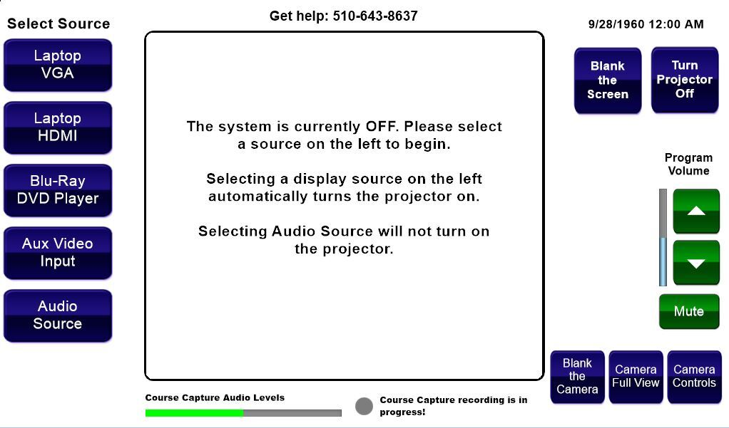

Touch Panel Home Page – New Design

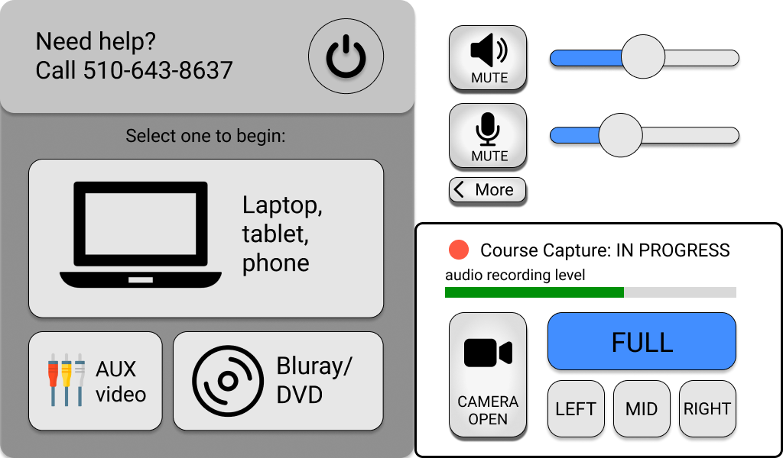

Design concepts and consideration on home page
- Deliberate sizing and legibility: enlarged button size according to importance and larger text for reduced vision
- Iconic representation: pictures supplement meaning to text
- Recognition over recall: design for recognition with pictures rather than recalling button label or location

Touch Panel HDMI Source Selected – Old Design
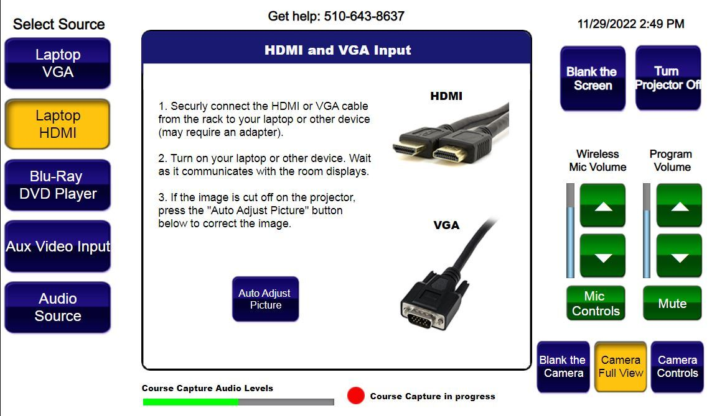

Touch Panel HDMI Source Selected – New Design

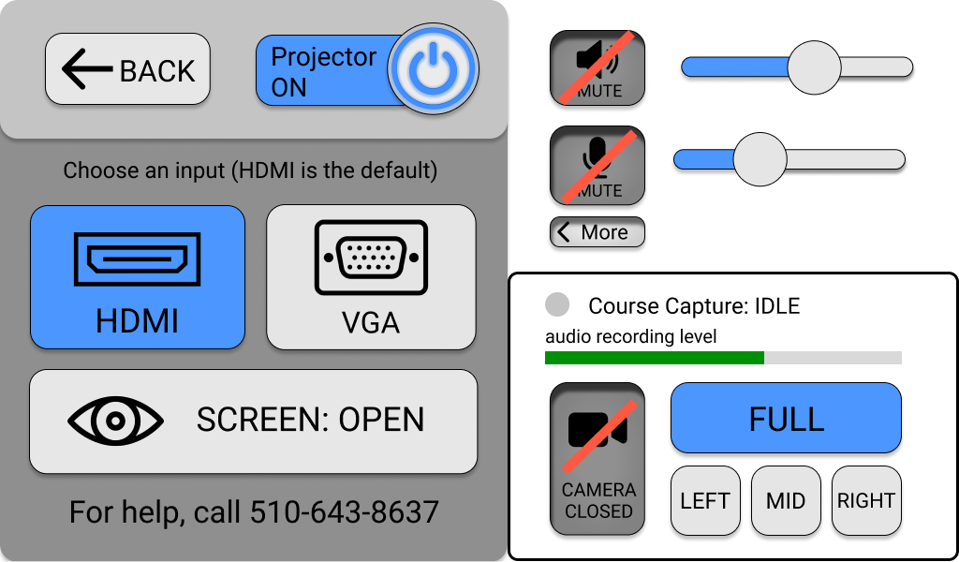

Design concepts and consideration on HDMI source selection page
- Consistency: icons for HDMI and VGA connection help instructors identify cables when speaking with the help desk
- Forgiveness: programming allows instructors to make mistakes
- Simplify the User Experience: programming smart defaults (e.g., HDMI source input for computer device projection) simplifies user interaction
- Hierarchy: organization guides instructors through a sequential order of touch panel interaction

