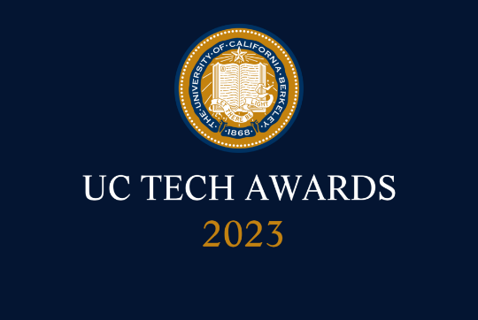
UC Tech Awards 2023 Candidate
Category: DEI LEADERSHIP
Name: Leiyah Shan, Director of UC San Diego Health PHSO Practice Affiliations and Epic Community Connect
Number of people: (1)
For: VIBRANT-IT ERG is the first employee resource group dedicated to serving the needs of women of color in technology at UCSDH.
Location: UC San Diego Health
- Person submitting the application/nomination
  - Melinda Battenberg
  - Email address: mbattenberg@health.ucsd.edu
  - The name of your organization: UC San Diego Health

- Award category DEI Leadership

- Name of person, name of the team, or name of the project to receive the award
Leiyah Shan, Director of UC San Diego Health PHSO Practice Affiliations and Epic Community Connect

- All project team members - if applicable All are staff
  - Leiyah Shan, Director of UCSDH PHSO Practice Affiliations and Epic Community Connect, ljshan@health.ucsd.edu
  - Marlowe McCray, IS Director of Finance and Human Resources, mamccray@health.ucsd.edu
  - Robin Nathan, Director EHR/PMS Implementations, rnathan@ucsd.edu
  - Andrea Cerda, Program Manager, Business Operations, acerda@ucsd.edu

- Which location was affected by the work? (the name(s) of the organization affected)
UC San Diego Health

- Summary: VIBRANT-IT ERG is the first employee resource group dedicated to serving the needs of women of color in technology at UCSDH. Its mission aligns with the JEDI work led by aCMO for Health Equity and EDI. We aim to allow each member to have a voice, feel supported and to know their potential and accomplishments are seen and celebrated.

- Narrative
VIBRANT-IT was established by a small group of women of color in the Information Service department at UC San Diego Health (UCSDH) in July 2022. Leiyah Shan, Marlowe McCray, Robin Nathan and Andrea Cerda saw a need to help women of color and self-identified minority colleagues find their voices and feel supported by each other in IT and in the health system. The VIBRANT-IT Employee Resource Group (ERG) was coached and sponsored by Crystal Cene, MD, Chief Administrative Officer, Health Equity, Diversity and Inclusion and Associate Chief Medical Officer, Health Equity at UCSDH as well as Amy Sitapati, MD, Chief Medical Information Officer for Population Health and Information Services. We also received generous support from Frank Silva, Associate Vice Chancellor for Equity, Diversity, and Inclusion at UC San Diego, and Josh Glandorf, Chief Information Officer at UCSDH.

Our ERG charter includes the following mission and scope:
- Mission: to bring the unique voices of our diverse teammate communities into the conversations about equity and inclusion at UCSDH Information Services​.
- Scope of work includes:
  - Reinforcing UCSD system’s mission, values, and strategic direction pertaining to JEDI (justice, equity, diversity and inclusion);
  - Developing and implementing strategies for hiring, retaining, and promoting a diverse workforce.
  - Strengthening relationships within the local diverse communities;
  - Strengthening and diversifying employee contacts and network;
  - Empower under-represented employees, especially women of color (WOC), to express their voices and find personal/professional growth.

At this time, there is very little visible demographic data at UCSDH at a department level to help establish the population of women who may identify themselves as people of color or minority. Being the first ERG for the WOC population at UCSDH, recruiting for membership was challenging. We grew from a small ERG of about eight women to now over 30 women and men from both within the IS department and across UCSDH, which has been an increase of over 200%.

As we were establishing the ERG, we learned about behaviors and certain cultural norms at work that are not conducive to building an environment of inclusivity and belonging. To help our volunteer facilitators feel confident in conversing about difficult topics, holding a safe space and potentially needing to mediate conflicts, we engaged NCRC (National Conflict Resolution Center) for the training the ERG facilitators and advisors needed. We also gained the support of the executive leadership in IS and across the health system and ensured they received the same training. Our ERG team coordinated training from NCRC on Culture, Communication and Conflict Resolution for the group of volunteer facilitators as well as four executives and four directors in IS and the health system, including our Associate Chief Medical Officer (aCMO), Chief Medical Information Officer (CMIO), Chief Information Officer (CIO) and Chief Technology Officer (CTO). The training totaled about 120 person-hours. During the training, our CTO, John Torello, shared that talking about EDI is not easy in IS and taking the right actions is even harder. However, the best first step one can take is simply admitting this is going to be challenging work.

In 2023, our success will be measured in membership growth and the number of support sessions hosted. In the past few months, we have held three sessions on topics including: Why a WOC ERG is needed; How to Establish a Sense of Agency; Overcoming Challenges through Building Resilience. Leiyah Shan and Marlowe McCray also had an opportunity to present the ERG’s feedback on our current work cultural norms that leave much to be desired to the IS Senior Leadership Team to raise awareness and seek actions. We received support from our CIO and CTO as they have shared the journey since the ERG was founded. There will be two upcoming sessions in May and June 2023 on “Finding Joy at Work and in Life” and “Navigating Work-Place Communications.”

In the coming years, we will extend our scope of work to community outreach at local colleges, universities and possibly even high schools to encourage young women and especially WOC individuals to pursue studies and careers in STEM fields. UCSDH is an organization rich in minority women talents. We plan to tap into the clinical and operational WOC talents here in the outreach work in hopes to highlight the work WOC perform in our organization, and to increase the diversity of our recruitment pools for the various career opportunities at UCSDH.

