UC Tech Awards 2023 Candidate
Category: DEI LEADERSHIP
Name: MyUCLA Voter Registration System (6)
Number of people: (6)
Location: UCLA
- Person submitting the application/nomination
    - Sultan Jinnah, IT Services, UCLA (Staff)
  - Email address:
    - sjinnah@it.ucla.edu
  - The name of your organization:
    - UCLA

- Award category
  - Innovation

- Name of person, name of the team, or name of the project to receive the award
Project MyUCLA Voter Registration System
Making it easier for UCLA students to register to vote in less than 90 sec

Submitter Sultan Jinnah, Manager, Distributed Technologies, IT Services
(310) 562-0228
sjinnah@it.ucla.edu

Technical Team Sultan Jinnah, Julia Sakowski, Naveen Chinthapally, Charles Paucar, Gevorg Ter-Petrosyan, Stephen Johann

- All project team members - if applicable (Name, title, department, location/organization, and please indicate if they are faculty or staff, along with their email address(s).

- Which location was affected by the work? (the name(s) of the organization affected)
UCLA
- Summary (1-3 sentences synthesizing the longer “Narrative - see below)

The new Voter Registration has been added to the MyUCLA portal application allowing UCLA Students to register or re-register to vote in 90 seconds or less. The State of California and UCLA formed a partnership to build voting registration into a student’s hectic schedules and make it as convenient as possible to improve the percentage of young people voting in elections.

UCLA became the first UC, and one of the first universities in the nation, to offer automatic, autofill voter registration to its students by linking the information through their MyUCLA portal and transfer the data to the CA Voter Registration portal. The application went live April 20, 2021.

The application was designed following WCAG compliance, making web content more accessible for people with disabilities.

Language preferences supported are: English, Spanish, Hindi, Chinese, Japanese, Khmer, Tagalog, Thai, and Vietnamese.

- Narrative
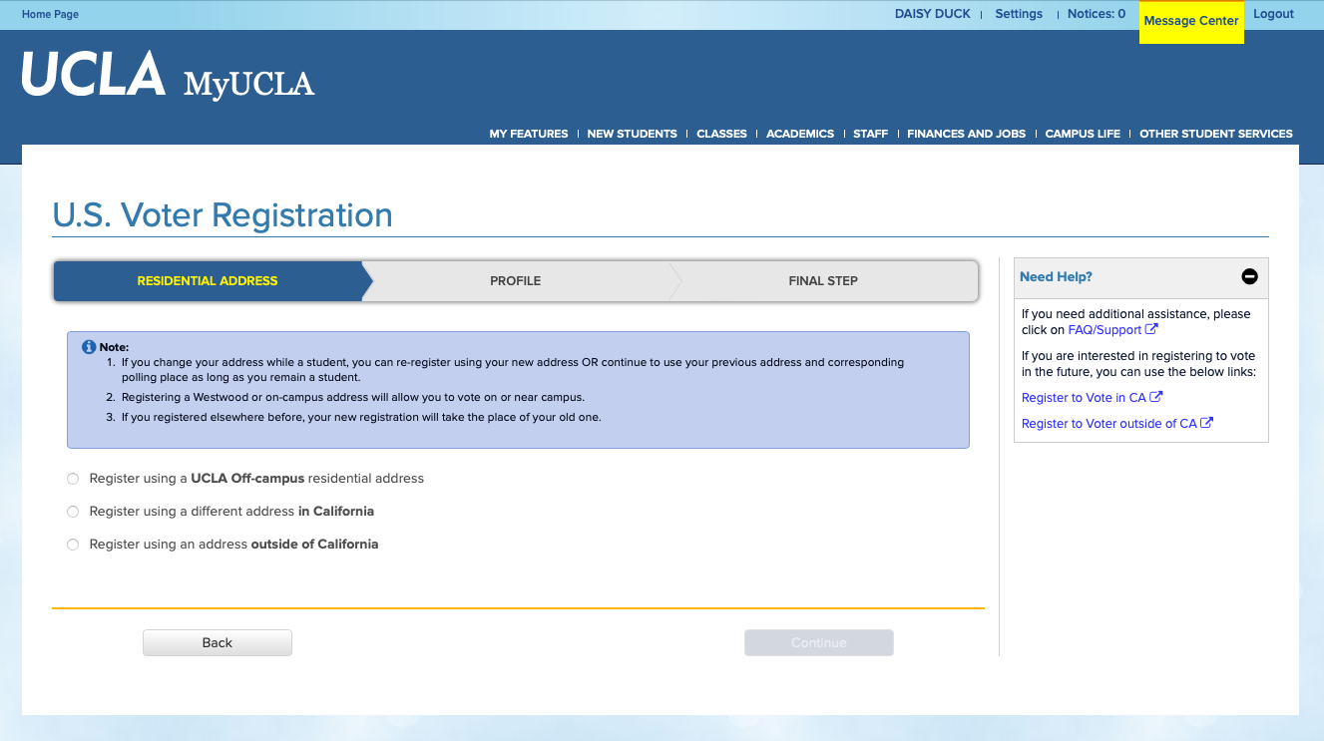

Executive Summary
The new Voter Registration has been added to the MyUCLA portal application allowing UCLA Students to register or re-register to vote in 90 seconds or less. The State of California and UCLA formed a partnership to build voting registration into a student’s hectic schedules and make it as convenient as possible to improve the percentage of young people voting in elections.

Benefits to Students
The are many benefits including empowering students to quickly register to participate in the democratic process of voting for local, state and federal elections. MyUCLA safeguards the student’s information and helps ensure that all registration records are accurate and up-to-date with the California Secretary of State’s office.
Benefits to Society
The Voter Registration System helps ensure that all registration records are accurate and up-to-date so that our elections are free and fair. Furthermore, this well-designed, user-friendly data platform layered on top of MyUCLA has simplified election organization by eliminating costly ballot paper work, removing the process of informing eligible voters by mail, making a physical space available to hold the registration, all previous requirements for students to vote. With connectivity to California Secretary of State’s office, we reduced the paper work errors that often occur in the voting registration and voting process.
The Impact
A common-sense idea for students to register to vote at the same time they are accessing MyUCLA to do many of the university processes that students do on a daily basis.

The State of California and UCLA built a voting registration process into the student’s hectic schedules and make it as convenient as possible to improve the percentage of young people voting in elections. UCLA and the State of California agreed to address student’s scheduling conflicts in order to promote student voting.

The accomplished system goals were:
ACCESSIBILITY: MyUCLA Voter Registration makes registering to vote accessible for more students who can sometimes find it a challenge to keep their registration information updated.
SECURITY: MyUCLA safeguards the student’s information and helps ensure that all registration records are accurate and up-to-date so that our elections are free and fair.
ACCURACY: MyUCLA helps keep the voter information accurate and up to date with the California Secretary of State’s office. This rids the errors and inaccuracies encountered by voters, advocates and campaigns each year.
EFFICIENCY: By replacing outdated paper-based systems with a modern, electronic one, we can eliminate wasteful red tape and save taxpayer money. MyUCLA Voter Registration can also improve efficiency at polling places on Election Day by reducing reliance on same-day registration.

