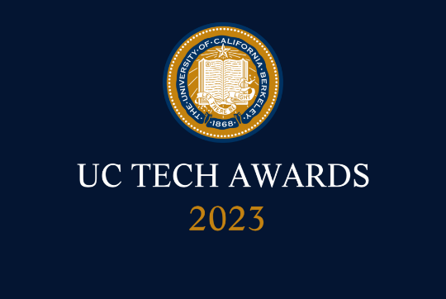
UC Tech Awards 2023 Candidate
Category: SUSTAINED IMPACT + DEI LEADERSHIP
Name: Chris Cabrera Thompson, IT Manager, English & Writing Programs, UCLA College /Humanites, Staff
Number of people: (1)
Location: UCLA
- Person submitting the application/nomination
  - Chris Cabrera Thompson, IT Manager, English & Writing Programs, UCLA College /Humanites, Staff
  - ccthompson@english.ucla.edu
  - UCLA

- Award category (Sustained Impact)

- Name of person, name of the team, or name of the project to receive the award
(R. Chris Cabrera Thompson)

- All project team members - if applicable
(N/A)
- Which location was affected by the work?
UCLA

- Summary
Chris has shown that by exemplifying a spirit of inclusiveness, a passion for supporting a diverse work environment, and supporting faculty research he has built a better environment for faculty, staff, and students throughout our department and more importantly, throughout UCLA and the UC system!

Narrative (1.5-2 pages in Word - up to about 1,000 words- feel free to include visuals).
Chris has been with UCLA since 2015 and his proven leadership, innovation, and creativity in the area of supporting faculty, staff, and students make him an excellent candidate for the UC Tech Sustained Impact Award. Chris joined the Department of English & Writing Programs in 2021 and his leadership skills, innovative nature, and inclusive spirit make him an ideal candidate for this award. Looking specifically at the last year and half, Chris' ability to stay faculty/student/staff focused and implement the right technology has made a difference to the department, to UCLA, and the UC system.

Specifically, Chris brings to our department an inherent spirit of inclusiveness that has been noted by faculty, lecturers, staff, and graduate students. Specifically, Chris spearheaded several critical innovations at English and with these projects created many avenues to bring our diverse department together. Most importantly, Chris was a key participant in creating the new English Digital Media Lab that is now a pillar of the department's Faculty and Graduate student research. His skills in managing the diverse team and ensuring the project was a success was essential. Chris was a key contributor to Professor Heise's, who won the Chancellor's Arts Initiative grant this year for her research in the new Digital Media Lab. Indeed, Chris has successfully been able to work with a wide range of faculty members and is also working on a new RAP lab which will be another milestone for the English Department. The RAP lab and Digital Media Lab are areas that bring faculty and students together for promoting instruction, research, and community. Chris will be presenting at the UC Tech 2023 conference on research and new media tools that are taking shape at English and indeed throughout the UC system.

While at English, Chris mentored and promoted key diverse candidates that were hired and are now performing exceptionally- new UCLA employees that would not have occurred if not for his interest in promoting UCLA values. In fact, his tenacity to see these hires through and his manner of couching the candidates are exemplary. We are a better department for his efforts, his commitment to diversity, and his foresight.

Importantly, Chris has helped improve the delivery of instructional throughout the English and Writing Programs by using his instincts to make the tech work. In 2021, the Writing Programs had limited funding to improve their technology in the classroom instructions. Chris reached out to other departments that were upgrading their tech and was able to deliver used screens from the Chancellor's office that became the instructional tech for the WP classrooms. Also, Chris championed the rollout of DTen Zoom appliances for both the English and Writing Programs department and took the time to train the staff to improve adoption and improve instruction.

At UCLA, Chris has been committed to several groups on campus that promote diversity, inclusion, and professional development. Chris has worked with the UCLA AMG (Administrative Management Group) since 2016 and with several UCLA and UC wide committees that he manages in addition to his daily workload.

The UCLA AMG, supported by Lubbe Levin, Associate Vice-Chancellor of Campus Human Resources, seeks to be an inclusive space on campus that promotes professional development and recognizes staff achievements. Chris was
a member of the board when AMG initiated its first Annual Conference which has been a focal point for campus managers to learn skills managing our diverse workforce. In fact, the AMG Conference has become the largest leadership conference in the UC system. Additionally, since 2017, Chris has been working with the UC AMP group, a UC-wide, committee that brings together professionals throughout the UC to learn and promote inclusiveness and ways to promote the UC workforce.

Chris has demonstrated an inherent ability to work with Faculty, Staff, and Students throughout the department and his interest in promoting our department's diverse mission is noteworthy.

For example, Chris' proven skills in supporting our diverse faculty are greatly applauded and he has gone out of his way supporting our lecturers, staff, and graduate students. Recently, he took the lead on ensuring our events provided not only the technology needed to host faculty members from other universities but also helped the participants feel included into the UCLA community. He graciously helped make the International Global Conference on Iranian Diaspora a success and went above and beyond helping remote and in person faculty members feel included and part of the UCLA community. (The UCLA CNES department recruited Chris after he assisted with an internal English Event on the and Afghanistan post-colonial research.)

Most importantly, Chris is able to bridge the technical with the needs of our faculty members. He was able to ensure that a panel talk highlighting Anti-Muslim Racism, Palestine, and White Supremacy put on by our Department Chair was a success by not only setting up the appropriate technology but also by ensuring that the technology supported the need to provide a safe, open, and inclusive environment for the panel to speak freely and without disruption.

Chris has shown that by exemplifying a spirit of inclusiveness, a passion for supporting a diverse work environment, and supporting faculty research he has build a better environment for faculty, staff, and students throughout our department and more importantly, throughout UCLA and the UC system!

https://dailybruin.com/2022/05/12/english-departments-digital-media-lab-expands-access-to-technological-resources

https://goarts.ucla.edu/news/15-faculty-projects-earn-chancellors-arts-initiative-grants?utm_source=newsroom&utm_medium=referral&utm_campaign=feature&utm_content=headline

https://amg.ucla.edu/current-board/

https://amg.ucla.edu/annual-conference/

https://uc-amp.org/about/

https://www.international.ucla.edu/cnes/event/15895

https://english.ucla.edu/events/anti-muslim-racism-palestine-and-white-supremacy/

