In the web client:
- Click the three lines at the top left of the window.

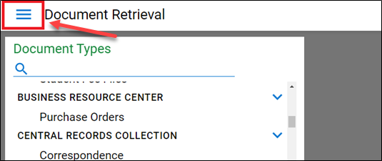

- Click “Document Retrieval” from the drop down if not already selected.
- You will see a column on the left that says your department name, and any other department’s records to which you have access. Your document types will appear under your department name. To search, you will need to click on a document type or types. A blue check mark will show up on the ones you have selected to search.
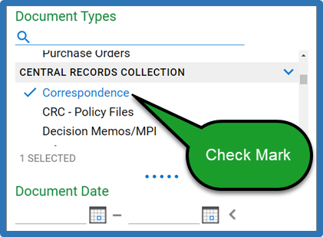

- In the “Search Type” box, you will see the option to search for keywords or for notes. Keywords will search for any descriptive words that have been assigned to your document (we call these words and numbers metadata). For example, employee ID, first name or last name, date, file title, etc. Notes are a post-it-note style feature. You can annotate documents by creating Notes, and you or others can search for them on Notes tab.

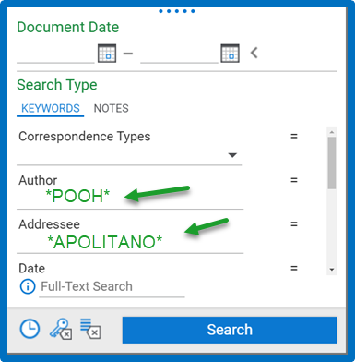

- To search in a key word field, you will need to use asterisks as wild cards. The system can only recognize exact titles, so to search for a part of a field, bracket your search term with asterisks. For example, if you know that the author’s last name is Pooh, but you do not know their first name, you would type *Pooh*, and any documents from someone with the string of letters pooh in their name would show up, including Poohat or Larpooh. This would also help you find a name that was entered with a comma next to it like Pooh, W.
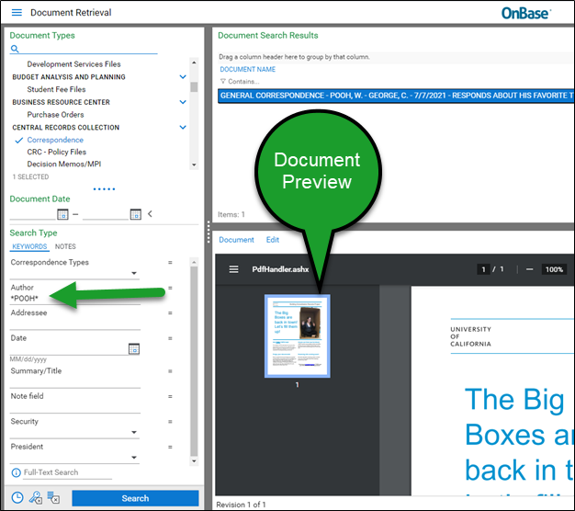

If you click on one of the items in the document search results, you may see a preview of the record. Previews will show up for PDFs or for image files like jpegs, but will not display for Word files, or most other formats. To see a larger image of the item, right-click on the document in the search results, and click “Open in new window.”
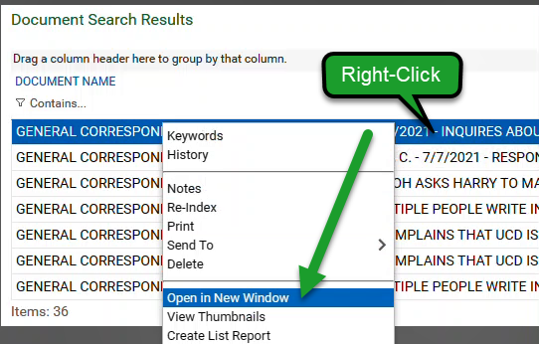
Note: Sometimes a box will pop up saying that you can’t search with asterisks. You can ignore this.
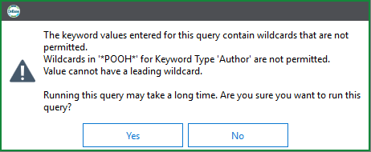

You may also get warnings that your search will take a long time—you can ignore this and run the query anyway.
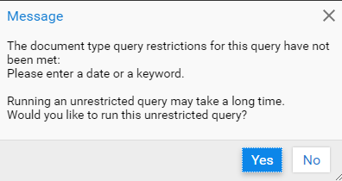
In Unity, you may also get a popup that says that your search cannot be conducted because it would return too many results. If you see this, you will need to narrow down your search parameters. Feel free to contact records management for more help refining searches.

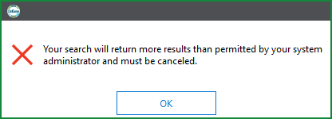

In the OnBase web client, your search will go through even if your search returns too many results. You will see a message on the footer of the results window indicating you should narrow your search.

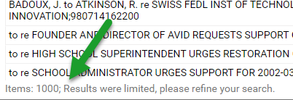

- To search the text of a document, instead of the keywords, you will use full-text search. In full- text search, you will not need to use asterisks. Full-text search is on the bottom of each search type box.
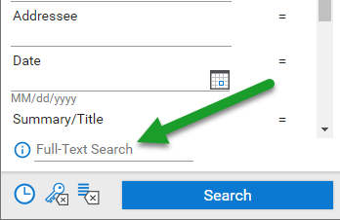

- To clear your search and try another in the same Document Type, click the Delete Keyword button, whose symbol is a Key and a Backspace/Delete icon.

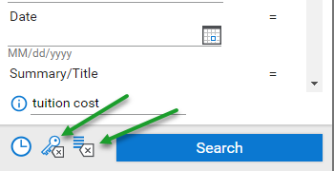

To Clear All Keywords, click the button with Four Lines and a Backspace/Delete icon will take you to a new search entirely, where you will have to select the doc type and all other fields again.
In the Unity Client
- At the top of the Unity client, click the magnifying glass icon labeled “Retrieval.”
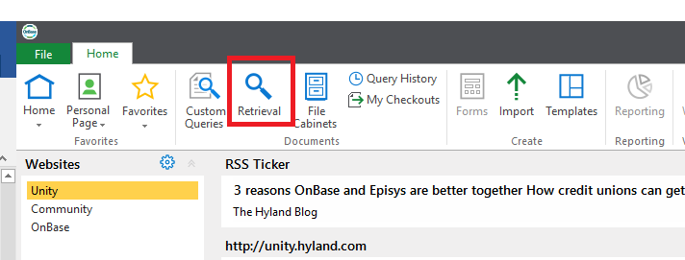
- Follow the same steps as in the OnBase web client instructions. The searching method is identical; the client just looks a little different.

A few helpful tips:
- In the web client, right click on a document in the search results and click “open in new window” to see the document displayed in a larger format. In Unity, the page will pop open in a new window automatically.
- Right click on the documents and click “Keywords” to see the metadata for any document.
- In Unity, click “Query history” at the top of the client to repeat any search.

