# Using the Document Separation tool in OnBase

Note: This can only be done in the Unity Client.

Document Separation can be used to split documents, and to add and delete pages from documents.

## Splitting Documents

1. Open a document. (Please see our other guide on retrieval in OnBase to get more information on this).
2. Note which page you would like to split the document at.
3. Go up to the ribbon and find the phrase “Send to.” Click on the drop-down arrow and select “Document Separation.”

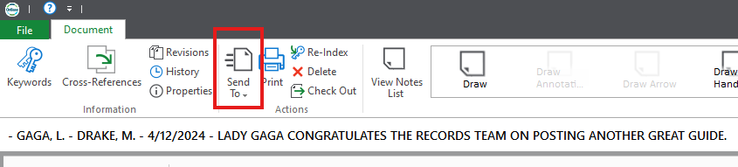

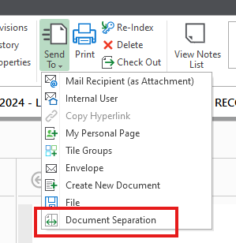

1. Once in the document separation area, go to the number of the page you wanted to separate the document at. If you hover between the two pages to be split, scissors will show up. Click, and the document will be split. Note: the pages will be blurry.

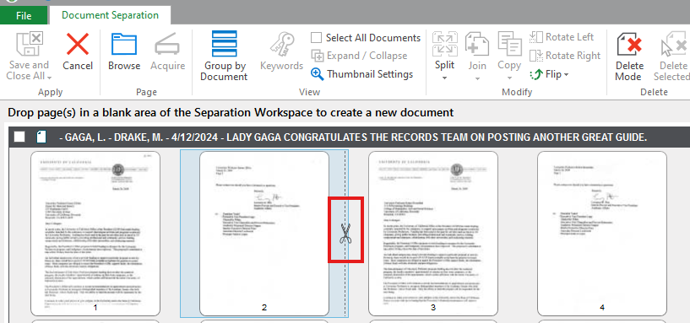

1. After splitting, you will see two documents, or more, if you split multiple times. The second document will have the same metadata on it, unless you choose to change it. Clicking on the “key” icon will pop open another panel to change the information about the document.

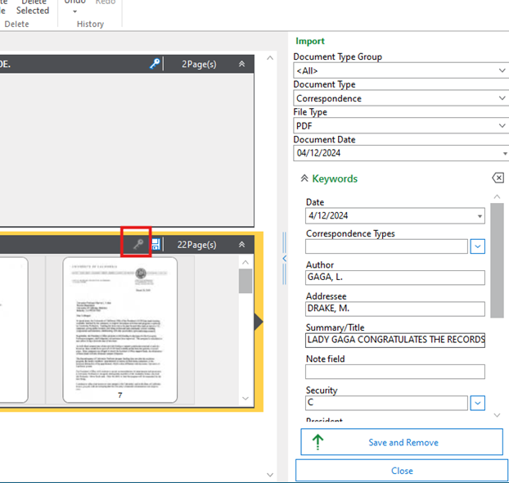

1. Pressing save and remove will save and close the new document, while the original remains open. You can go up to the upper left corner and press save and close all, when you are entirely finished.

## Add or delete pages from a document.

1. Open a document. (Please see our other guide on retrieval in OnBase to get more information on this).
2. Note which page you would like to add or delete the page at.
3. Go up to the ribbon and find the phrase “Send to.” Click on the drop-down arrow and select “Document Separation.”





Deleting a page:

4a.) To delete a page, go to “Delete mode,” in the ribbon. Click on that, and then left click any page for deletion. A large red X will show up on the page. Note: The pages will be blurry.

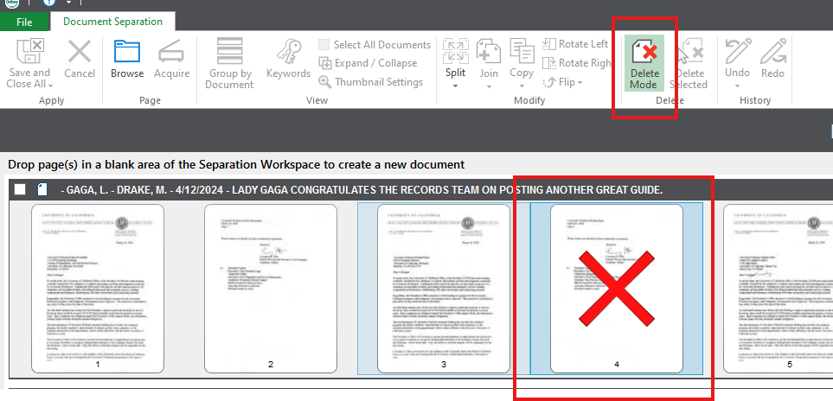

You can undo selecting the page by clicking it again, or by clicking “undo” in the ribbon. The document will not be deleted until you save and close the document.

4b.) When you are satisfied, click “save and close all.” The page(s) will be gone upon your next retrieval of the document.

Adding a page

5a.) To add a page, go to browse on the ribbon to select a page to add to the document. This will open a file explorer page. Note: the new page will have to be an image file. Also, the images will be blurry.

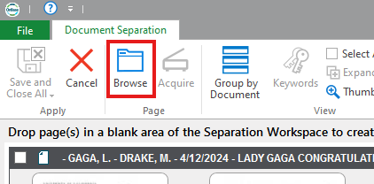

5b.) The new page will show up as a new document. You will need to click and drag it to where you would like it to be in the original document.

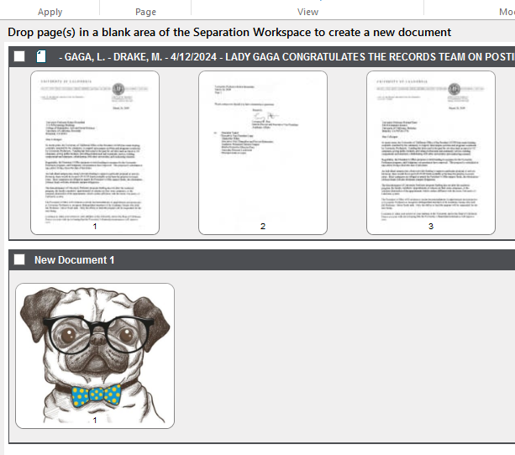

This is what it will look like after the page is dragged in.

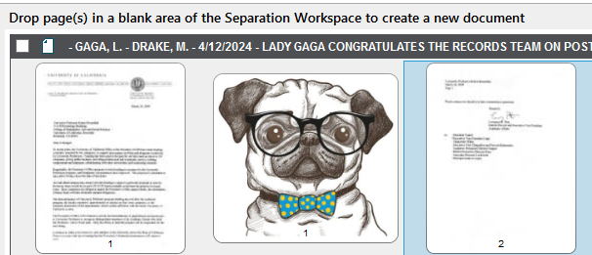

5c.) Press save and close all to save all changes.

**A few tips:**

1. You can click and drag at any time to reorder pages.
2. Using rotate left or right in the ribbon can fix pages that are oriented incorrectly.
3. It may be helpful to click “thumbnail settings,” in the ribbon to make the thumbnails larger or smaller. Unfortunately, the pages will stay mostly blurry.
4. Hovering over a page will make it pop out slightly larger for viewing. It will still be blurry.
5. Each page will have a small number beneath it, to help you find the pages you are looking for.