Note: This guide is for uploading documents one-by-one. If you have a large number of documents to upload, reach out to Records Management (records@ucop.edu), and they will assist you with the upload.

Importing documents using the web client:
- Go up to the three lines in the top left:
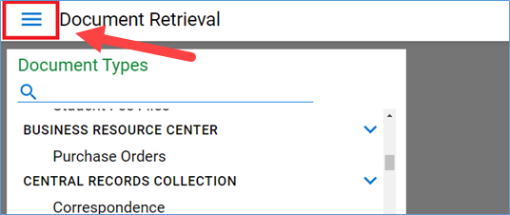

- Click on the three lines, and then scroll down and click Import. If you don’t see import on the list, that means you don’t have permissions to import. If you think that you should be able to import documents, reach out to the records team.

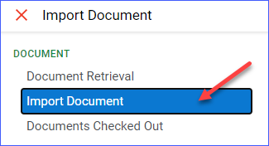

- A box will pop up when you select import. There you will see drop downs for document type groups, document types, file types, a document date, and then the keywords associated with your document. The fields you see will be different than the ones here. Click the Choose File button to select the relevant document with file explorer. Choose your file.
Select your document type group from the drop down and your document type. You do not need to select the File Type, the system will recognize it automatically.

If the file is a photo file or a PDF, you will see a preview on the right. If it’s a Word file or any other type of file, you will not see a preview.
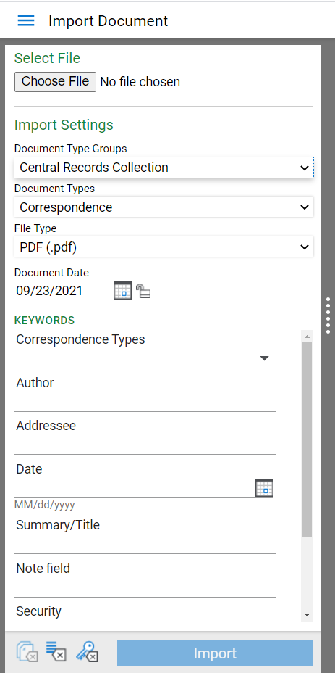
Put in your dates and the relevant metadata, then click Import.
5.) After you import the item, you will see it appear green in the Document Queue, and you will see the message “imported successfully.” You can import up to 5 files at one time using the web interface. After you import five documents, you will need to refresh the page.
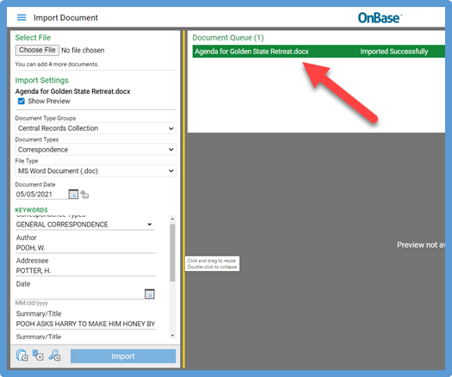

Importing documents using the Unity client
Importing into Unity is much like importing into the web client, it just looks slightly different.
- After loading Unity, look on the top ribbon for the import button.
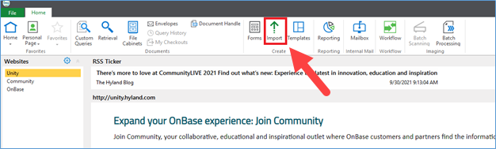

- You will be taken to the import page to upload the document. You will need to click “Browse,” to be taken to your standard Windows file explorer to find the file.

You will see drop downs for document type groups, document types, file types, a document date, and then the keywords associated with your document. The fields you see will be different than the ones here.

Select your document type group and your document type from the drop down.
You do not need to select the File Type. The system will recognize it automatically. You will see a preview of the file on the right for most file types.
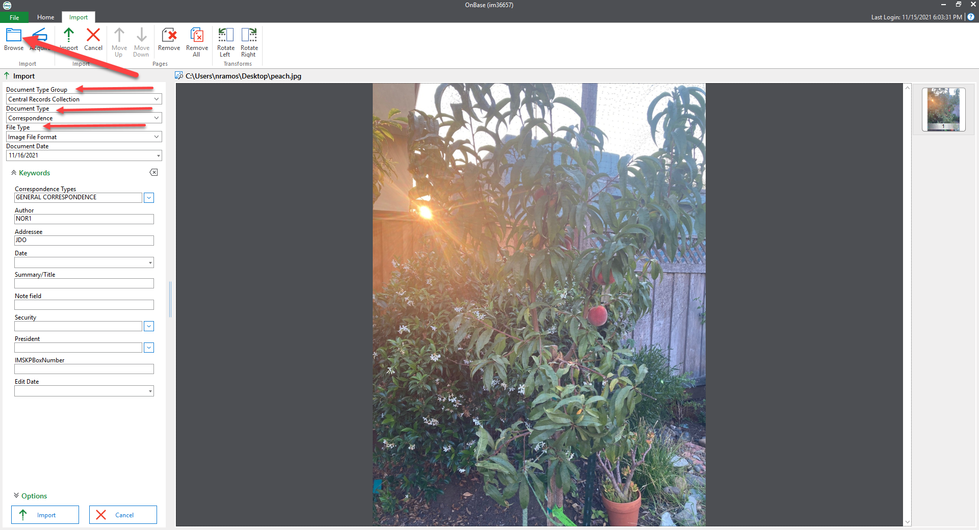
Put in your dates and the relevant metadata, then click import: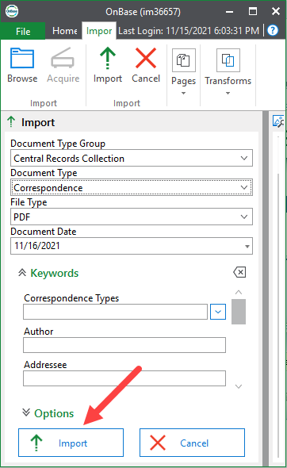

- After you import the item, a box will pop up showing that it’s uploading. After upload, the record will automatically pop up in a separate box. Click open to complete the preview.
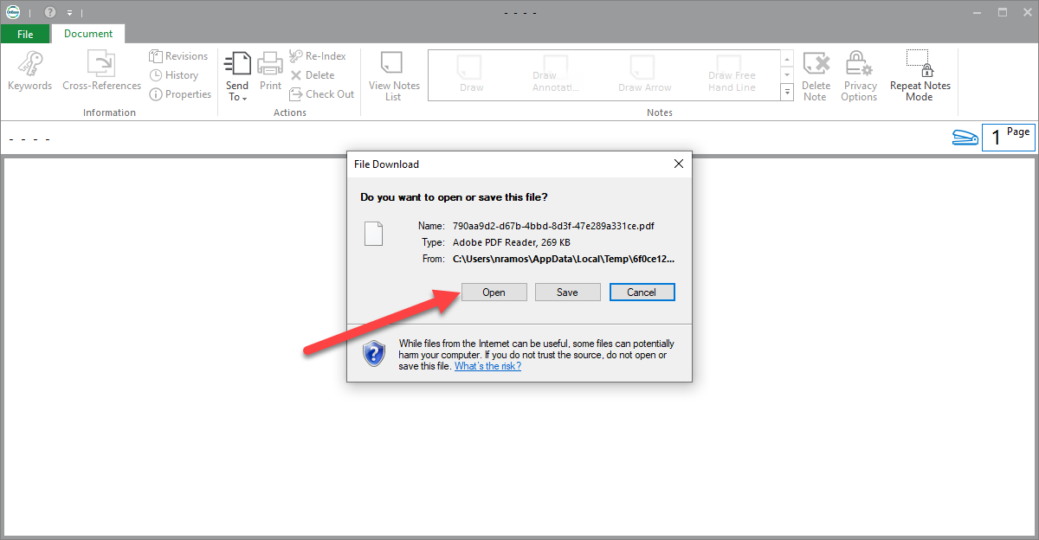
- You can only select 1 file at a time for upload, but you do not need to refresh anything to upload another file.

