Editing Document Keywords in the OnBase web client and the Unity client:
- Find the document you want to edit using the Document Retrieval function:

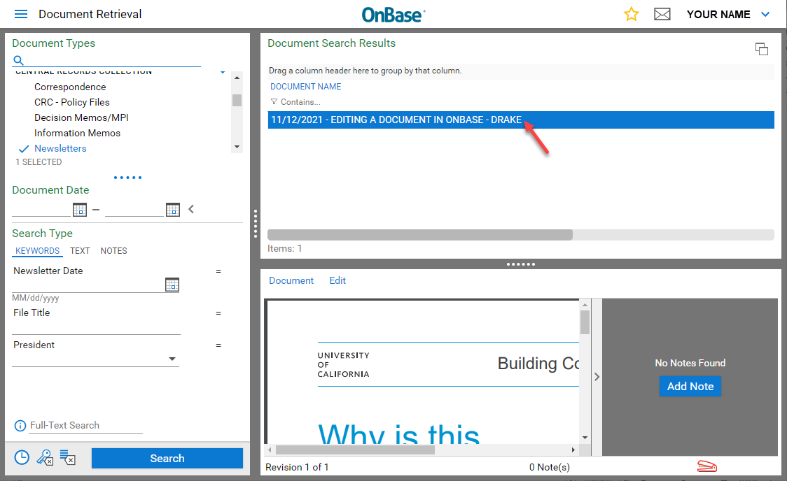

- Right-click on the document and select Re-Index or Keywords. This pop-up will look slightly different in Unity than in the web client. The Re-Index option allows more changes to the document properties than Keywords:

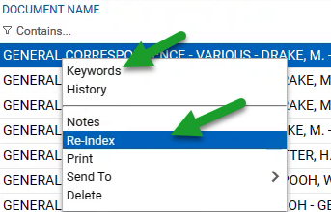
- You will see a screen as shown below. You will only be able to change the Document Type if you have editing privileges. The document types you will see will vary from these examples.

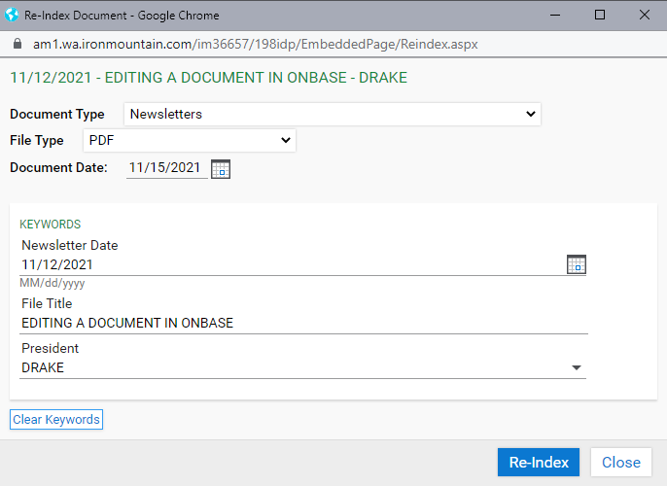

- Once you make changes to the document keywords, select the Re-index button. OnBase will display a message announcing your successful edits.

