Accessing the OnBase Web Client:
- From a recommended browser on a Mac or Windows computer, go to https://am1.wa.ironmountain.com/im36657/211idp
  - We recommend using Chrome, Firefox, Edge or Safari to access OnBase in the web client.
  - Internet Explorer is not recommended.

- Click on the UCOPSAMLPROD button, on the right: Do not use the Username login on the left of the pop-up window. You will get a chance to enter your user info soon!
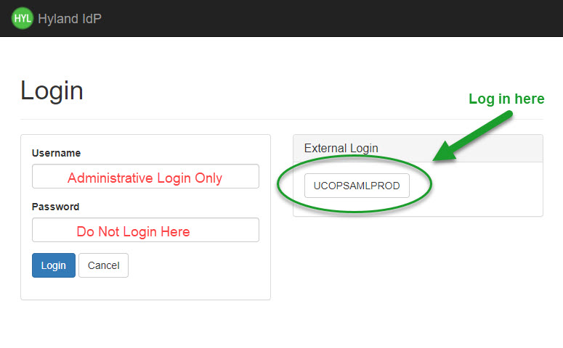

- Proceed through the single-sign-on process. Enter your UCOP credentials and password (this may pre-populate from your browser settings).

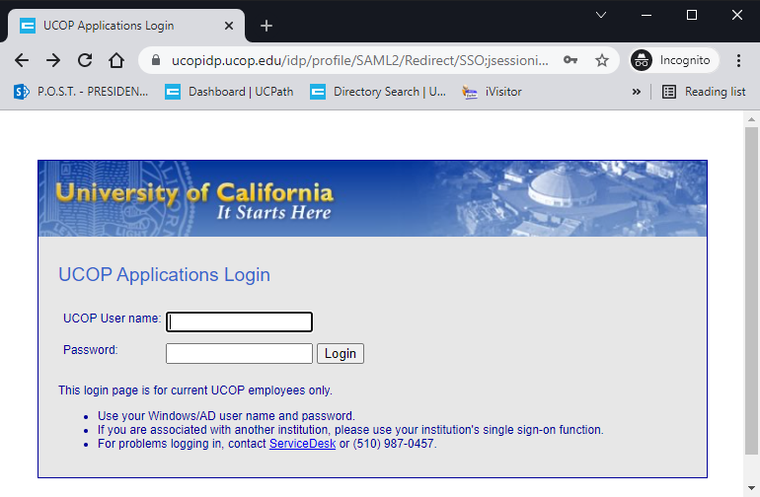

- Access OnBase Web. See an example below of the first screen you will view. Your view will show different Document Types than in this example.

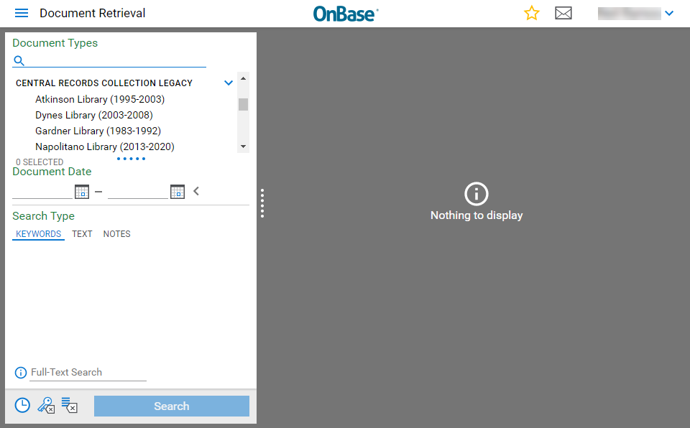
- See below for Unity login instructions.

Accessing the OnBase Unity Client:
- From your UCOP Windows computer only, go to your taskbar and type in “Unity”. Unity is only available for PCs, not Macs.

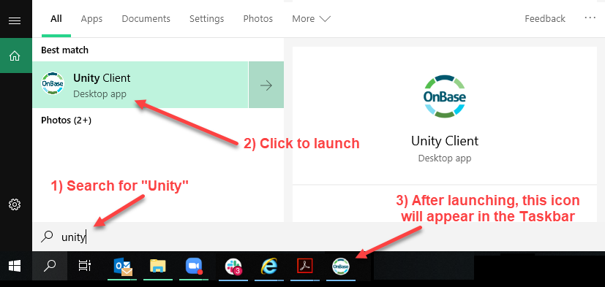

- Click on the UCOPSAMLPROD button, you may have to scroll down: Do not use the Username/Password login on the upper part of the pop-up window.

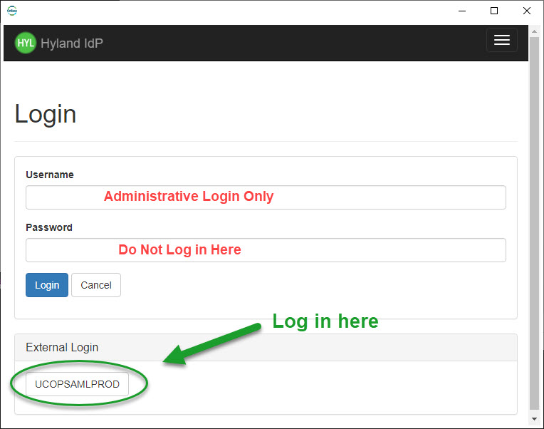

- Unity will take a few moments to load. The first time you open Unity the loading time may be over 30 seconds. Enter your UCOP login credentials. This will not auto-populate with saved user name and password, as this is not a web browser.

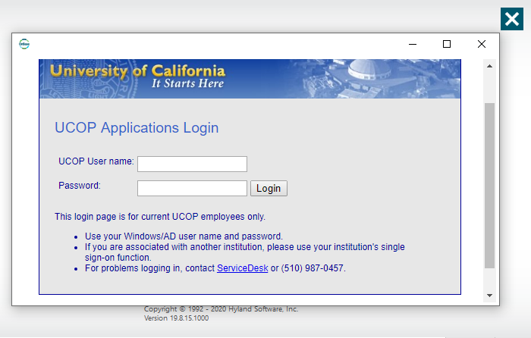

- The initial view of OnBase Unity should look like the image below. You can save a shortcut on the taskbar or desktop for future access.

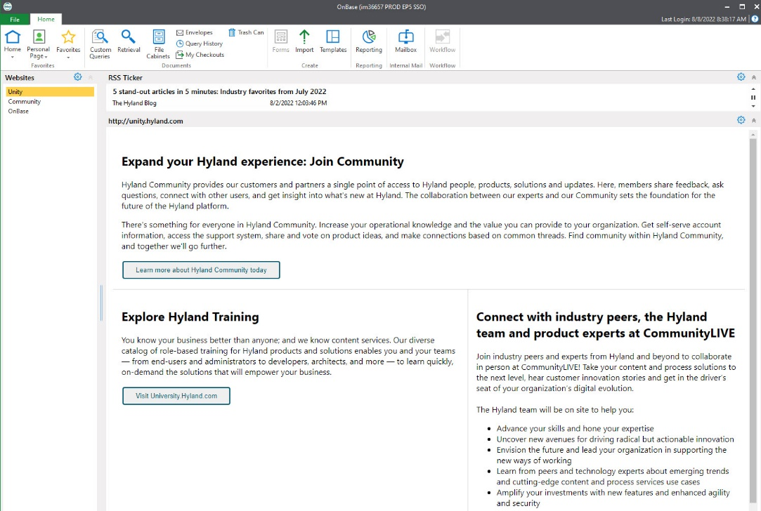

- See other guides to explore retrieving, editing and uploading documents.

