Access the UC Learning Center
- Open an internet browser.
- Type http://www.ucop.edu/ucoplearningcenter/ in the Address box and click Login.
- Enter your UCOP User name and password and click Login.

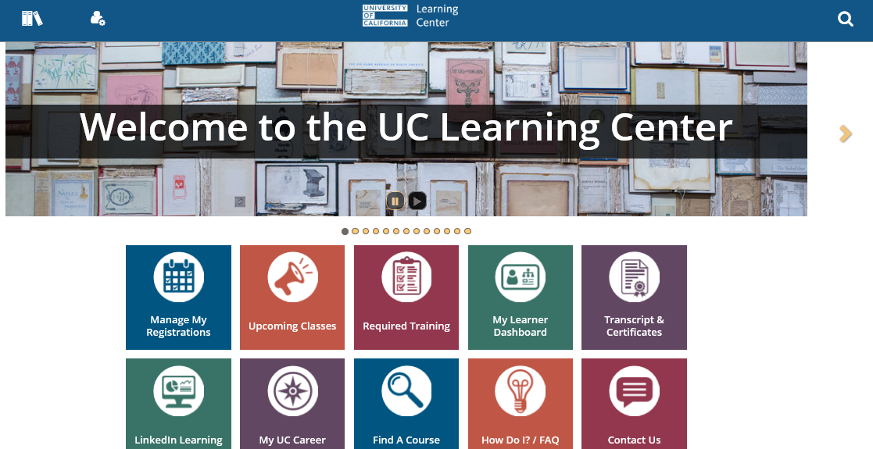

Search for Activities by name
- Click Magnifying Glass
- Or Click the Find a Course icon.
- Enter your search criteria in the Search box.
- lick All Results.


Browse the Library of courses
- Click the Library
- Click a category name.
- Browse the section to locate the activity.

Register for a Class
- Search or Browse for the course you want
- Click the down arrow next to select.
- Click register.

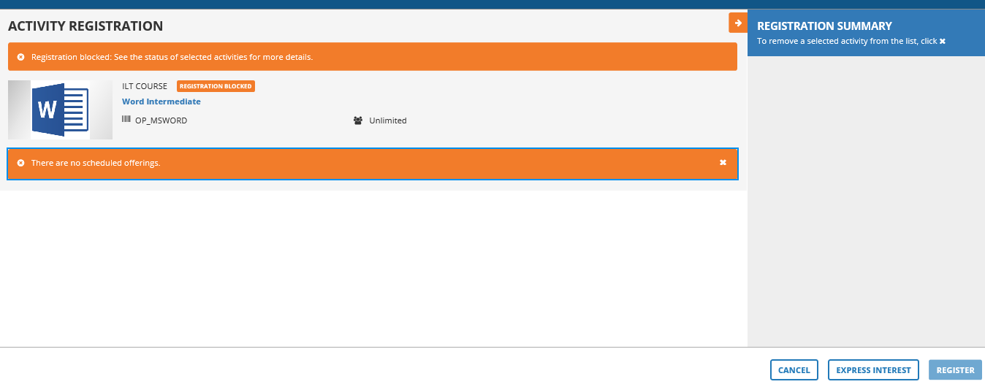

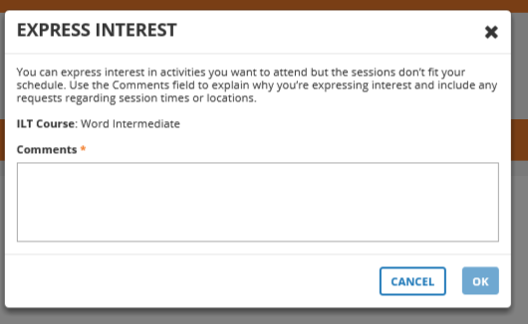

Express Interest
- If there are no Sessions available – click Express Interest – this will create a list of employees interested in the class.
- Add a comment to the box and hit OK
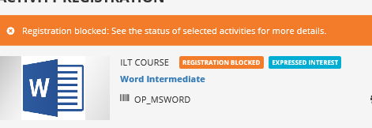
- You will now see a status update on the course

