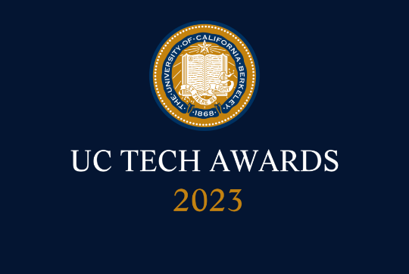
UC Tech Awards 2023 Candidate

Category: INNOVATION
Name: UC San Diego IT Asset Management Program
Number of people: (5)
Location: UC San Diego
- Person submitting the application/nomination: Kenny Li, Business Systems Analyst, Information Technology Services, UC San Diego, Staff
  - Email address: kenny.li@ucsd.edu
  - The name of your organization: UCSD ITS – Document & Case Management

- Award category INNOV

- Name of person, name of the team, or name of the project to receive the award

UC San Diego IT Asset Management Program

- All project team members - if applicable
  - Kenny Li - ServiceNow team Endpoint Management team Bookstore, Staff
  - Paul Yellin – Business Systems Analyst – ITS, UCSD, Staff
  - Saul Garza – ServiceNow developer – ITS, UCSD, Staff
  - Ben Wong – ServiceNow developer – ITS, UCSD, Staff
  - Sean Jones – ServiceNow developer – ITS, UCSD, Staff

- Which location was affected by the work? (the name(s) of the organization affected)
  - UC San Diego
  - UC San Diego Information Technology Services
  - UC San Diego Bookstore

- Summary (1-3 sentences synthesizing the longer “Narrative - see below)
  - We developed a brand-new integrated information system in ServiceNow that automates the collection and maintenance of IT asset and CMDB information from cradle-to-grave, giving us full insight into our entire computer hardware estate. In addition, we consolidated our hardware sourcing with the UCSD Bookstore, eliminating the need to maintain our own inventory and improved hardware availability for our customers. This program replaced a patchwork system of emails, tickets, phone calls, ad-hoc inventory rooms, spreadsheets, bespoke databases, and duplicative work. Our efforts resulted in easy reporting into our asset estate, enabling our agents to focus on more valuable tasks, and strengthened the collective bargaining power of the university with hardware vendors.

- Narrative (1.5-2 pages in Word - up to about 1,000 words- feel free to include visuals). This is a descriptive narrative about the person/team (and their portfolio of work - or the initiative/project - in terms of the selection criteria for that award. Please include:
  - Description of the initiative(s) or portfolio of work that supports the nomination based on the award description.
  - How they meet selection criteria (complexity, impact, and mission alignment).
  - How their success is measured/quantified.
  - The time during which the work was done.
For more information to help you create this narrative, please scroll below to learn more about each award category.

