APPLICATION FOR THE 2009 LARRY L. SAUTTER AWARD
UNIVERSITY OF CALIFORNIA

PROJECT TITLE:
Integrated UC Davis-wide Electronic Document Management System (EDMS)

SUBMITTER(S):
Radhika Prabhu
Manager, Project Management Office
206 University Services Bldg,
1441 Research Park Drive,
Davis, CA 95618
rprabhu@ucdavis.edu
(530) 754-6805

Mike Kuhner
Implementation Lead, Project Management Office
206 University Services Bldg,
1441 Research Park Drive,
Davis, CA 95618
mjkuhner@ucdavis.edu
(530) 757-8522

PROJECT LEADER(S) AND TEAM MEMBERS:
Mike Allred Project Sponsor (Campus)
Bill McGowen Project Sponsor (Medical Center)
Radhika Prabhu Project Manager
Michael Kuhner Implementation Lead
Peter Choi Operations Programmer
Katie Stevens Operations Lead
Jonathan Keller DaFIS DS Architect
Alex Matsis DaFIS DS Developer
Anne Marie Ross Campus Accounts Payable Subject Matter Expert
Ross O’Brien UCDHS Accounts Payable Subject Matter Expert
Cindy Jones Campus Payroll Subject Matter Expert
Cecilia Labrado UCDHS Payroll Subject Matter Expert
Ann Steele UCDHS Finance Subject Matter Expert
Eben Sutton Project Advisor

PROJECT SUMMARY

The EDMS project provides an enterprise-wide document imaging solution for a variety of UC Davis campus and Health System divisions, departments, and business offices. While each implementation has its unique needs, the core goals of each solution include:
- Ability to scan and index paper documents
- Provide desktop retrieval with enhanced search capabilities
- Integrate with existing business information systems
- Improve document security and safety
- Reduce the dependency on paper and paper storage

Using industry-leading software, such as Kofax Capture and Oracle IBPM, custom database and web API integrations, and stringent implementation methodologies, the project has successfully brought on-line five departments in its first year of operation – with an additional seven to ten expected in the next year.

PROJECT DESCRIPTION

Background

The UC Davis Division of Accounting and Financial Services (A&FS) and the UC Davis Health Services (UCDHS) collaborated to procure and implement a fully scalable, state of the art, electronic document management system (EDMS). The solution needed to be capable of meeting the long-term strategic needs of both divisions, while allowing a multi-phase approach for full implementation. Starting with Accounts Payable departments at both divisions, it was anticipated that the project would progressively add departments over a five year implementation period.

Key needs to be addressed by the project include:

- Store and manage the large volume of information received and retained by various departments
- Improve upon the environmental goals of the UC community
- Streamline access of existing information, including the ability to seamlessly link documents from the EDMS to the existing finance decision support environment
- Add efficiencies to the current business processes
- Provide the ability for distributed document capture across campus departments
- Enable end-users to access and annotate documents securely and safely
- Decrease dependency on paper records and paper document storage devices and services
- Reduce the number of lost and/or misplaced files and documents\
- Consistently destroy records in accordance with UC records disposition schedules
- Enable multiple versions of scanned documents and MS Office documents
- Train and develop in-house resources capable of deploying and supporting the system

After a multi-year information gathering and selection period, it was decided to implement two best-in-breed software packages: Kofax Ascent Capture and Oracle IPM (formerly named Stellent). These components would be implemented by a combination of UC Davis in-house resources and a software integration specialist ImageSource, Inc. After the initial departments were successfully using EDMS, the in-house team would take over full responsibility for deployment and maintenance of the system.

Implementation Methodology

A critical element of the project’s success thus far has been employing a strict project implementation methodology. Developed jointly by the UC Davis A&FS Project Management Office and consultants from ImageSource, the methodology below ensures that during each implementation the department’s unique processes and goals are analyzed and considered before customizing and deploying their EDMS solution. This is especially critical considering the enterprise-wide deployment of the software and the centralized support and maintenance models in place. Implementation life-cycle is averaging three months from kick-off to go-live.

Phase | Description
1.0  Develop Charter | Discovery, interviews, analysis and documentation to produce the Project Charter. During this phase, the goals and scope of this implementation will be determined and agreed upon. The charter document will give clear direction for the more detailed analysis and design in Phase 2, as well as any necessary hardware or software procurement recommendations.  Deliverable: The outputs are the Project Charter and Procurement Recommendations.
2.0  Analysis and Design | More detailed discovery, planning and design. More interviews in greater detail with the same SME's from the Charter meetings. Coordination with other technical resources if integration is required. Possible proto-typing of the proposed system. The resulting documentation will be a detailed plan for building all aspects of the EDMS solution.  Deliverable: The output is the Project Plan.
3.0  Build and Install | During this phase, the EDMS team and other technical resources will install hardware and software, configure Kofax and Oracle as per the Project Plan and write any custom integration code. Each component will be individually tested.  Deliverable: The output is the fully functional system, ready for end-user acceptance testing
4.0  Training and User Testing | This phase will be used to train the department’s power users. Once trained, the power users will conduct complete end-to-end testing to ensure that the designed system meets the expectations outlined in the Project Plan. Any necessary changes will be immediately implemented and re-tested.  Deliverable: The output is the fully functional system. Also, departments will receive a detailed user manual for the new EDMS processes.
5.0  Go-Live and Support | Once the new system has been migrated to Production, the EDMS team will be available to support end-users with production issues. Once this phase has ended, support will transition to the EDMS Help Desk. Lastly, the Project Plan will be updated to reflect any changes during Testing and a Project Closure meeting will occur to finalize the project.  Deliverable: A live system. The final Project Plan with the production configuration documented.

Accounts Payable Implementation

Summary
The UCD and UCDHS Accounts Payable offices implemented a shared solution of EDMS to manage their large volume of invoice retention. On average, the offices handle roughly two thousand invoices daily. These invoices are delivered to the departments in paper format, and required considerable time and space to manually file. Since AP is the department of record for invoices, the departments who originated the invoices consistently made requests for copies to facilitate audits and reviews – which cost the AP department valuable invoice processing time.

The EDMS solution developed allows AP to scan the paper invoices with a high-speed production scanner (typically operating at 60+ pages per minute). Once scanned, the invoices can be validated by any of the AP staff. The key index used is the “DaFIS” document number – which is generated by the UC Davis financial system. After entering this index, the system automatically populates a variety of other index fields by looking up information in DaFIS. This additional information is then checked against the image of the document to ensure that the user has keyed in the correct document number.

Finally, the validated documents are stored in the Oracle repository. The AP staff can utilize the robust Oracle IPM search tools to retrieve and annotate the documents. Additionally, web integration with the DaFIS decision support tool allows the campus-wide audience to retrieve invoice images. This feature has greatly reduced the customer service time spent by the AP departments.

Specific business value of EDMS:
- Reduced and/or eliminated physical storage requirements of invoices (roughly 3000-5000 pages / day)
- Greatly enhanced options for retrieval – the current filing allows retrieval only by date and processor while the new system will allow retrieval by numerous index fields, both unique documents and ranges
- Ability to push document retrieval requests to Self-Service by Audit and Originating departments
- Potential to scale system to allow pre-scanning which could create a truly paper-less environment for AP processors

Since going live in June of 2008, the AP departments have imaged more than 500,000 pages of invoices. The DaFIS DS integration, which went live in October of 2008, has been responsible for close to 10,000 invoice retrievals; retrievals which would previously have required manual effort by the AP department.

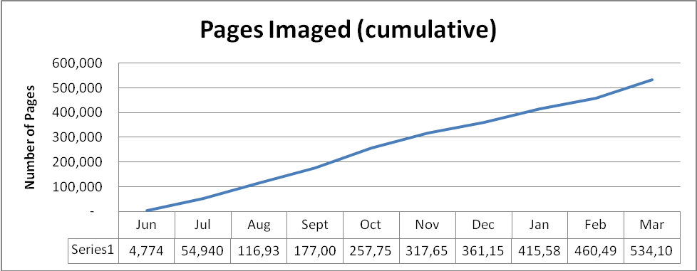
* estimated based on partial month data

Integrations
On the capture-side, the Kofax application integrates with the production financial system, DaFIS TP. Users can enter an approved DaFIS document # which corresponds to the invoice being imaged. Based on the document #, an ODBC lookup will retrieve a variety of additional fields from DaFIS TP. These additional fields, such as Vendor Name, Amount, Initiator ID, have been identified by AP users as useful for search and audit requirements. Once indexed, a document can be retrieved by searching any or all of these fields, including the DaFIS document #.

To facilitate wide-audience retrievals, an additional integration imbeds a retrieval link within specific DaFIS DS reports. To eliminate the need for redundant logins, this approach uses the DaFIS DS system to make a direct request to the Oracle IPM server, as opposed to each user’s client making the request. Once DS has retrieved the document, it forwards it to the client as a read-only PDF. This access is available to any of the thousands of DaFIS DS users with authority to via AP reports.

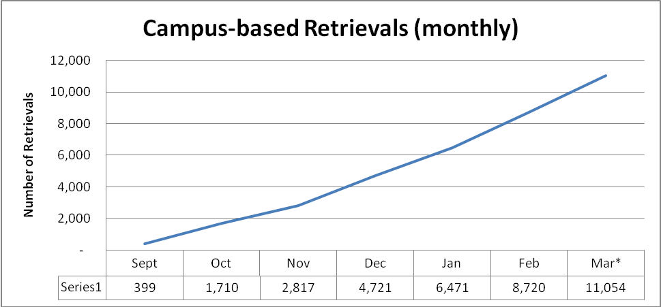
* estimated based on partial month data

DaFIS Decision Support Web API Integration

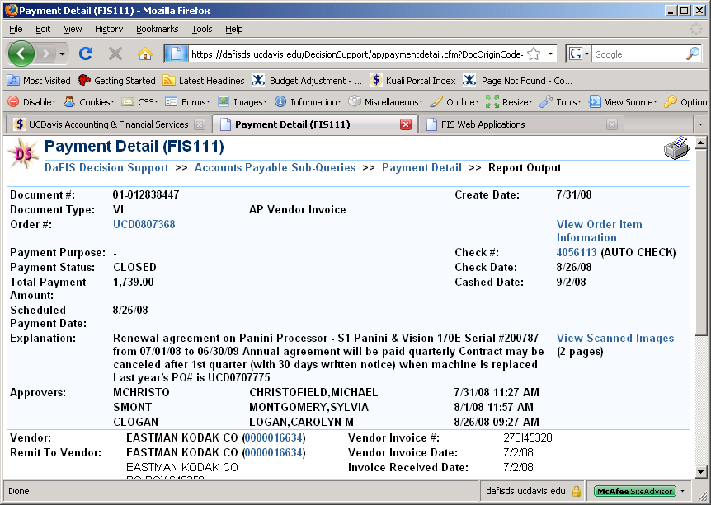

Payroll Implementation

Summary
The UCD and UCDHS Payroll departments implemented their own unique solutions of EDMS. The campus department focused on employee documents and pay cycle documents, while the UCDHS department required a solution to manage timecards, reports, and miscellaneous employee documents. Combined, the two departments can accommodate over 235,000 pages per month of imaging – the bulk of which is expected to be the imaging of existing employee files at the campus.

For campus employee files, a high-volume scanner was deployed allowing over 15,000 pages of scanning per day. As the campus retains over 1,000,000 pages of employee files, this capacity was needed for the department to image all its paper records within one year. For pay cycle documents, Optical Character Recognition (OCR) was incorporated to greatly minimize the validation processing time per document. After scanning, the system checks the image against three different templates and automatically extracts the employee ID.

For UCDHS timecard documents, another form of OCR was utilized. For this solution, the system automatically extracts the employee ID and pay date from the timecard. Pre-populated drop-down list were created to facilitate the validation of the employee files, as there exists a variety of different document types. Whereas documents were previously filed by type, they are now searchable by type, employee ID, name, scan date, etc.

Both solutions incorporate a database lookup based upon the employee ID. This lookup automatically populates additional index fields, saving time and labor during the validation process. Once validated, the documents are stored in the Oracle repository. The Payroll staff can utilize the robust Oracle IPM search tools to retrieve and annotate the documents.

Specific business value of EDMS:
- Reduced and/or eliminated physical storage requirements for employee payroll records
- Greatly enhanced options for document retrieval
- Ability to consistently and systematically destroy files in accordance with UC policies

Since going live in October of 2008, the Payroll departments have imaged more than 420,000 pages and indexed over 150,000 individual documents. Combined, they have retrieved more than 4000 documents from the system.

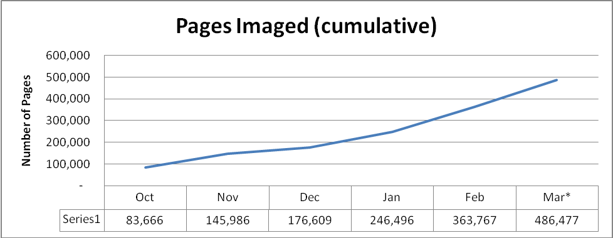
* estimated based on partial month data
Integrations
On the capture-side, the Kofax application integrates with the production payroll system, PPS. Users can enter an employee ID which corresponds to the document being imaged. Based on the employee ID, an ODBC lookup will retrieve the employee’s first, last, middle, and prior names. Once indexed, a document can be retrieved by searching any or all of these fields, including the employee ID.

Next Steps

Roll-out Schedule

Over the next several years, an additional eight to nine departments are approved to take part in the EDMS roll-out:

Phase / Year | Department
1 | Campus AP (In Production, 7/1/08)  UCDHS AP (In Production, 7/1/08)
2 | Campus Payroll (In Production, 9/24/08)  UCDHS Payroll (In Production, 10/7/08)  EH&S (estimated go-live: 4/15/09)
3 | UCDHS Finance (In Production, 1/27/2009)  Student Accounting (estimated go-live: 4/21/09)  Police and Fire  Human Resources
4 | Purchasing and Contracts  UCDHS Patient Financial Services  UCDHS Pharmacy
5 | UCDHS Pathology  UCDHS Facilities Design (tentative)

New Departments
In addition to those departments already approved, it is the goal of the EDMS team to expand the project to any interested departments or units. Some departments, such as the California National Primate Research Center (CNPRC), have already expressed an interest in joining the project. To facilitate these new departments, the project is currently developing an internal rate charge for project resource and license costs.

Oracle Workflow
To continue providing the best service and features possible, the project is planning to configure and deploy the Oracle IPM workflow tool. This tool is fully integrated with the document search GUI and will allow users access additional time and labor saving workflow features.

TECHNOLOGY UTILIZED

The EDMS back-end infrastructure is comprised of the following servers:

Description | Specifications | Required Software
Oracle IBPM Application Server  - Routes documents, manages searches, authenticates users, writes audit logs | Dual-core Xeon  4 Gigabytes RAM  200 Gigabytes storage | Windows 2003 Server  Oracle IBPM 7.7
Oracle IBPM Storage Server  - Stores, retrieves and manages document files  Kofax Application Server  - Communicates with remote site servers and Oracle IBPM | Dual-core Xeon  4 Gigabytes RAM  700 Gigabytes storage | Windows 2003 Server  Oracle IBPM 7.7  Kofax Capture 7.5
Oracle IBPM Web Server  - Web access for user community | Dual-core Xeon  4 Gigabytes RAM  200 Gigabytes storage | Windows 2003 Server  IIS

Note: In addition to the above servers, EDMS makes use of an Oracle database server shared by other UC Davis system-wide applications.

Each department utilizing EDMS has the following on-site infrastructure:

Description | Specifications | Required Software
Kofax Remote Site Server (RSS)  - Communicates between department and central server | Current-generation client workstation | Windows XP Pro  Kofax Capture 7.5
Kofax Capture and Validation workstation  - Connected to scanner, used to scan and index documents | Standard client workstation | Windows XP Pro  Kofax Capture 7.5
Scanner / Capture device  - Typically high-volume dedicated scanner, examples include Fujitsu fi-5750 and fi-6770 scanners | Departmental or Production level scanner | Kofax VRS
Retrieval workstation  - Any workstation authorized to retrieve documents | Standard client workstation | Internet Explorer

For integrations, the project has leveraged the following tools and applications:
Description | Toolset
Database look-ups  - Database views to automate data entry while validating documents | Oracle ODBC
Integration with existing decision support application (DaFIS DS)  - Leverages single sign-on to reporting tools; allows for web-based retrieval access of imaged AP invoices to campus-wide audience | Web API  ImageSource I-Linx
Transmission of documents between servers and clients | HTTPS protocols

Graphical representation of the EDMS architecture:
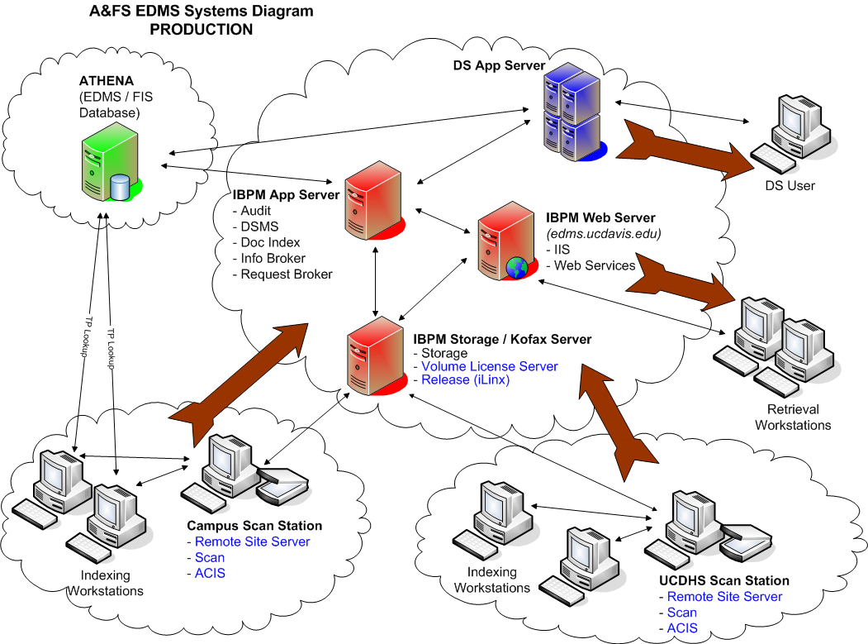

TIMEFRAME OF IMPLEMENTATION

Timeframe | Description
June, 2004 | Request for Information (RFI) sent to vendor community
October, 2005 | Request for Proposal (RFP) sent to select vendors
November, 2007 | Contract awarded to ImageSource, Inc for core software and implementation services
April, 2008 | Start of the Campus and UCDHS Accounts Payable implementations
June, 2008 | Go-live of the Campus and UCDHS Accounts Payable solutions
July, 2008 | Start of the Campus Payroll implementation
August, 2008 | Start of the UCDHS Payroll implementation
September, 2008 | Go-live of the Campus Payroll solution
October, 2008 | Go-live of the UCDHS Payroll solution
November, 2008 | Start of the UCDHS Finance implementation
January, 2009 | Go-live of the UCDHS Finance implementation
January, 2009 | Start of the Environmental Health and Safety (EH&S) implementation
February, 2009 | Start of the Student Accounting implementation
April, 2009 | Expected go-live of the EH&S and Student Accounting departments
2009-2010 | Expected go-live of the Police and Fire, Human Resources, Purchasing and Contracts, UCDHS Patient Financial Services, UCDHS Pharmacy, UCDHS Pathology departments

OBJECTIVE CUSTOMER SATISFACTION DATA

“The UC Davis Health System Accounts Payable office began imaging disbursement documents this fiscal year. The implementation process from kickoff to completion was amazingly smooth. There were no issues or concerns that the EDMS project team didn't address or resolve. We received excellent training and were provided with well detailed instruction materials. The team frequently traveled from Davis to Sacramento to provide any support that was needed to ensure a successful launch. Shortly after the implementation, we received numerous calls from our department managers expressing their gratitude to have the ability to retrieve payment information with minimal Accounts Payable involvement. EDMS had provided them with a tool that allowed them to complete their general ledger reviews timely and accurately. My staff enjoys the ease of scanning in the documents and the benefit of no longer having to maintain the paper documentation. With less payment inquiries and the ability to retrieve the documents faster in a myriad of different search formats, my group has been able to provide better customer service to our vendors. We are unable to thank the team enough for keeping us very informed throughout the entire process and facilitating our overall disbursement process.”
Ross O'Brien
Assistant Manager
Travel and Entertainment
AP/Payroll Department
UC Davis Health System

“The Payroll Services staff has been very pleased with every aspect of the planning, training, implementation and rollout of our EDMS project… Specific to the Payroll Services office, many of our employee documents have information on them that is considered “private and protected” under federal law. At all times they kept this in mind and ensured the highest levels of security were in place to give us the confidence we needed to move to this “paperless” system.

Perhaps even more important than the convenience and cost savings is that imaging these critical employee files ensures that we finally have a back-up system. If a fire should erupt or some other major structural disaster should occur, we would be unable to reproduce any of these original and vital employee documents. Imaging these files will meet the intent of our Business Continuity and Recovery plans.

I would like to thank Radhika and Mike for their expertise, leadership, insight, and positive encouragement. We are a very busy, deadline driven workplace and they were willing to be flexible about finding meeting and training time, while still keeping us focused on meeting the stated project plan deadline. The new EDMS system is a huge benefit for us – saving time and making our lives so much easier. Documents can be found with a few keystrokes and we no longer have the previous concerns of misfiled, lost or destroyed documents. This project ensures we are able to retrieve the records of current and former employees, whether for audit inquiries, retirement and service credit requests, life insurance handling, intercampus transfers, etc, - now and for years to come. We could not be more pleased. “
Cindy Jones, Manager—Payroll Services
University of California, Davis
Accounting & Financial Services

“I utilize DS 112 (Payment/Credit Lookup) daily which, when viewing specific transactions, will take me to DS 111 where I can then view any/all pertinent scanned documents for that transaction. In my opinion, having documents available in that format is very efficient and time-saving so I will certainly give a "thumbs up" to that recent development. I'm of the mind that there's no such thing as having too much information at your fingertips so I appreciate having our documents scanned into DS even if I don't utilize that feature daily. Thanks for everything.”
Paul Clarke
Business Office Supervisor/Account Manager
California Animal Health & Food Safety Laboratory System (CAHFS)
University of California, Davis

"The Payroll Office began the planning of implementing imaging of all documents earlier this year. [The project leads] met weekly with us to discuss any concerns we may have had. Training materials were made readily available to us and [they] conducted individual training to make this transition happen with ease. This feature has enabled us to retrieve information much more quickly than we have been able to in the past, therefore assisting the customer more promptly.”
Kathy Stuhr
Accountant II - Supervisor
Payroll Division
Accounting & Financial Services
University of California, Davis

“EDMS has been a positive addition to our department. It has streamlined our filing system and made it extremely effortless to locate paperwork. In addition, this process has helped in becoming more organized and staying current on filing documents.”
Marea Ruiz
Payroll, Specialist
UCD Payroll Department

